Evaluation and Implementation of Machine Learning Models to Predict Customer Churn in the Telecommunications Sector

Stephen Hasson

A Thesis Submitted in Partial Fulfilment

of the requirements for the

Degree of

Master of Science in Data Analytics



September 2024

Supervisor: Kayoum Khubli

**CCT College Dublin**

**Assessment Cover Page**

To be provided separately as a word doc for students to include with every submission

|  |  |
| --- | --- |
| **Module Title:** | Capstone Project |
| **Assessment Title:** | Evaluation and Implementation of Machine Learning Models to Predict Customer Churn in the Telecommunications Sector |
| **Supervisor Name:** | Kayoum Khubli |
| **Student Full Name:** | Stephen Hasson |
| **Student Number:** | sba23014 |
| **Assessment Due Date:** | 27th September 2024 |
| **Date of Submission:** | 19th May 2024 |

**______________________________________________________________________**

**Declaration**

|  |
| --- |
| By submitting this assessment, I confirm that I have read the CCT policy on Academic Misconduct and understand the implications of submitting work that is not my own or does not appropriately reference material taken from a third party or other source. I declare it to be my own work and that all material from third parties has been appropriately referenced. I further confirm that this work has not previously been submitted for assessment by myself or someone else in CCT College Dublin or any other higher education institution. |

Abstract

The research aims to address the issue of customer churn in the Telecommunication (Telecom) industry by employing Machine Learning (ML) models to predict customers at risk of leaving and provide a series of data-driven recommendations for targeted customer retention based on model predictions. Review of literature found ML to be an effective method to address Telecom churn, however further research is needed particularly in relation to the ethical implications of ML and Artificial Intelligence (AI) in churn prediction and its potential bias towards vulnerable groups. The Cross-Industry Standard Process for Data Mining (CRISP-DM) framework was tailored for the project management of this research, which helped to guide the development of three Supervised Learning (SL) ML classification models, Random Forests (RF), LightGBM (LGBM) and XGBoost (XGB). These models were implemented in combination with various class resampling techniques including oversampling, undersampling and combined resampling to address the class imbalance within the data model. Research findings identified five key feature groups as being the most significant predictors of churn at Viatel Technology Group (VTG): customer billing and pricing; discounts & upgrades; customer lifecycle; service & retention efforts and product offerings.

Additionally, whilst several models demonstrated promising results, LGBM-SMOTETomek recorded the best overall model performance when predicting the minority (churn) class with precision of 97.92%, recall of 95.25% and F1-score of 96.57%, and in general boosting ensemble methods outperformed bagging models in terms of predictive performance. The research concludes with a series of recommendations which aim to encourage the transition towards automatic payment methods, reward long-standing legacy customers and proactively engage with customers who have frequently contacted the company.

**Keywords:** Customer Churn Prediction, Telecommunication, Machine Learning, Random Forests, LightGBM, XGBoost

**Github Capstone URL:** <https://github.com/CCT-Dublin/msc-data-analytics-capstone-thesis-july-2024-sba23014>

Acknowledgements and Dedication

I would like to extend my thanks to the lecturers and staff at CCT College Dublin and our programme coordinator David McQuaid for their ongoing support and teaching. Additionally, I’d like to thank my supervisor Kayoum Khubli who provided helpful guidance throughout the course of this research. This past year has been truly transformative in terms of my development in Data Analytics and the wide portfolio of projects undertaken, which will prove invaluable as I progress in my career.

To my classmates I would like to extend my thanks for all of their ongoing support and for providing an engaging and collaborative environment that I have learned a lot from, with the hope that these connections can be carried forward into the future.

Finally, and most importantly I would like to thank my wife and the birth of my son which took place on the 11th July whilst conducting this research. This has undoubtedly been some of the best and most challenging months in my life, but you have supported me all the way, being incredibly patient, and it is a testament to you that I am able to submit this research on-time in what was originally thought to be an almost impossible task. Thank you.

Table of Contents

List of Figures 8

List of Tables 12

List of Equations 13

List of Acronyms 14

1. Introduction 16

1.1 Background 16

1.2 Problem Definition 16

1.3 Research Objectives 19

1.3.1 Primary Research Objectives 19

1.3.2 Technical Objectives 20

1.4 Contribution 20

1.5 Research Scope 21

1.6 Thesis Structure 21

2. Literature Review 22

2.1 Introduction 22

2.1.1 Customer Churn 22

2.1.2 Telecom Industry 23

2.1.3 Global and Domestic Churn Landscape 23

2.2 Analysis of Churn Dynamics in the Telecom Industry 24

2.3 The Role of ML Models in Predicting Churn in Telecom 26

2.3.1 Supervised and Unsupervised Learning 27

2.3.2 Classification and Regression Techniques 28

2.3.3 Classification Model Approach 28

2.3.4 Ensemble Learning 29

2.3.5 Overfitting and Underfitting 29

2.3.6 Bagging & Boosting 30

2.3.7 Classification Model Selection 32

2.3.8 Classification Model Performance Evaluation 34

2.4 Frameworks for ML Model Development and Optimisation in Telecom 37

2.4.1 Exploratory Data Analysis 37

2.4.2 Data Preprocessing and Feature Engineering 38

2.4.3 Feature Importance and Dimensionality Reduction 39

2.4.4 Class Imbalance and Sampling Strategies 43

2.4.5 Cross-Validation 45

2.4.6 Model Optimisation and Regularisation 46

2.4.7 Research Summary 48

2.5 Strategies and Innovations for Effective Implementation of ML Churn Prediction Models 50

2.5.1 Cross-Industry Standard Process for Data Mining (CRISP-DM) 50

2.5.2 Strategies and Innovations for Effective Implementation of ML Churn Prediction Models 52

2.6 Conclusion 53

3. Research Methodology 55

3.1 Primary Research Methodology 55

3.1.1 Primary Research Design 55

3.1.2 Sampling Strategy 56

3.1.3 Sample Composition 56

3.1.4 Content Analysis 57

3.2 Secondary Data 59

3.2.1 Data Source Systems 59

3.2.2 Data Sources 60

3.3 Timeframe and Supervisor Meetings 61

3.4 Research Validity 62

3.4.1 Face Validity 62

3.4.2 Content Validity 62

3.4.3 Construct Validity 63

3.4.4 Internal Validity 63

3.4.5 External Validity 63

3.5 Ethics, Legal and Regulatory Considerations 63

3.5.1 Informed Consent 64

3.5.2 Data Privacy and Confidentiality 64

3.5.3 Data Security 64

3.5.4 Bias and Fairness 64

3.5.5 Regulatory and Compliance Considerations 65

3.6 Tools and Technologies 65

3.7 Project Management Framework 66

3.8 Data Understanding and Preparation 67

3.8.1 Primary Research Findings 68

3.8.2 Data Understanding 70

3.8.3 Data Preparation 74

3.8.4 Exploratory Data Analysis (EDA) 75

3.9 Modelling 94

3.9.1 Model Selection 94

3.9.2 Model Assumptions 99

3.10 Test Design 101

3.10.1 Dataset Splitting 101

3.10.2 Dataset Scaling 102

3.10.3 Performance Evaluation Metrics 103

3.10.4 Dimensionality Reduction 104

3.10.5 Cross Validation Techniques 104

3.10.6 Class Resampling Methods 104

3.10.7 Hyperparameter Tuning 104

3.8 Conclusion 108

4 Evaluation 109

4.9 Overview of Model Performance 109

4.9.1 Random Forest Model Performance 109

4.9.2 LightGBM Model Performance 118

4.9.3 XGBoost Model Performance 129

4.10 Evaluation Summary 140

4.10.1 Model 1 Evaluation Summary 140

4.10.2 Model 2 Evaluation Summary 140

4.10.3 Model 3 Evaluation Summary 142

4.11 Conclusion 150

5 Research Findings and Discussion 151

6 Conclusions and Recommendations 158

References 161

Appendix 173

Primary Research Interview Transcriptions 173

Chief Operating Officer at VTG (COO) 173

Head of Sales at VTG (HOS) 178

Head of Operations (HOO) 185

Care and Collections Manager at VTG (CCM) 192

Data Analytics External Consultant (SME) 197

# List of Figures

Figure 1: Line Market Shares based on Wholesale and Retail Revenue 18

Figure 2: Fixed Market - Retail Fixed Voice Subscriber Lines 18

Figure 3: Fixed Market - Retail Fixed Broadband Market Shares based on Subscriber Lines 19

Figure 4: Fixed Market - FTTP Subscriber Line Market Share 19

Figure 5: State of Churn by Industry in the US 24

Figure 6: Telecom Customers Reason for Changing Providers 26

Figure 7: Field of Artificial Intelligence and Data Science 28

Figure 8: Supervised and Unsupervised Learning 29

Figure 9: Classification Model 29

Figure 10: General Approach to Building a Classification Model 30

Figure 11: Overfitting vs Underfitting in Supervised Learning Algorithms 31

Figure 12: Ensemble Learning Development of a Strong Learner 31

Figure 13: Bagging Ensemble Learning 32

Figure 14: Boosting Ensemble Learning 33

Figure 15: Supervised Learning Models for Regression and Classification 34

Figure 16: Supervised ML Model Selection 34

Figure 17: Comparison of XGBoost & LightGBM 35

Figure 18: Confusion Matrix in the Context of Churn Prediction 37

Figure 19: Classification Report 38

Figure 20: Area Under the ROC Curve 38

Figure 21: Fundamental Steps of the Exploratory Data Analysis Process 40

Figure 22: Data Preprocessing Steps 40

Figure 23: Feature Engineering 41

Figure 24: Tree-Based Classification Model Using Gini Criterion 42

Figure 25: Tree-Based Classification Model Using Entropy Criterion 43

Figure 26: Gini Impurity and Entropy Visualised 44

Figure 27: Feature Importance Scores for Customer Churn using Random Forest Classifier 45

Figure 28: Class Imbalance Sampling Approaches 46

Figure 29: K-Fold Cross-Validation Concept 48

Figure 30: Train, Test & Validation Split 48

Figure 31: LightGBM Ensemble Model Optimisation Framework 49

Figure 32: Grid Search and Random Search Hyperparameter Tuning Methods 49

Figure 33: Cross-Industry Standard Process for Data Mining (CRISP-DM) Framework 53

Figure 34: Tasks and Outputs of the CRISP-DM Reference Model 54

Figure 35: Interview Type Differences 58

Figure 36: Qualitative Content Analysis Process 60

Figure 37: Project Timeline 64

Figure 38: Tailored CRISP-DM Research Implementation 69

Figure 39: Data Description Report 73

Figure 40: Conceptual, Logical and Physical Data Model 74

Figure 41: Conceptual Data Model 74

Figure 42: Logical Data Model 75

Figure 43: Customer Creations by Creation Year 77

Figure 44: Customer Count by Duration Group 78

Figure 45: Customer Cancellations by Cancellation YearMonth 79

Figure 46: National Heatmap of Active Customers 79

Figure 47: National Heatmap of Cancelled Customers 80

Figure 48: Active Customer Count by County 81

Figure 49: Cancelled Customer Count by County 82

Figure 50: Active and Cancelled Customer Count by County 83

Figure 51: Active and Cancelled Customer Count by Province 84

Figure 52: Choropleth Map No. Active Customers by County 85

Figure 53: Choropleth Map No. Cancelled Customers by County 86

Figure 54: Choropleth map of Pct. Cancelled vs Active Customers by County 87

Figure 55: Cancelled Customer Count by Customer Bill Group Type 88

Figure 56: Active Customer Count by Product Group 89

Figure 57: Cancelled Customer Count by Product Group 89

Figure 58: No. Customers by Cancellation Reason 90

Figure 59: No. Customers Saved by Retention Approach 91

Figure 60: Random Forest Architecture Digram 97

Figure 61: LGBM Architecture Diagram 98

Figure 62: XGBoost Architecture Diagram in ML 100

Figure 63: Supervised ML Model Selection 101

Figure 64: Customer Lifecycle Related Features Correlation Matrix Heatmap 102

Figure 65: Dataset Class Distribution 102

Figure 66: One-Hot Encoding Process 103

Figure 67: Test Design Implementation Flowchart 103

Figure 68: Stratified Sampling in Machine Learning 104

Figure 69: Dataset Split(s) Class Distribution 104

Figure 70: Standard Scaling Before and After Effects 105

Figure 71: RF-M1: CFI Threshold Performance Metrics 112

Figure 72: RF-M1: CFI Line Chart 113

Figure 73: RF-M1: CFI Threshold Performance Metrics Charts 114

Figure 74: RF-M2: Class Resampling Randomized Search Best Parameters 114

Figure 75: RF-M2: Class Resampling Randomized Search Performance Metrics 115

Figure 76: RF-M2: Class Resampling Randomized Search Performance Charts 116

Figure 77: RF-M3: Class Resampling Grid Search Best Parameters 117

Figure 78: RF-M3: Class Resampling Grid Search Performance Metrics 117

Figure 79: RF-M3: Class Resampling Randomized Search Performance Charts 119

Figure 80: RF-M3: Class Resampling Grid Search Test Set Classification Report 120

Figure 81: LGBM-M1: CFI Threshold Performance Metrics 121

Figure 82: Figure 80: LGBM-M1: CFI Line Chart 121

Figure 83: LGBM-M1: CFI Threshold Performance Metrics Charts 123

Figure 84: LGBM-M2: Class Resampling Randomized Search Best Parameters 123

Figure 85: LGBM-M2: Class Resampling Randomized Search Performance Metrics 123

Figure 86: LGBM-M2: Class Resampling Randomized Search Performance Charts 126

Figure 87: LGBM-M3: Class Resampling Grid Search Best Parameters 127

Figure 88: LGBM-M3: Class Resampling Grid Search Performance Metrics 127

Figure 89: LGBM-M3: Class Resampling Randomized Search Performance Charts 129

Figure 90: LGBM-M3: Class Resampling Randomized Search Performance Charts 130

Figure 91: LGBM-M3: Class Resampling Grid Search Test Set Classification Report 131

Figure 92: XGB-M1: CFI Threshold Performance Metrics 132

Figure 93: XGB-M1: CFI Line Chart 132

Figure 94: XGB-M1: CFI Threshold Performance Metrics Charts 134

Figure 95: XGB-M3: Class Resampling Grid Search Best Parameters 134

Figure 96: XGB-M3: Class Resampling Randomized Search Performance Metrics 135

Figure 97: XGB-M2: Class Resampling Randomized Search Performance Charts 137

Figure 98: LGBM-M3: Class Resampling Grid Search Best Parameters 138

Figure 99: LGBM-M3: Class Resampling Grid Search Performance Metrics 138

Figure 100: XGB-M3: Class Resampling Randomized Search Performance Charts 141

Figure 101: LGBM-M3: Class Resampling Grid Search Test Set Classification Report 142

Figure 102: M1 Features at CFI 85% Importance Threshold 143

Figure 103: M3 Minority Class (1) Prediction Evaluation | Precision 146

Figure 104: M3 Minority Class (1) Prediction Evaluation | Recall 147

Figure 105: M3 Minority Class (1) Prediction Evaluation | F1-score 148

Figure 106: M3 Majority Class (0) Prediction Evaluation | F1-score 149

Figure 107: M3 Weighted Average Evaluation | F1-score 150

Figure 108: M3 Accuracy Evaluation 151

Figure 109: M3 Log Loss Evaluation 152

Figure 110: M3 Time Taken (s) Evaluation 153

# List of Tables

Table 1: Churn Prediction Methods and Evaluation Metrics in Telecoms 34

Table 2: Classification Model Performance Metrics 35

Table 3: Feature Groups for Churn Modelling 42

Table 4: Feature Importance Scores Obtained Using Feature Selection 42

Table 5: Comparison of Different Sampling Methods on Imbalanced Datasets 45

Table 6: Research Summary of Model Development and Sampling Methods Reviewed 49

Table 7: Secondary Data Source Systems 59

Table 8: Secondary Data Sources 60

Table 9: Tools and Technologies 66

Table 10: Data Dictionary 89

Table 11: Model Selection Tree-Based Splitting Methods 94

Table 12: RF-M1: CFI Threshold Feature Importance Evaluation Hyperparameters 104

Table 13: RF-M2: Class Resampling Randomized Search Evaluation Hyperparameters 105

Table 14: RF-M3: Class Resampling Grid Search Evaluation Hyperparameters 105

Table 15: LGBM-M1: CFI Threshold Feature Importance Evaluation Hyperparameters 105

Table 16: LGBM-M2: Class Resampling Randomized Search Evaluation Hyperparameters 106

Table 17: LGBM-M3: Class Resampling Grid Search Evaluation Hyperparameters 106

Table 18: XGB-M1: CFI Threshold Feature Importance Evaluation Hyperparameters 107

Table 19: XGB-M2: Class Resampling Randomized Search Evaluation Hyperparameters 107

Table 20: XGB-M3: Class Resampling Grid Search Evaluation Hyperparameters 107

Table 21: Key factors influencing churn at VTG identified in Primary Data 155

Table 22: ML Modelling Most Important Churn Factor Categories 157

Table 23: Highest and Lowest Performing ML Models 159

# List of Equations

Equation 1: Customer Churn Rate (CCR) % 23

Equation 2: Customer Lifetime Value (CLV) 25

Equation 3: Customer Retention Rate (CRR) % 25

Equation 4: Customer Retention Cost (CRC) 25

Equation 5: Customer Acquisition Cost (CAC) 26

Equation 6: Log Loss Performance Measure Equation 39

Equation 7: Gini Impurity Equation 41

Equation 8: Entropy Equation 42

Equation 9: Linear Regression Objective 50

Equation 10: L1-Regularised Linear Regression Objective 50

Equation 11: L2-Regularised Linear Regression Objective 50

Equation 12: RF Algorithm Equation 98

Equation 13: LGBM Algorithm Equation 99

Equation 14: XGBoost Model Error Equation 100

Equation 15: XGBoost Algorithm Equation 100

Equation 16: Customer Duration Equation 102

Equation 17: Standard Scaling Equation 105

# List of Acronyms

|  |  |
| --- | --- |
| **Acronym** | **Description** |
| ADASYN | Adaptive Synthetic Sampling |
| AI | Artificial Intelligence |
| AIJOA-CPDE | AI-Driven Jaya Optimisation Algorithm |
| ANN | Advanced Neural Network |
| AUC | Area under the ROC curve |
| B2B | Business-to-Business |
| B2C | Business-to-Customer |
| BDLSTM | Bidirectional Long Short-Term Memory |
| BT | British Telecom |
| CPS | Call Path Service |
| CapEx | Capital Expenditure |
| CCM | Care and Collections Manager |
| CCP | Customer Churn Prediction |
| CCR | Customer Churn Rate |
| Churn | Customer Churn |
| CLV | Customer Lifetime Value |
| ComReg | Commission for Communications Regulations |
| COO | Chief Operating Officer |
| CRC | Customer Retention Cost |
| CRM | Customer Relationship Management |
| CRR | Customer Retention Rate |
| CSAT | Customer Satisfaction Score |
| DA | Data Analytics |
| DSL | Digital Subscriber Line |
| EDA | Exploratory Data Analysis |
| EFB | Exclusive Feature Bundling |
| EFT | Electronic Funds Transfer |
| FC | Fixed Communications |
| FPR | False Positive Rate |
| FTTC | Part-Fiber / Fiber-to-the-Cabinet |
| FTTH | Fiber-to-the-Home |
| FX | Foreign Exchange |
| GBDT | Gradient Boosted Decision Tree |
| GBM | Gradient Boosting Machine |
| Gini | Gini Impurity |
| GOSS | Gradient-based-one-side-sampling |
| HOO | Head of Operations |
| HOS | Head of Sales |
| IoT | Internet of Things |
| ISP | Internet Service Provider |
| LASSO | Least Absolute Shrinkage and Selection Operator |
| LDA | Linear Discriminant Analysis |
| LGBM | Light Gradient-Boosting Machine |
| LLM | Large Language Models |
| LLU | Local Loop Unbundling |
| Log Loss | Logarithmic Loss |
| ML | Machine Learning |
| MRR | Monthly Recurring Revenue |
| NBI | National Broadband Ireland |
| NGA | Next Generation Access |
| NLP | Natural Language Processing |
| NPS | Net Promotor Score |
| OAO | Other Authorised Operator |
| OpEx | Operational Expenditure |
| P&L | Proft & Loss |
| PCA | Principal Component Analysis |
| PII | Personally Identifiable Information |
| POS | Point of Sale |
| PSO | Particle Swarm Optimisation |
| RF | Random Forest |
| ROC | Receiver Operating Characteristic |
| ROS | RandomOverSampling |
| RUS | RandomUnderSampler |
| SL | Supervised Learning |
| SME | Subject Matter Expert |
| SMOTE | Synthetic Minority Oversampling Technique |
| SMOTEENN | SMOTE and Edited Nearest Neighbours |
| Telecom | Telecommunication |
| TFM | Time-Frequency-Monetary |
| TPR | True Positive Rate |
| UL | Unsupervised Learning |
| USP | Unique Selling Point |
| VCEM | Voting Classifier Ensemble Method |
| VOIP | Voice over IP |
| VTG | Viatel Technology Group |
| XGB | XGBoost / eXtreme Gradient Boosting |

# Introduction

## Background

It is generally agreed that in the highly competitive Telecom sector maintaining a loyal customer base is essential for sustained business growth and success. TechSee (2022) identified that customer churn (churn), which refers to the loss of clients or customers is a widespread challenge across many industries, but is particularly pervasive in Telecoms. It is evidenced in the literature (Reichheld, 2001; Wagh et al., 2024) that retaining existing customers is more cost effective than acquiring new ones due to the higher costs associated with customer acquisition. Furthermore, McKinsey (2023) argues that if left unaddressed customer churn can significantly undermine a company’s stability and future growth prospects.

Wagh et al. (2024) emphasise the emergence of Machine Learning (ML) as an increasingly important technology in customer churn prediction (CCP) in Telecoms, arguing that given the vast amount of data generated in the sector and the limitations of human capabilities, ML offers a powerful tool for analysing patterns and predicting customer behaviour with greater accuracy. This research aims to address the issue of CCP in Telecoms by implementing a data-driven approach that leverages ML to proactively identify customers at risk of leaving. Enabling the development of actionable recommendations for targeted customer retention strategies.

The word count for this research is 17,562 (from the Introduction to the Conclusion, not including appendices, indexes, diagrams, tables, code, references, title or acknowledgements)

## Problem Definition

Bidgoli (2003) outline the Telecom industry as being defined in the 1996 Telecommunications Act as including a broad spectrum of communications businesses, including those involved in telephone, television, radio and internet services. In Ireland, the Commission for Communications Regulations (ComReg) (2024) is the statutory body responsible for the regulation of the electronic communications sector, which gathers data on quarterly basis from companies operating within the sector representing 95% of total domestic Telecom markets. As evidenced by ComReg’s (2024) latest Quarterly Key Data Report for Q1 2024, there were 52 operators within Irish markets, divided into Fixed Communications (FC) and mobile markets. Statista (2024) define FC as wired services such as home broadband, voice or landline services, whereas mobile services comprise of voice, text and data via wireless networks. According to ComReg’s (2024), Eir had the highest revenue share in the FC market at 37.9%, with the next eight largest operators contributing to a further 46.1%, and the remaining 16% accounted for by Other Authorised Operators (OAOs).

This research explores the problem of CCP in Telecom’s by leveraging data sourced from Digiweb, a retail Business-to-Customer (B2C) business line that forms part of the larger VTG, which according to ComReg’s (2024) accounted for approximately 3% market revenue share in the following Irish Telecom markets: fixed markets; fixed voice; retail broadband market; network broadband market and mobile market. For Telecom companies like Digiweb with a small market share, leveraging Data Analytics (DA) is essential to remain competitive. This research aims to enhance customer retention by applying ML to proactively predict churn. It achieves this by first understanding the dynamics of churn within the Telecoms industry and in Digiweb’s business, followed by an evaluation of how ML has been employed in existing literature to address similar challenges. With the primary aim of this research being to provide actionable recommendations, derived from ML predictions for targeted customer retention which can potentially reduce churn, improve customer loyalty and contribute to long-term growth and financial stability.

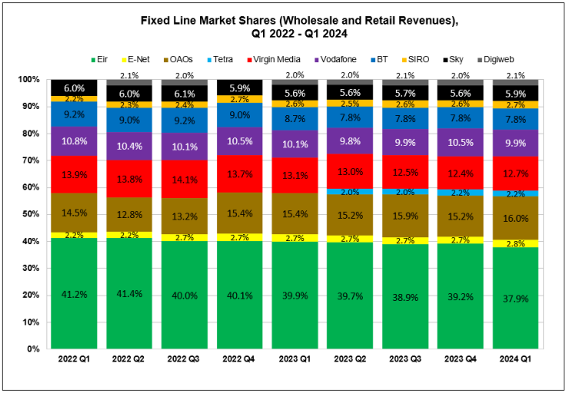

Figure : Line Market Shares based on Wholesale and Retail Revenue

*| Source: ComReg (2024)*

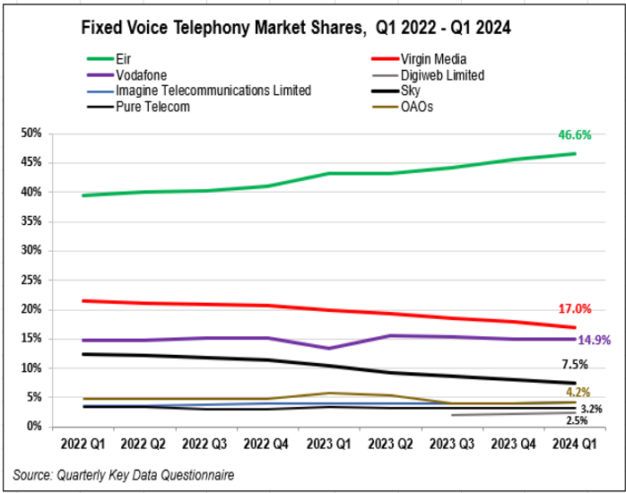

Figure : Fixed Market - Retail Fixed Voice Subscriber Lines

*|*

*Source: ComReg (2024)*

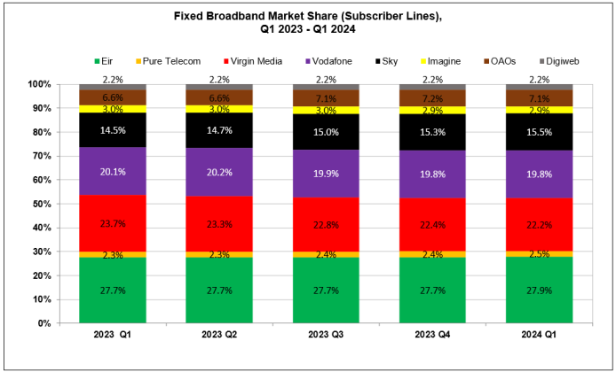

Figure : Fixed Market - Retail Fixed Broadband Market Shares based on Subscriber Lines

*| Source: ComReg (2024)*

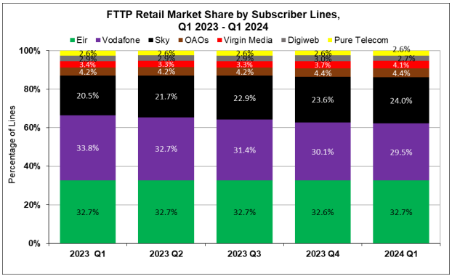

Figure : Fixed Market - FTTP Subscriber Line Market Share

| Source: ComReg (2024)

## Research Objectives

Research objectives are divided into primary research objectives which are the main objectives this research aims to address, and technical objectives which outline the methods and tools used to achieve these goals.

### Primary Research Objectives

**RO1**: Investigate and identify the key factors resulting in Telecom churn at Viatel Technology Group (VTG), by focusing on leveraging data currently available within VTG’s existing data infrastructure.

**RO2**: Develop an optimised and generalised ML model to predict customer churn at VTG and evaluate its effectiveness using appropriate performance comparison metrics and techniques.

**RO3**: Formulate a cohesive, data-driven strategy for VTG that incorporates actionable recommendations for targeted customer retention based on insights derived from ML model predictions.

### Technical Objectives

**TO1:** Conduct primary research through structured interviews with relevant internal stakeholders at VTG as well as external Subject Matter Experts (SMEs). Accompanied by secondary research of relevant literature and data within VTG’s existing data infrastructure, to establish the key factors influencing churn and retention in Telecom and at VTG.

**TO2:** Select, construct and refine features that influence churn prediction accuracy using feature engineering and feature importance selection. Develop Supervised Learning (SL) ML models, with a focus on ensemble learning methods, Random Forests (RF), Light Gradient-Boosting Machines (LGBM) and eXtreme Gradient Boosting (XGB). Enhance model generalisation by addressing class imbalance through various sampling approaches and regularisation techniques. Optimise model performance through hyperparameter tuning using methods like Grid Search and Randomized Search.

**TO3**: Evaluate ML model performance using cross-validation techniques and a comprehensive set of comparison metrics, including Accuracy, Precision, Recall, F1 score, Area under the ROC curve (AUC), and Log Loss. Ensure models generalise well to unseen data by employing robust validation strategies. Leverage the most effective model predictions to formulate a cohesive, data-driven strategy with actionable recommendations for targeted customer retention at VTG.

## Contribution

This research aims to address multiple gaps and in doing so makes several contributions. First, the research extends the understanding of churn in the Irish Telecom industry through the identification of key churn factors based on a service provider operating in the industry. Second, this research presents a critical evaluation and comparison of a novel framework for CCP in Telecoms through the development of RF, LGBM and XGB SL classification algorithms, each categorised by distinct tree-based splitting behaviours. Additionally, the research investigates several class resampling techniques, including oversampling, undersampling and combined resampling to address the common issue of class imbalance in CCP datasets. In doing so this research aims to identify the most suitable approach for CCP in Telecoms, and proposes a data-driven strategy to address churn through the incorporation of ML predictions for targeted customer retention based on a customer segmentation approach.

## Research Scope

This research focuses exclusively on the Republic of Ireland’s domestic retail Telecom sector, therefore geographic regions outside of Ireland are not within the scope of this research. Additionally, the secondary data utilised in this research is sourced from VTG’s B2C residential business Digiweb, which exclusively services the FC market, therefore mobile services markets are not within the scope of this research. The research focuses on currently active Digiweb customers as of 17th June 2024, as well as those who left the company between 1st January 2023 and 17th June 2024, thus Digiweb customers who left prior to 1st January 2023 are excluded to ensure that model predictions are based on valid and reliable data.

## Thesis Structure

This research is organised into several chapters, with each building on the previous one to contribute to a comprehensive understanding of the research undertaken. The introductory chapter sets the stage by providing background information regarding the problem, research objectives, contribution and the scope of the research. Chapter two delves deeper into the existing body of knowledge in literature relevant to the research topic, critically evaluating previous studies, identifying gaps in literature and establishing a theoretical framework that focuses on addressing the research objectives. Chapter three details the approach and research methods used to conduct the study, including primary research, validity and ethical considerations as well outlining the steps taken during data exploration, preparation and model development. Chapter four evaluates model performance using a comprehensive set of performance metrics and techniques, followed by chapter five which critically analyses research findings and results against both literature and primary research findings. The final chapter summarises key findings, drawing conclusions based on the research and outlines whether research objectives have been achieved, including limitations and areas for further improvement.

# Literature Review

## Introduction

The purpose of this literature review aims to critically assess the viability of ML modelling as a DA method for identifying and predicting customers at risk of churn in the Telecom, and in doing so guide the guide the implementation of preventative measures to reduce customer attrition. The review will explore four key aspects aligned with the research objectives.

1. Analysis of churn dynamics in the Telecom industry
2. The role of ML models in predicting churn in Telecom
3. Frameworks for ML model development and optimisation in predicting churn in Telecom
4. Strategies and Innovations for effective implementation of ML churn prediction models

### Customer Churn

Churn is of critical importance across various industries which has several definitions based on the field of application. Ahn et al. (2020) define churn as a prolonged period of inactivity, however the criteria for inactivity and prolonged can vastly differ among research areas and industries, such as internet services, gaming and insurance (p.220817). In contrast Aggarwal and Vijayakumar (2024) define churn as the termination of subscriptions or services by customers (p. 1), a definition which is supported by Lazarov and Capota (2007), who trace the term back to its roots in ‘change’ or ‘turn’, signifying the discontinuation of a contract. Fishel (2024) expands this definition as the rate at which customers cease doing business with an entity, expressed as the percentage of subscribers who discontinue their subscriptions within a given time period, also known as the rate of attrition or Customer Churn Rate (CCR).

$$CCR (\%) = \left( \frac{Lost Customers}{Total Customers at Start of Chosen Time Period} \right)× 100$$

Equation : Customer Churn Rate (CCR) % | Source: Fishel (2024)

Manzoor et al. (2024) define this period as 90 consecutive days of inactivity and categorise churn into voluntary, driven by customer dissatisfaction or changing circumstances, and involuntary, where the business terminates the service due to unpaid bills or a breach of terms. Lazarov and Capota (2007) further classify churn into active/deliberate, rotational/incidental and passive/non-voluntary (p. 2). Research by Park and Ahn (2022) emphasises involuntary churn in particular as posing a significant business challenge, which can damage customer trust and relationships if not properly managed. Additionally, Kotler (2023) introduces the concept of silent churn, where customers leave without providing feedback, further complicating churn detection and management. Pandithurai et al. (2023) outline the importance of addressing churn due to its impact on company revenue in many large scale industries. Similarly, Fanderl (2023) emphasises the impact of churn on company growth and profitability, contending that 80% of the value creation achieved by successful growth companies came from new revenue generation from existing customers, stating that companies need to acquire three new customers for every customer lost.

### Telecom Industry

As Bidgoli (2003) previously state, the Telecom industry is defined in the 1996 Telecommunications Act as including a broad spectrum of communications businesses, including those involved in telephone, television, radio and internet services.

### Global and Domestic Churn Landscape

Senthilselvi et al. (2024) note customer turnover is particularly challenging in the Telecom sector, similarly Aggarwal and Vijayakumar (2024) also contend that churn is a significant challenge in the Telecom industry. In the area of research, Bhattacharyya and Dash’s (2022) literature review reveals the vital nature of this issue, moreover a recent study by TechSee (2022) found churn to be pervasive in Telecoms, with 46% of those surveyed in the United States reporting cancelling a phone, internet, TV or cable contract in the previous year.

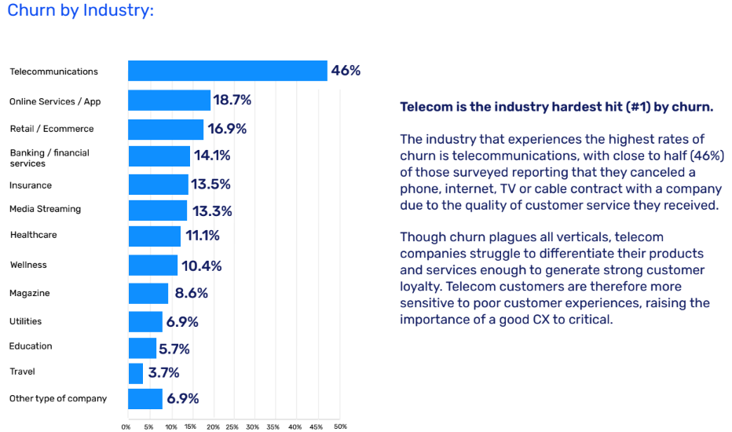

Figure : State of Churn by Industry in the US

*| Source: TechSee (2022)*

While there appears to be a gap of a similar study in the Irish Telecom industry, the EY Global Consumer Index (2024), which obtained data through an anonymous on-line survey of 22,000 responses from customers aged between 18 - 90 in 28 countries globally. Found that 62% of Irish consumers were extremely concerned about the cost of living, which is broadly aligned with 55% of global consumers expressing similar concerns. Further highlighting, that as a result of the current global economic backdrop, Irish consumers are choosing to prioritise affordability, and have shifted their preferences in favour of essential purchases and cheaper options, with 42% of respondents stating that they have either stopped or reduced purchases of certain products, or had switched to less expensive alternatives.

## Analysis of Churn Dynamics in the Telecom Industry

Zhao et al. (2021) highlight loyal customers as essential for enhancing business performance and competitiveness, though companies often prioritise new customer acquisition over retention. Bhale and Bedi (2024) emphasise the importance of reducing churn, as it fosters customer loyalty, increases sales and improves profitability (p. 7). Similarly, Khoh (2023) argues that customers are a company’s most valuable resource for sustainability. Fishel (2024) defines customer growth as the rate of acquisition exceeding attrition, stressing the impact of churn on preventing a net reduction in the customer base. Furthermore, Vanamala et al. (2024) highlight how churn negatively impacts Customer Lifetime Value (CLV), defined by Kotler (2023) as the total revenue a company can expect from a single customer throughout their service relationship.

$$CLV= avg. order value × no. of transactions ×avg. length of customer relationship$$

Equation : Customer Lifetime Value (CLV) | Source: Kotler (2023)

Salesforce (2024) define the Customer Retention Rate (CRR) as a measure to calculate the percentage rate of customer retention.

$$CRR (\%)= \left( \frac{Cust. at End of Period-New Cust. Acquired}{Cust. at Start of Period} \right)× 100$$

Equation : Customer Retention Rate (CRR) % | Source: Salesforce (2024)

However, Finmark (2024) contends that Customer Retention Costs (CRC), such as loyalty programs, marketing and staffing, and should be carefully considered before establishing retention strategies.

$$CRC = \left( \frac{Customer Retention Costs During a Set Period}{No. Customers Retained During that Period} \right)$$

Equation : Customer Retention Cost (CRC) | Source: Finmark (2024)

Furthermore, Wagh et al. (2024) argue that whilst Customer Acquisition Costs (CAC) are 5 times higher than CRCs, the complexity of predicting which customers might churn make retention strategies challenging to implement, adding that the unpredictability of customer behaviour can often lead to ineffective retention strategies and a misallocation of financial resources.

$$CAC = \left( \frac{Cost of Sales+Cost of Marketing}{New Customers Acquired} \right)$$

Equation : Customer Acquisition Cost (CAC) | Source: Wagh et. al (2024)

Reicheld (2001), who created the Net Promotor Score (NPS) as a measure of customer company loyalty, goes further arguing that CACs are five to twenty-five times that of CRCs, contending that increasing CRR by 5% can increase profits by 25% to 95%, underscoring the financial benefits of focusing on customer loyalty. Verhelst (2019) goes further, contending that attracting new customers can be up to six times more expensive that retaining existing ones, leading companies to switch from a selling-oriented to a customer-oriented marketing approach (p.1). Furthermore, Pawar et al. (2024) outline the challenge of customer loyalty in Telecoms, attributing high churn rates due to issues related to customer satisfaction and service quality. Similarly, TechSee (2022) found 92% of Telecom customers, up 9% from 2019 cited quality of service as their primary reason for leaving a provider, quoting ineffective customer service and self-service systems as contributing factors.

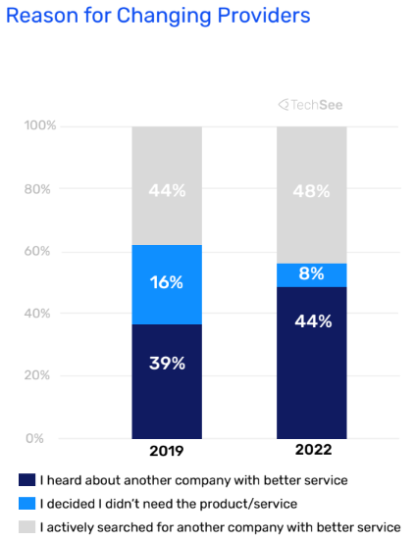

Figure : Telecom Customers Reason for Changing Providers | TechSee (2022)

Copăceanu (2021) contends that churn in Telecoms often results from customers finding more attractive offers elsewhere, either in terms of price or service quality, stating that the industry’s competitive nature means that service dissatisfaction often leads to customer defection. Furthermore, Kotler (2023) emphasises that low barriers to switching providers in the Telecoms exacerbate churn as competitors employ new initiatives to attract customers, outlining that network quality became a prominent reason for churn during the recent COVID-19 pandemic, as customers home connectivity requirements increased. Another factor identified by Silver (2023) suggests that COVID-19 had a significant impact on remote working dynamics, with the increased percentage of U.S. and European employees working from home, directly impacting Telecom providers services. TechSee (2022) survey results support these statements, which found a 22% decrease in customer loyalty since the beginning of the pandemic, attributed to decreased customer tolerance for subpar service. Furthermore, Baashar et al.(2020) define Customer Relationship Management (CRM) as a framework which aims to enhance customer satisfaction, loyalty, and profitability through effective relationship building and interaction with stakeholders (p. 103442). Lalwani et al. (2022) define churn management as an area that resides within the CRM framework that can be approached in two ways, reactively, where a company responds only after receiving a customer cancellation request; or proactively, where churn is predicted in advance of a customer cancellation request or involuntary churn (p. 272). Additionally, Ascarza et al. (2018) argue the selection between reactive and proactive churn management strategies come with several trade-offs, such as determining which customers are at risk versus which should be targeted as these groups don’t always overlap, as well as the available timeframe to address the issue.

## The Role of ML Models in Predicting Churn in Telecom

ML is defined by IBM (2021a) as a branch of Artificial Intelligence (AI) and computer science that focuses on using data and algorithms to enable AI to imitate the way that humans learn, gradually improving its accuracy. According to Wagh et al. (2024), ML has become a critical tool in predicting churn in Telecoms to address the limitations of human capabilities. Murphy (2015) attributes this rise in relevance due to the vast amount of data generated in Telecoms during the era of Big Data, which according to Zahid et al. (2020) can reach terabytes or petabytes daily. Rose et. al (2015) further highlights that the growth of the Internet of Things (IoT), which extends internet connectivity and computing capabilities to everyday objects, will only accelerate the adoption of ML for predictive modelling. Moreover, Sidiq et al. (2023) demonstrates ML’s effectiveness in churn management, outlining that by employing SL classification algorithms, companies can proactively identify customers likely to churn, addressing a traditionally complex challenge.

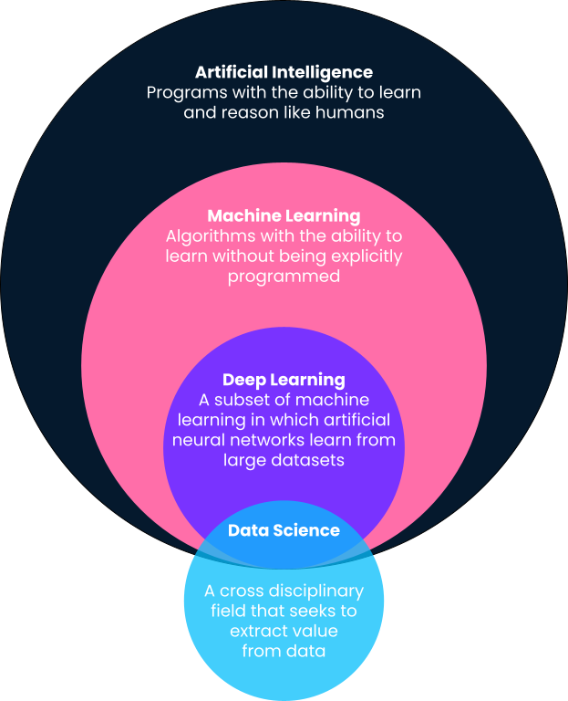

Figure : Field of Artificial Intelligence and Data Science | Crabtree (2023)

### Supervised and Unsupervised Learning

Burkov (2019) describe ML algorithms fall under two broad categories, which they define as (pp. 3-4).

**Supervised Learning (SL):** The goal of SL algorithm is to use the dataset to produce a model that takes a feature vector x as input and outputs information that allows deducing the label.

**Unsupervised Learning (UL):** The goal of an unsupervised learning algorithm is to create a model that takes a feature vector x as input and either transforms it into another vector or into a value that can be used to solve a practical problem.

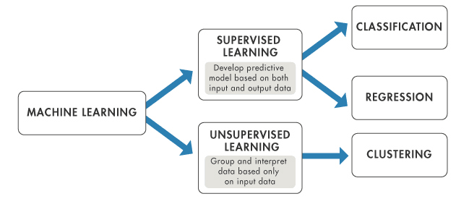

Figure : Supervised and Unsupervised Learning | Source: MathWorks (2024)

### Classification and Regression Techniques

Mathworks (2024) outline that SL use either classification or regression techniques to develop predictive models, defined as.

**Classification**: Techniques that predict categorical responses by classifying input data into categories, for example, whether an email is genuine or spam, or whether a tumour is cancerous or benign.

**Regression**: Techniques that predict continuous responses, for example, changes in temperature or fluctuations in power demand.

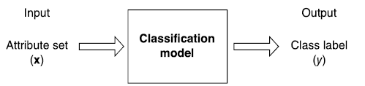

Figure : Classification Model

*Source: Pang-Ning Tab et al. (2019)*

### Classification Model Approach

Pang-Ning Tan (2019) explains that classification techniques are most suited for predicting or describing data sets with binary or nominal categories, such as churn prediction, but are less effective for ordinal categories. These techniques typically involve splitting the data into a training set and test set, often at a 80:20 or 70:30 ratio, whereby the training set is used to build the classification model, which is then applied to the test set which contains records with unknown class labels. The primary goal of this process is to develop a model with strong generalisation capabilities, accurately predicting the class labels of previously unseen records.

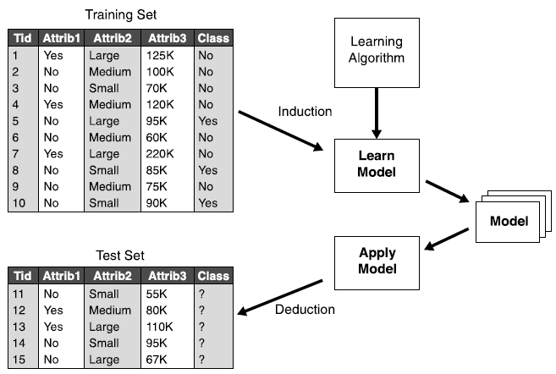

Figure : General Approach to Building a Classification Model | Source: Pang-Ning Tan et al. (2019)

### Ensemble Learning

Burkov (2019) defines ensemble learning, as focusing on training a large number of low-accuracy models (weak learners), and then combining model predictions through weighted voting, to create a high-accuracy meta-classifier with better generalisation than each individual classifier alone (p. 8). Moreover, Sina and Amiri (2022) highlight that ensemble learning methods are particularly effective in handling imbalanced datasets typical in Telecom churn prediction, whereby the minority (churn) class has fewer samples than the majority (non-churn) class. This imbalance can make it challenging for some machine learning algorithms to accurately identify the minority class.

### Overfitting and Underfitting

Moreover, Kalirane (2023) outlines that ensemble methods effectively mitigate the issue of individual high-bias or high-variance weak learners inherent with individual models, which can lead to underfitting or overfitting, defined as.

**Underfitted Model**: Fails to capture the underlying patterns in the training data, leading to poor performance on both the training and test sets.

**Overfitted Model**: Captures noise in the training data too well, causing it to perform poorly on unseen data.

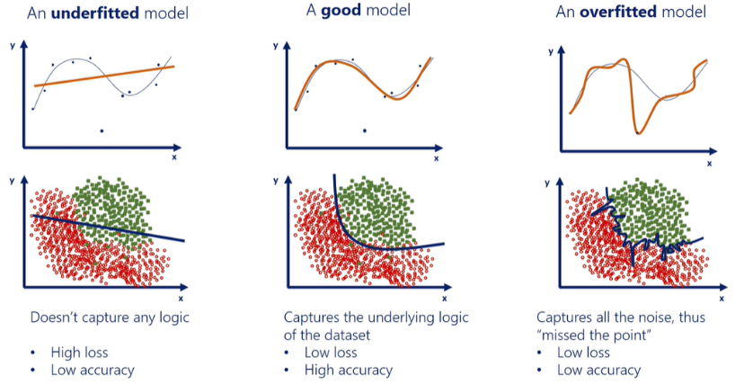

*Regression Model*

*Classification Model*

Figure : Overfitting vs Underfitting in Supervised Learning Algorithms | Source: 365DataScience (2021)

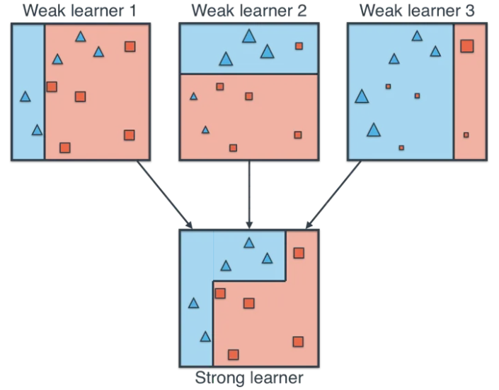

Figure : Ensemble Learning Development of a Strong Learner | Source: Akturk (2021)

### Bagging & Boosting

Furthermore, Sutton (2005) describes that ensemble learning can be categorised into two main paradigms, defined as (pp. 303-305).

**Bagging:** Also known as Boostrap aggregation, which generates multiple samples from the training data, applies a prediction method to each, and combines results through voting, which leads to reduced variance and an enhancement in overall prediction robustness.

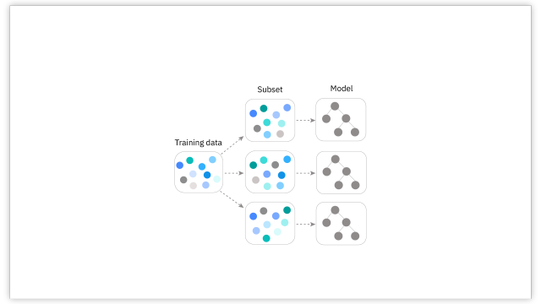

Figure : Bagging Ensemble Learning | Source: IBM (2021b)

**Boosting**: Creates a weighted average of predictions, adjusting the sample weights iteratively to focus on incorrectly predicted instances. By applying more weight to errors in subsequent steps, boosting progressively improves model accuracy.

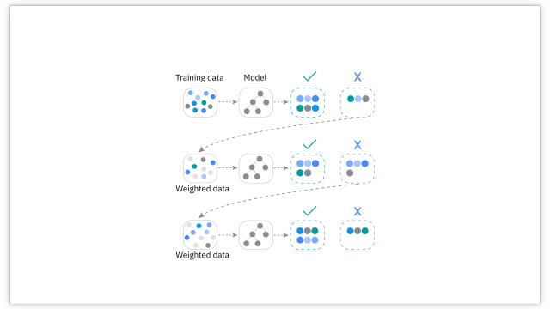

Figure : Boosting Ensemble Learning | Source IBM (2021b)

### Classification Model Selection

According to Aized et al. (2017), appropriate ML model selection depends on several key factors including the size and dimensionality of the dataset, class distribution, the required level of accuracy, the complexity of the problem, and computational efficiency considerations. However, Mokhtari et al. (2021) argues that appropriate model selection on its own doesn’t guarantee relevant and usable model predictions, outlining that model accuracy of 76% was deemed insufficient in the context of stock price prediction in financial markets, given that it would lead to substantial financial losses. Contending, that model predictions should be evaluated in the context of the problem domain in which they are developed. Furthermore, O’Reilly (2024) summarises a diverse selection of commonly used SL models for both regression and classification problems, and outlines an approach for narrowing down the search for the appropriate ML algorithm, given the advantages and disadvantages of each model, as shown in Figures 15, 16.

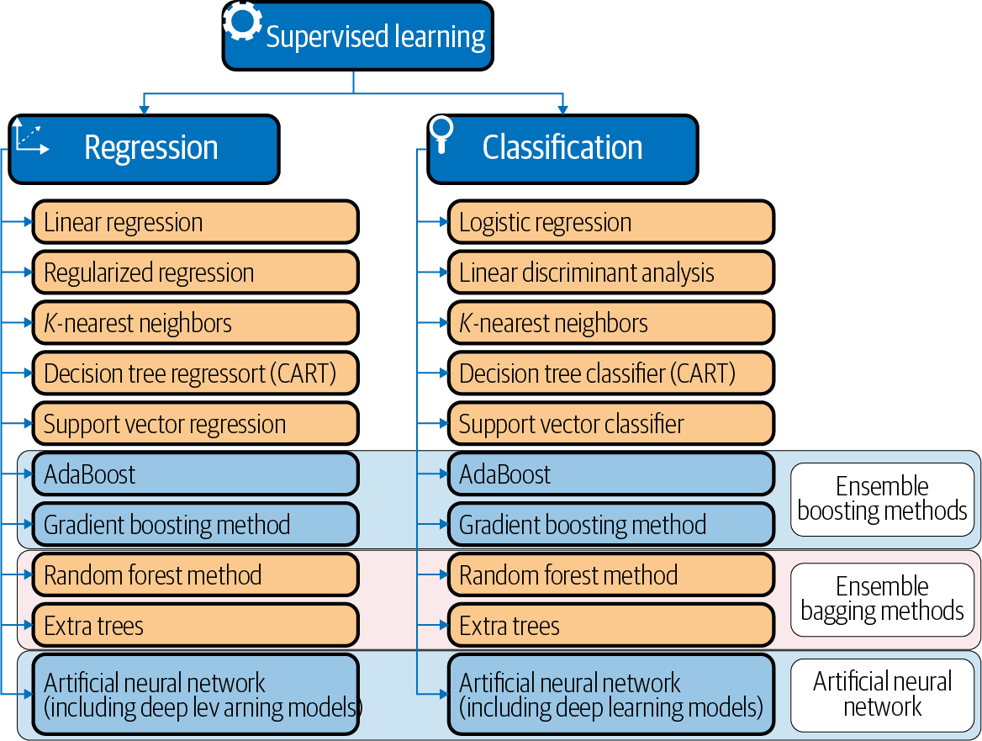

Figure : Supervised Learning Models for Regression and Classification | Source: O'Reilly (2024)

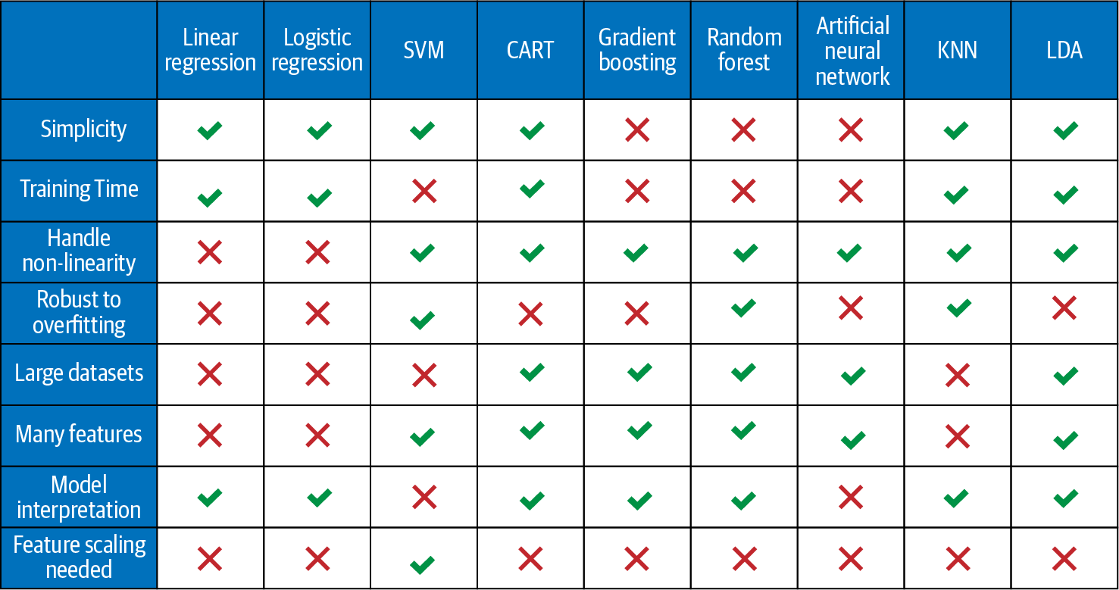

Figure : Supervised ML Model Selection | Source: O'Reilly (2024)

In their evaluation, Jin et al. (2022) compare two widely used boosting algorithms for classification problems, XGB and LGBM in which they found LGBM to be faster and more memory-efficient primarily due to its leaf-wise approach and use of gradient-based-one-side-sampling (GOSS), however LGBM has a tendency to overfit by growing deeper trees. In contrast, XGB is recognised for its robustness across a wide range of predictive tasks but comes with the drawback of added complexity during the node-splitting process and higher space complexity due to the pre-sorting required.

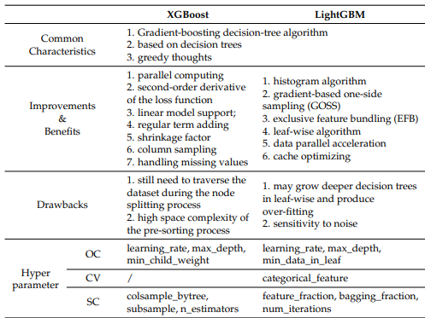

Figure : Comparison of XGBoost & LightGBM | Source: Jin et al (2022)

### Classification Model Performance Evaluation

Sina and Amiri (2022) outline various evaluation metrics employed in the context of a churn prediction in Telecoms as shown in Table 1, whereby the research emphasises the importance of a comprehensive suite of performance metrics being used to evaluate model performance. Singh (2022) argue that accuracy alone is a poor indicator of a model’s performance when class imbalance is observed, highlighting that a model could achieve high accuracy by predicting the majority class most of the time, known as the Accuracy Paradox. Instead Singh (2022) propose metrics such as precision, recall and F1-score are often being more important.

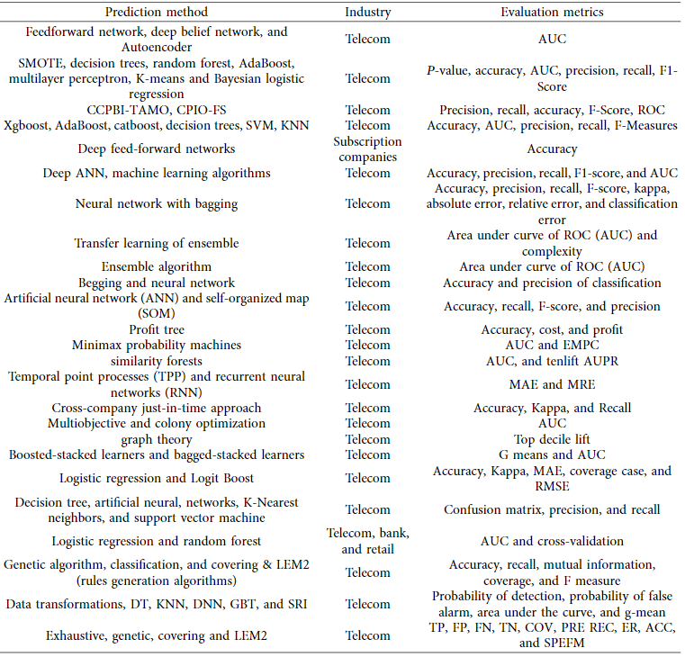

Table : Churn Prediction Methods and Evaluation Metrics in Telecoms | Source: Sina and Amiri (2022)

Furthermore, Burkov (2019) underscores the increased complexity of evaluating classification models compared to regression models, defining a confusion matrix as an effective tool for assessing a model’s ability to correctly predict each class that provides insights into model performance across different classes (p. 14).

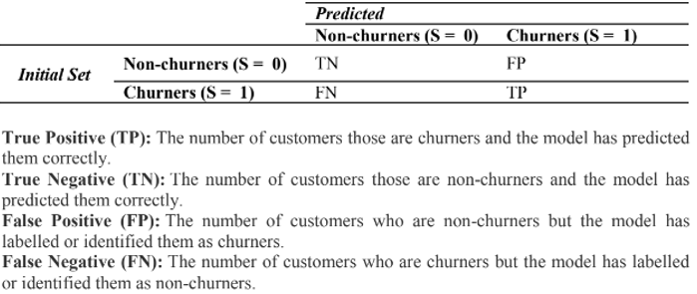

Figure : Confusion Matrix in the Context of Churn Prediction | Source: Damla et al. (2023)

GoogleDevelopers (2024) define several relevant classification model performance metrics that should be considered when evaluating classification model performance, as shown in Table 2.

Table : Classification Model Performance Metrics | Source: GoogleDevelopers (2024)

|  |  |  |
| --- | --- | --- |
| **Metric** | **Description** | **Equation** |
| Accuracy | Proportion of all classifications that were correct, whether positive or negative. |  |
| Recall / Sensitivity / True Positive Rate (TPR) | Proportion of all actual positives that were classified correctly as positives. |  |
| False Positive Rate (FPR) | Proportion of all actual negatives that were classified incorrectly as positives. |  |
| Precision | Proportion of all the model's positive classifications that are actually positive. |  |
| F1-score | Harmonic mean of precision and recall, making it preferable to accuracy for class-imbalanced datasets. |  |

Furthermore, Scikit Learn (2023) outline a Classification Report as an important tool for evaluating common classification performance metrics such as precision, recall, F1-score and accuracy for each model class.

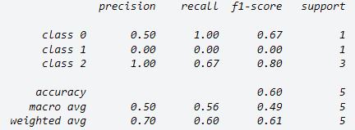

Figure : Classification Report | Source Scikit Learn (2023)

Moreover, Burkov (2019) defines the Receiver Operating Characteristics (ROC) as a commonly used method to measure aggregate model performance, whereby a combination of the TPR and FPR is calculated at every possible threshold, which returns a confidence score of model performance (pp. 16-17). The Area Under the Receiver ROC Curve (AUC) quantifies this performance, with higher AUC values indicating better classifiers, with an AUC of 1 representing a perfect classifier.

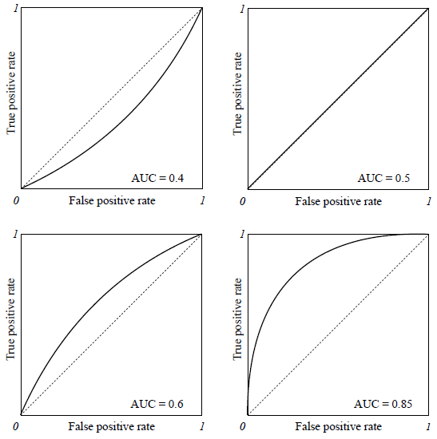

Figure : Area Under the ROC Curve | Source: Burkov (2019)

Additionally, Dembla (2024) defines Logarithmic Loss (Log Loss) as indicative of how close the prediction probability is to the corresponding actual/true value (0 or 1 in case of binary classification), outlining that the more the predicted probability diverges from the actual value, the higher is the log-loss value. Furthermore, Dembla (2024) defines the log-loss value as being calculated for each observation based on its actual value (*y*) and prediction probability (*p*), whereby the log-loss score of the classification model is reported as average of log-losses of all the observations (*N)*.

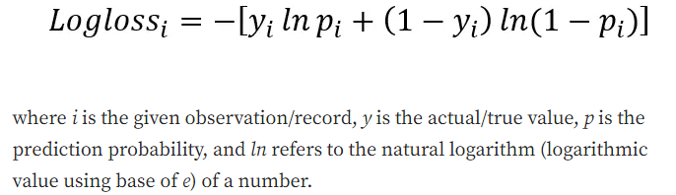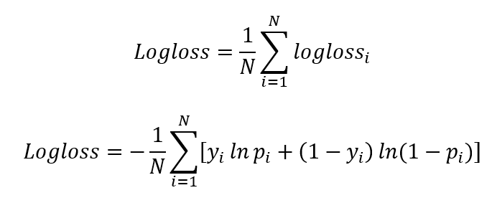

Equation : Log Loss Performance Measure Equation | Source: Dembla (2024)

## Frameworks for ML Model Development and Optimisation in Telecom

Firican (2023) defines a data management framework as a set of guidelines, policies and procedures that organisations use to manage their data. McCausland (2021) emphasises data managements importance for companies as they increasingly adopt data-driven business models, arguing that poor data quality will progressively become a systemic problem for companies, especially those that specialise in AI and ML to make informed decisions.

### Exploratory Data Analysis

Ghosh et al. (2018) highlight the importance of Exploratory Data Analysis (EDA) as part of ML model development, defined as a fundamental procedure that makes use of statistical techniques and graphical representations in order to obtain insights from data (p. 235).

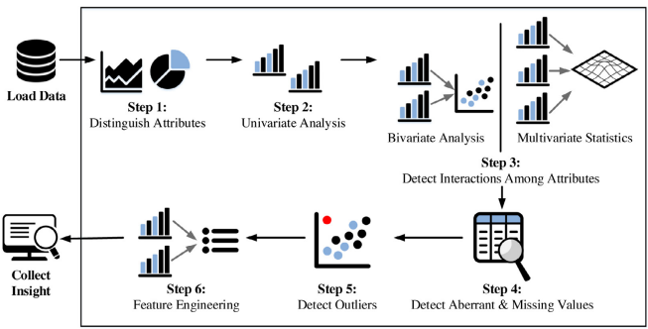

Figure : Fundamental Steps of the Exploratory Data Analysis Process | Source: Ghosh et al. (2018)

### Data Preprocessing and Feature Engineering

Zdziebkoo (2024) emphasise the importance of data preprocessing and feature engineering as crucial steps in ML model development, particularly in the context of handling often inaccurate and vague data in Telecom companies. Prabadevi et al. (2023) found that ML models can be improved by incorporating non-conventional features such as NPS and Customer Satisfaction Score (CSAT), which can help to address model limitations by more closely aligning with customer perceptions. Acheme et al. (2021) define data preprocessing as the concept of changing raw data into a clean data set, through preprocessing the data in order to check missing values, noisy data, and other inconsistencies before using it in a ML algorithm (p. 322). Additionally, Burkov (2019) defines feature engineering as the process of transforming raw data into features that are suitable and usable in ML model algorithms (p. 3).

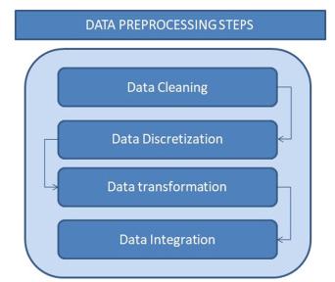

Figure : Data Preprocessing Steps | Source: Acheme et al. (2021)

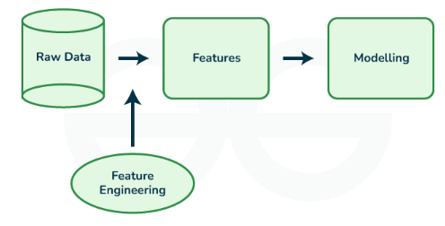

Figure : Feature Engineering | Source: GeeksforGeeks (2023)

### Feature Importance and Dimensionality Reduction

Codeacademy (2024) outline that during SL model fitting it’s important to determine which features are associated with the outcome of interest, as in doing so will help facilitate the removal of irrelevant features, known as dimensionality reduction. According to Aznar (2020) the two most commonly used metrics used in calculating feature importance during tree-based learning is Gini Impurity and Entropy, defined as.

**Gini Impurity:**  Measures the frequency at which any element of the dataset will be mislabelled when it is randomly labelled. The minimum value of Gini Index is 0 which means that the node is pure, and all the contained elements in the node are of one unique class, therefore the node will not split again which means that the optimum split is chosen by the features with a lower Gini Index. In contrast a maximum value of 0.5 means that the probability of the two classes are the same.

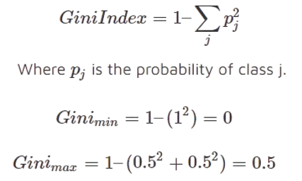

Equation : Gini Impurity Equation | Source: Aznar (2020)

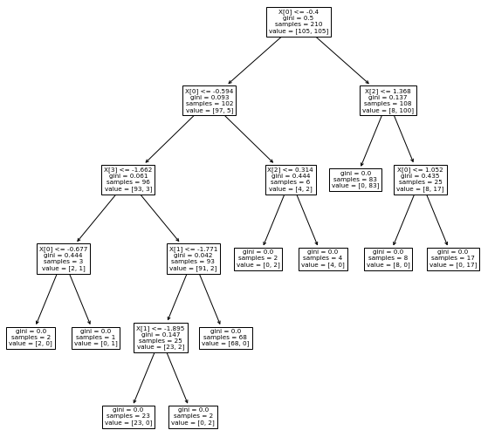

Figure : Tree-Based Classification Model Using Gini Criterion | Source: Aznar (2020)

**Entropy:** Measure of information that indicates the disorder of the features with the target, with the optimum split chosen by the feature with lower Entropy. It’s maximum value is when the probability of the two classes is the same and a node is pure when the entropy has its minimum value of 0.

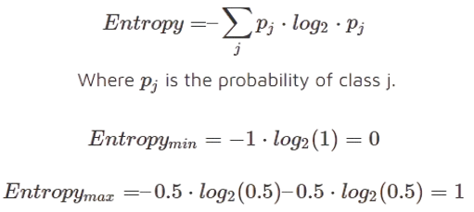

Equation : Entropy Equation | Source: Aznar (2020)

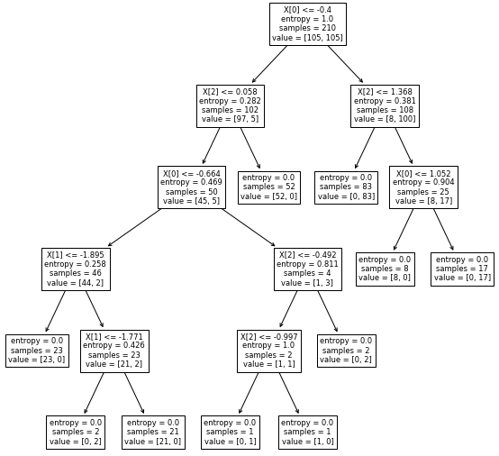

Figure : Tree-Based Classification Model Using Entropy Criterion | Source: Aznar (2020)

Aznar (2020) outlines that aside from differences in the scale of internal values, the primary trade-off is the increased computational cost associated with entropy, since entropy calculations rely on logarithms, which leads to greater computational complexity and longer training times compare to the simpler Gini Index, which requires fewer calculations and is therefore faster to compute.

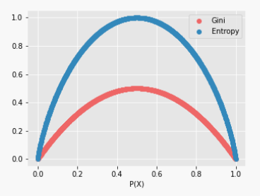

Figure : Gini Impurity and Entropy Visualised | Source: Aznar (2020)

Moreover, Zdziebkoo (2024) used feature importance measures to identify and group features crucial for predicting churn in Telecoms based on common characteristics. The study found that features such as subscription amounts, customer interaction levels, and service usage prior to churning had a significant impact on model accuracy.

Table : Feature Groups for Churn Modelling | Source: Zdziebkoo (2024)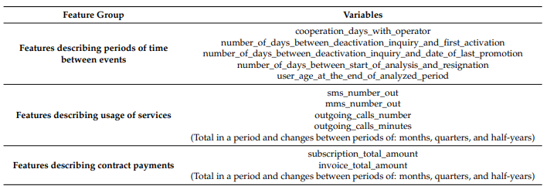

Similarly, Copăceanu (2021) identified features related to customer care service, value-added services and credit information as important predictors in Telecom churn models. The study found that customers with lower total recurring charges, fewer months in service, lower service usage, and older equipment were more likely to churn.

Table : Feature Importance Scores Obtained Using Feature Selection | Source: Copăceanu (2021)

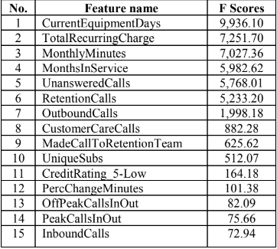

In contrast, Wagh et al. (2024) observed that features associated with customer contract type, total product charges and customer specific charges returned high feature importance scores in their analysis of customer churn, as shown in Figure 27.

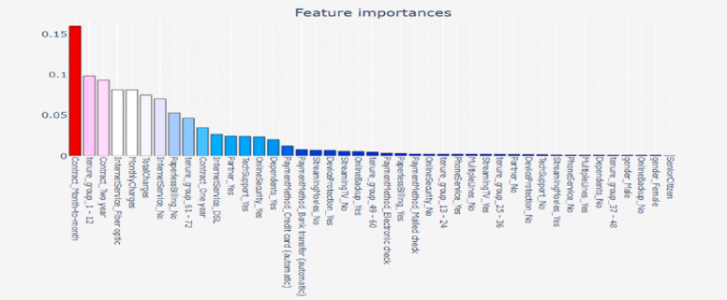

Figure : Feature Importance Scores for Customer Churn using Random Forest Classifier | Source: Wagh et al. (2024)

### Class Imbalance and Sampling Strategies

Sina and Amari (2022) contend that churn datasets suffer from a class imbalance problem. Toor and Usman (2022) propose resampling as an effective method to address this issue, categorising resampling techniques into two broad categories, defined as (pp. 3755-3756).

**Oversample Minority Class:** This resampling technique takes more samples from minority class and less from majority class. This way the resultant dataset contains almost equal number of classes, examples of which include: RandomOverSampling (ROS), Synthetic Minority Oversampling Technique (SMOTE) and Adaptive Synthetic Sampling (ADASYN).

**Under Sample Majority Class:** In undersampling the minority class is selected as it is, but fewer copies of the majority class are selected, so that the balance of both classes is maintained, examples of which include RandomUnderSampler (RUS).

Toor and Usman (2022) argue that oversampling methods can lead to an increase in recall, but often at the cost of a decrease in precision and F1-score as well as being less effective with large datasets. In contrast, undersampling is less sensitive to dataset size and generally more efficient, however by removing a significant portion of majority class samples there is a risk of valuable information being lost, which can lead to a deterioration in overall predictive performance. Furthermore, El-Amir et al. (2024) evaluate several common resampling techniques (as shown in Table 5) and propose combined methods such as SMOTE and Edited Nearest Neighbours (SMOTEENN), SMOTE and Tomek Links (SMOTETomek). These hybrid approaches address the limitations of individual methods, leading to improved predictive performance by balancing recall and precision effectively.

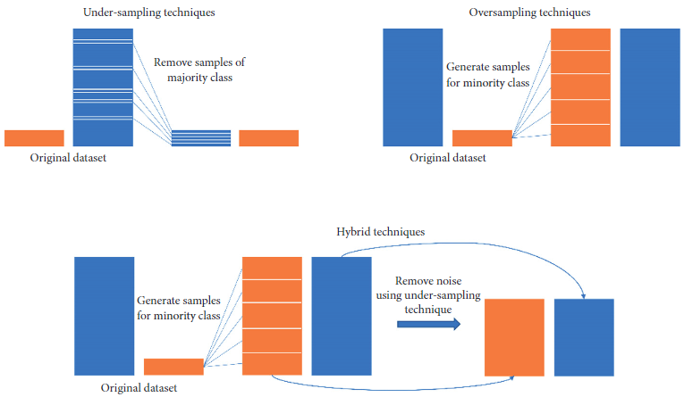

Figure : Class Imbalance Sampling Approaches | Source: Le et al. (2019)

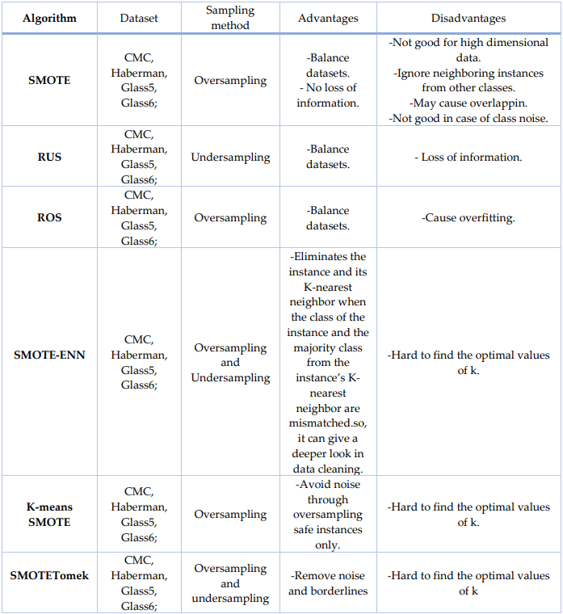

Table : Comparison of Different Sampling Methods on Imbalanced Datasets | Source: El-Amir et al. (2024)

### Cross-Validation

Pawluszek-Filipiak (2020) emphasises the importance of using a validation set from training data to fine-tune classifiers using K-fold cross-validation, which enhances model generalisation and reduces overfitting by ensuring strong performance on both training and unseen data. Burkov (2019) supports this finding, noting that in K-fold cross-validation, five folds $\{F1, F2,...,F5\}$ are typically used whereby each $Fk, k = 1,..., 5$ contains 20% of training data. Five models are trained, starting with $f1$ which uses all examples from folds $F2, F3, F4, and F5$ as the training set and examples from $F1$ as the validation set, with the process repeated until all five $f1,…,5$ are trained. Performance is then averaged across all folds to calculate the final result. However, GeeksforGeeks (2017) caution that K-fold cross validation comes with increased computational cost and training time. Furthermore, Burkov (2019) recommends only using cross-validation when sufficient data is available, noting that for smaller datasets, a training/test split with cross-validation on the training set may yield better predictive performance.

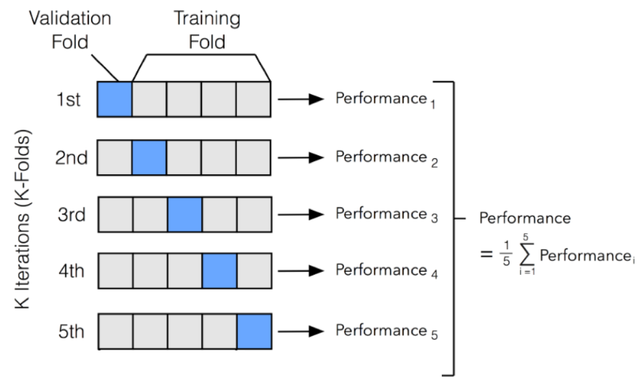

Figure : K-Fold Cross-Validation Concept | Source: Mali et al. (2023)

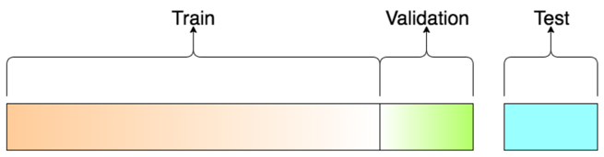

Figure : Train, Test & Validation Split | Source: SAP (2018)

### Model Optimisation and Regularisation

Sina and Amari (2022) emphasise the importance of hyperparameter tuning to optimise Telecom churn prediction models and propose a framework using Grid Search, Randomized Search and Bayesian Optimisation, which found Bayesian-optimised LGBM as the most effective model for predicting churn, as shown in Figure 31. Moreover, Scikit Learn (2024a)highlight the significance of automated methods like Grid Search and Randomized Search for hyperparameter optimisation, outlining the importance of tree-based classification hyperparameters, such as the number of estimators, maximum tree depth, minimum samples required to split a node, and minimum samples per leaf for fine-tuning model performance.

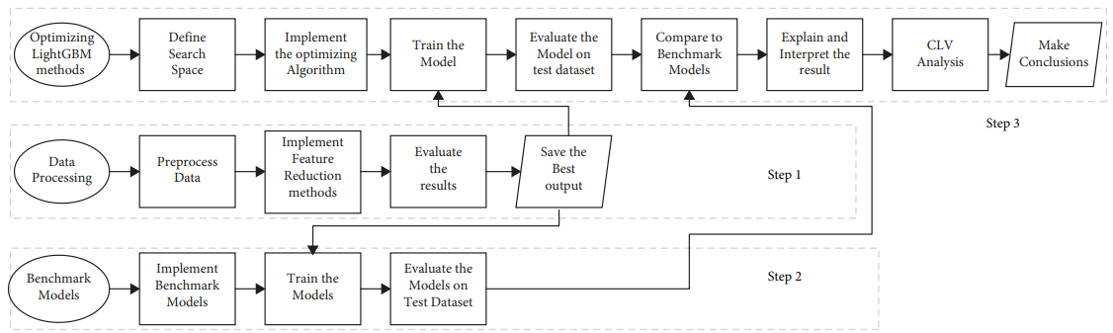

Figure : LightGBM Ensemble Model Optimisation Framework | Source: Sina and Amari (2022)

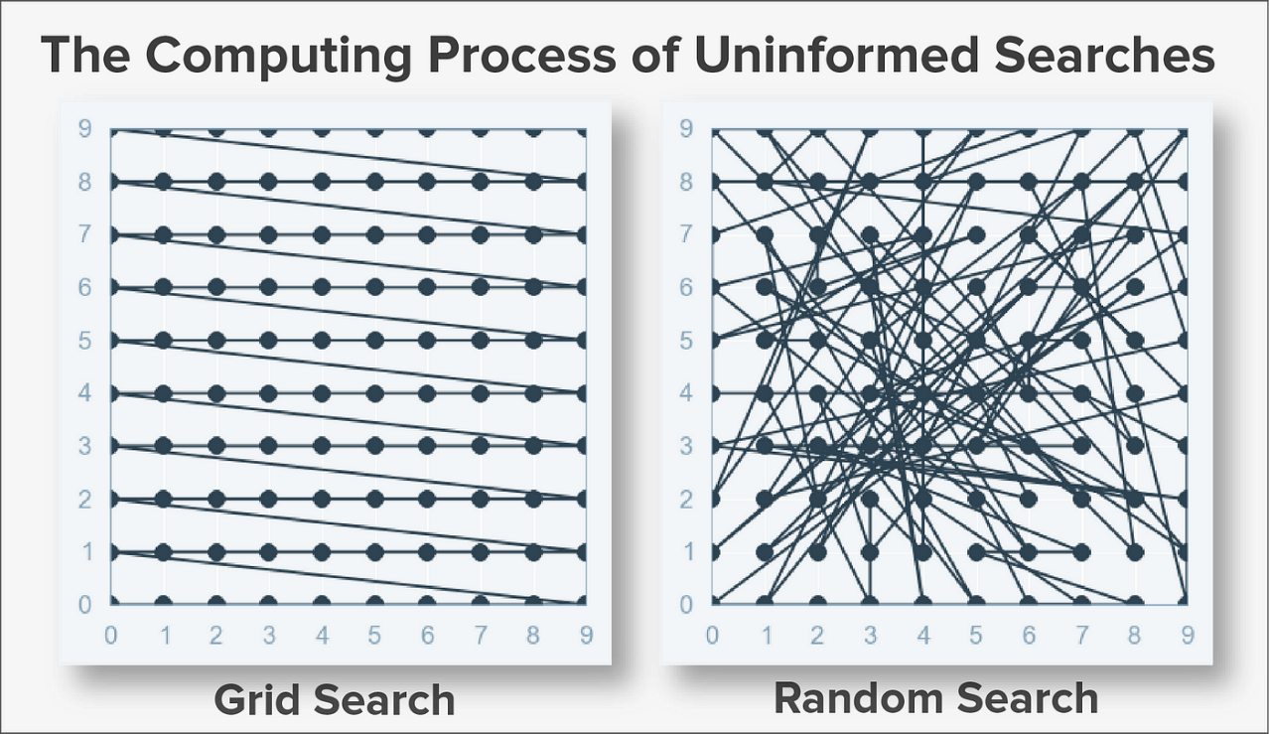

Figure : Grid Search and Random Search Hyperparameter Tuning Methods | Source: Hestisholihah (2023)

Burkov (2019) defines regularisation as a broad term for methods that force the learning algorithm to build less complex models (p. 12), arguing that it often leads to slightly higher bias, but significantly reduced variance, known as the bias-variance trade-off. Regularisation is the most common approach to prevent overfitting by modifying the objective function with a penalty term that increases with model complexity. Burkov (2019) defines L1 and L2 regularisation as the two most widely used techniques, particularly in linear regression, where the objective is to minimise $w$ (a D-dimensional vector) and $b$ (a real number) (p. 12).

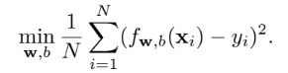

Equation : Linear Regression Objective | Source: Burkov (2019)

Burkov (2019) defines L1-Regularisation, also known as Least Absolute Shrinkage and Selection Operator (LASSO), as a method to prevent overfitting by selecting the most important features for prediction. In L1-regularised linear regression, the objective function includes a penalty that forces some coefficients to become zero, effectively removing less relevant features (p. 12).

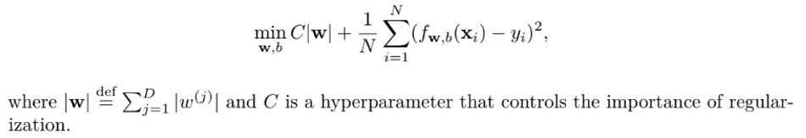

Equation : L1-Regularised Linear Regression Objective | Source: Burkov (2019)

Similarly, Burkov (2019) explains L2-regularisation, also called Ridge Regularisation, as preventing overfitting by shrinking all coefficients towards zero. This method reduces the influence of less important features without eliminating them entirely (p. 13).

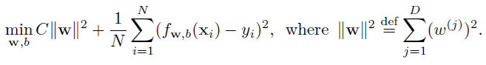

Equation : L2-Regularised Linear Regression Objective | Source: Burkov (2019)

### Research Summary

Table 6 below summarises a selection of the most relevant model development and sampling methods explored during the literature review. Whilst no consensus on the ideal model is reached, several models display promising results and will be explored during the Methodology.

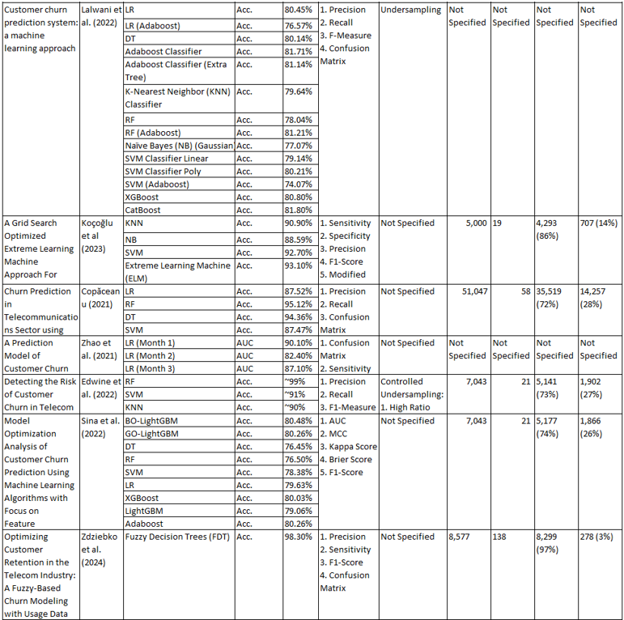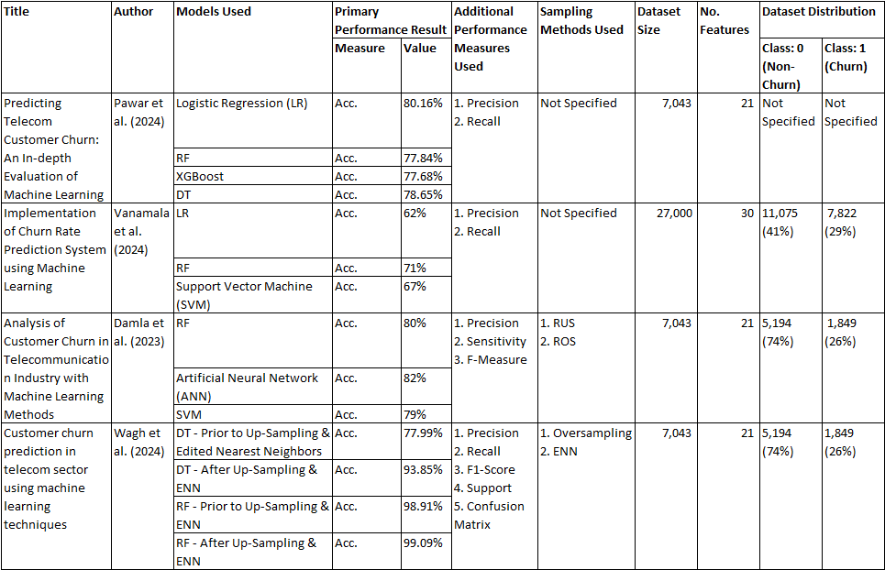Table : Research Summary of Model Development and Sampling Methods Reviewed



## Strategies and Innovations for Effective Implementation of ML Churn Prediction Models

### Cross-Industry Standard Process for Data Mining (CRISP-DM)

Shearer (2000) defines CRISP-DM as a well-established structured approach to data mining and ML projects, consisting of six iterative phases from Business Understanding to Deployment (p. 14), outlining a selection of tasks and outputs applicable for each phase of the reference model.

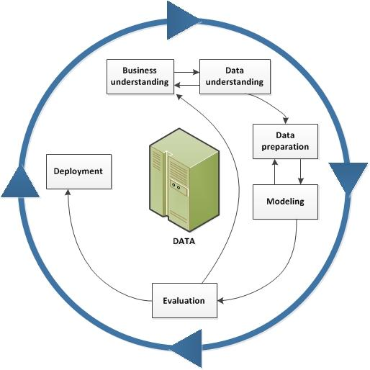

Figure : Cross-Industry Standard Process for Data Mining (CRISP-DM) Framework | Source: Shearer (2000)

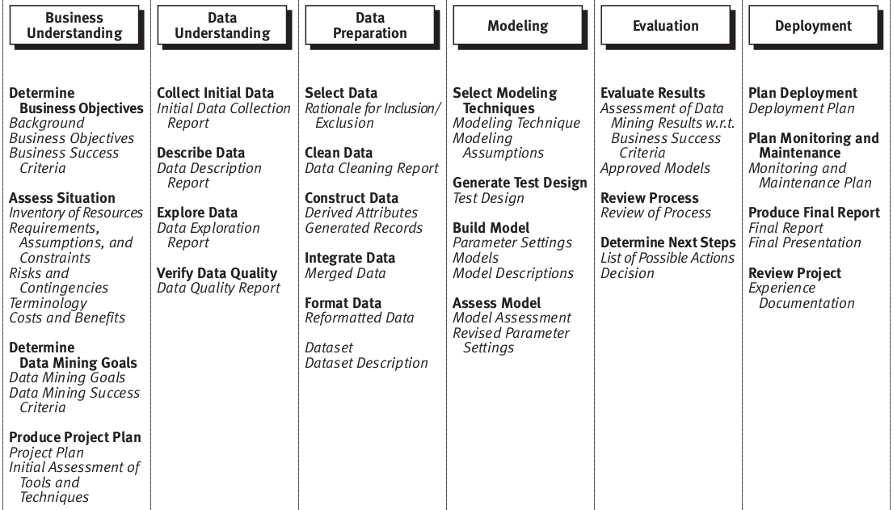

Figure : Tasks and Outputs of the CRISP-DM Reference Model | Source: Shearer (2000)

Sidiq et al. (2023) contend that a limitation of CRISP-DM is it can be too general and lack the specificity needed for ML projects. However, Schröer et al. (2021) contend that it is in-fact, largely due to the industry-independent framework of CRISP-DM that makes it the de-facto industry standard for applying Data Mining projects, though acknowledges the paucity studies with regard to the practical implications of the final phase of deployment.

### Strategies and Innovations for Effective Implementation of ML Churn Prediction Models

MRS (2024) observed that British Telecom’s (BT) customer retention rate decreased by 40% when customers experienced convenient customer service options, moreover the Net Easy Score was found to be a better predictor of churn compared to NPS and CSAT metrics. However, CustomerGauge (2022) acknowledges that whilst incorporating feedback scores such as NPS may enhance model performance, there are limitations to relying on feedback metrics as they might not capture underlying behavioural aspects effectively. Moreover, Fareniuk et al. (2022) stress the significance of comprehending customer behaviour in the Telecom industry given its competitive nature, however the study falls short in detailing how to put customer data into practice. Du et al. (2022) seek to fill this void by suggesting a Kano model for tailored recommendations focused on customer preferences, like pricing or services offered. Furthermore a study by Tan Yan Lin et al. (2023) discovered that real-time data processing led to understanding of customer behaviour when utilising methods such as PCA and Linear Discriminant Analysis (LDA) in conjunction with LGBM models. Moreover, Wassouf (2020) suggests a segmentation plan for Syritel Telecom that focuses on short term forecasting by using a Time Frequency Monetary (TFN) approach to predict loyalty, although there may be advantages to considering long-term loyalty trends. Additionally, Sun and Tan (2022) argue that merging CRM systems with machine learning technologies can enhance customer retention by better leveraging customer data. Abdullaev et al. (2023) present an AI-Driven Jaya Optimisation Algorithm (AIJOA-CPDE) which enhances churn prediction through AI in the process of feature selection by employing Bidirectional Long Short-Term Memory (BDLSTM) networks. Furthermore, Li et al. (2019) suggest a strategy for small to medium sized companies, using IoT, Blockchain and AutoML to overcome limitations in data and expertise for churn prediction tasks. Pandithurai et al. (2023) came up with a Voting Classifier Ensemble Method (VCEM) which combines models such as FT, RF, LR and SVM to enhance accuracy when compared with individual ensembles. Furthermore, Somak Saha et al. (2024) present ChurnNet, a model that utilises Advanced Neural Networks (ANN) to address the issue of vanishing gradients in ANN’s thereby improving the efficiency of model training. Sadeghi et al. (2023) integrate PCA, Particle Swarm Optimisation (PSO), and K Means Means into a model resulting in enhanced churn prediction performance when compared to standalone models.

## Conclusion

This chapter began with an analysis of churn dynamics in the Telecom industry, followed by an exploration of the role of ML models in predicting churn. Frameworks for ML model development and optimisation were assessed, and finally strategies and innovations for effective implementation of ML churn predictions were evaluated. Research revealed that the Telecom industry was the most significantly affected by churn among all the industries evaluated (TechSee, 2022), which can lead to serious negative financial implications for companies if left unaddressed (Bhale and Bedi, 2024; Mäkilä et al., 2010), particularly due to the outweighed cost of acquisition to retention (Reichheld, 2001; Verhelst, 2019).

While the reasons for churn in Telecom are varied (Copăceanu, 2021; CustomerGauge, 2022; Fareniuk et al., 2022; Kotler, 2023; MRS, 2024; Silver, 2023; TechSee, 2022; Wagh et al., 2024; Zdziebko et al., 2024), a selection of common features were found to score highly in their importance and ability to improve model accuracy and generalisation capabilities. These features can be grouped into several categories that will help to address RO1 by steering the direction of enquiry during primary research.

1. Service Quality (Copăceanu, 2021; Kotler, 2023)
2. Billing (Wagh et al., 2024; Zdziebko et al., 2024)
3. Customer Service (MRS, 2024; Wagh et al., 2024)
4. Pricing and Value Perception (Copăceanu, 2021; Wagh et al., 2024)
5. Service Usage Patterns (Copăceanu, 2021; Fareniuk et al., 2022; Zdziebko et al., 2024)
6. Customer Feedback (CustomerGauge, 2022)
7. Contract and Commitment (Copăceanu, 2021; Wagh et al., 2024; Zdziebko et al., 2024)
8. Market Competition (Fareniuk et al., 2022)

A growing body of research demonstrate ML as an effective approach for addressing churn in Telecoms, which found that ensemble methods outperform their non-ensemble counterparts (Kalirane, 2023; Sina and Amiri, 2022). However, ML model selection alone doesn’t guarantee relevant and usable model predictions (Mokhtari et al., 2021), therefore ML project frameworks such as CRISP-DM provide an industry standard process for maximising the predictive capabilities of developed models (Shearer, 2000). Issues such as class imbalance in Telecoms raise important ethical concerns, particularly around data usage and bias which both ML and AI have the potential to propagate based on underlying biases found in data (Toor and Usman, 2022). Future research should therefore ensure that the advancements of ML and AI in churn prediction (Sun and Tan, 2022), be aligned to ensure fairness in customer treatment.

The diverse range of reviewed sources within this literature review summarised in Table 6, offer a variety of methodologies and frameworks to address the unique challenges associated with churn prediction ML in Telecoms, which will be leveraged as part of primary research considerations as well as helping to address RO2 and RO3. Future research could explore several promising areas, such as the integration of CRM, and real-time data analytics in enhancing churn prediction models (Sun and Tan, 2022; Tan Yan Lin et al., 2023). Furthermore, another promising avenue could be the evaluation of the cross-industry application of Telecom churn ML models in comparable industries such as retail or financial services. Critically, there is a need for deeper research into the ethical implications of ML and AI in customer churn prediction modelling, whereby future studies should focus on methodologies to identify and mitigate associated model risks and biases.

# Research Methodology

The methodology chapter details the approach and methods used to address the research objectives outlined in this study, which include the primary research methodology, secondary data, research validity, ethical, legal and regulatory considerations as well as a comprehensive outline of the taken as part of the defined project framework.

**RO1**: Investigate and identify the key factors resulting in Telecom churn at Viatel Technology Group (VTG), by focusing on leveraging data currently available within VTG’s existing data infrastructure.

**RO2**: Develop an optimised and generalised ML model to predict customer churn at VTG and evaluate its effectiveness using appropriate performance comparison metrics and techniques.

**RO3**: Formulate a cohesive, data-driven strategy for VTG that incorporates actionable recommendations for targeted customer retention based on insights derived from ML model predictions.

## Primary Research Methodology

### Primary Research Design

Jamshed (2014) outline the suitability of qualitative research methodologies when the researcher either investigates a new field of study or intends to ascertain and theorise prominent issues. Additionally, George (2022) defines semi-structured interviews as a data collection method which rely on asking questions within a predetermined thematic framework, though without the restrictions of a set order or phrasing. Furthermore, George (2022) contends that semi-structured interviews offer a best of both worlds approach, which make them suitable for capturing complex qualitative data necessary to address the research objectives outlined in this study. Interviews were conducted based on non-probability sampling strategy, defined by Nikolopoulou (2022) as using non-random criteria in the selection of individuals who are well positioned to provide relevant data to address the research objectives of the study. Each interview was guided by a set of predetermined questions outlined in the appendix, using prompts (Jiménez and Orozco, 2021) and probes (Robinson, 2023) which allowed for flexibility based on participant responses whilst ensuring all key areas were covered.

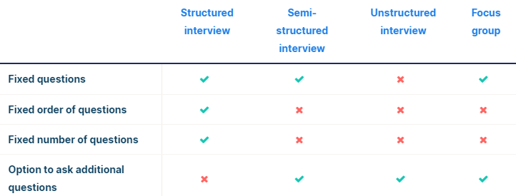

Figure : Interview Type Differences | Source: George (2022)

### Sampling Strategy

Non-probability purposive sampling was selected to target individuals both internally and internally of VTG, with semi-structured interviews selected to provide relevant and insightful perspectives on customer behaviour, preferences and factors influencing churn and retention. The target population consisted of individuals who had direct exposure or knowledge in customer-related processes at VTG, as well as an external data analytics consultant. Selection of interview participants was based on researcher judgement based on participants perceived strategic and operational insights into customer behaviours, retention strategies and factors influencing churn which formed the basis of the interviews. Rahimi and Sara (2024) outline the principle of saturation in qualitative research, which is to ensure all relevant themes are thoroughly explored to the point at which further interviews would offer diminishing returns. Given this principle the sample size of five was deemed sufficient to achieve the research objectives whilst maintaining the depth and quality of data collected. However, one key limitation of this sampling strategy is the exclusion of direct customer engagement to understand directly from customers their reasons for churn and retention. This was not possible given the scope of this research, which potentially limits the validity and generalisability of research findings.

### Sample Composition

The sample composition included the following participants:

**Chief Operating Officer at VTG (COO):** Selected to provide a holistic overview of VTG’s operational practices and company policies that impact retention and churn.

**Head of Sales at VTG (HOS):** Selected to provide detailed insights into customer acquisition and retention sales strategies that have been employed to address churn.

**Head of Operations at VTG (HOO):** Selected to provide an day-to-day overview of logistical operations, and how they influence customer churn and retention.

**Care and Collections Manager at VTG (CCM):** Selected to provide perspective on direct customer interactions, particularly feedback, complaints and service experience, as well as retention strategies employed.

**Data Analytics External Consultant (SME):** Selected to provide expertise in the implementation of ML and churn related projects in comparative industries beyond what’s handled internally at VTG, which will guide model and data analytical framework development.

### Content Analysis

Bengtsson (2016) outlines the purpose of a qualitative content analysis as a methodology to organise and elicit meaning from the data collected and to draw realistic conclusions from it. For this reason it was selected as the method to evaluate collected primary data. Bengtsson (2016) outlines this method as involving four stages as detailed in Figure 36, which were completed sequentially to form a robust foundation for subsequent chapters.

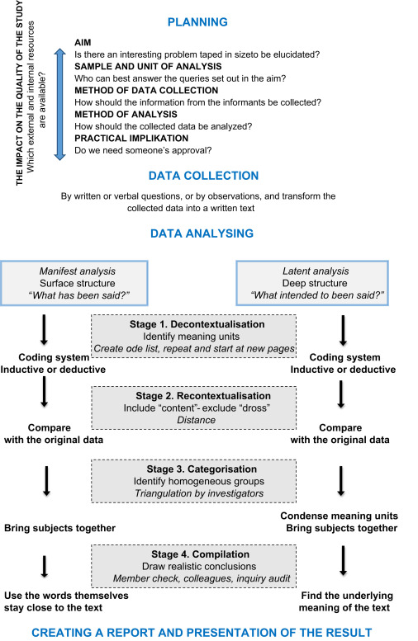

Figure : Qualitative Content Analysis Process | Source: Bengtsson (2016)

## Secondary Data

Along with qualitative primary research data, quantitative data was also explored as part of a mixed methods approach to research, described by George (2021) as a combination of elements of both quantitative and qualitative research in order to address research objectives. Tables 7, 8 outline the data source systems and secondary data sources used as part of quantitative analysis and throughout the CRISP-DM framework lifecycle.

### Data Source Systems

Table : Secondary Data Source Systems

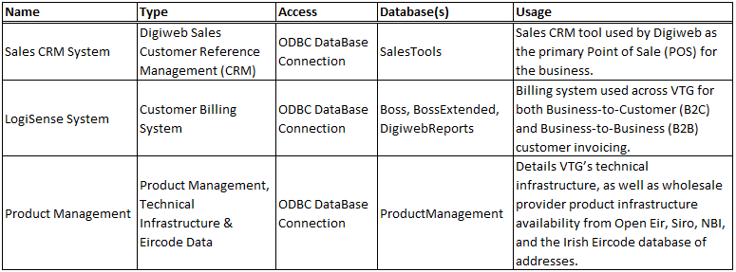

### Data Sources

Table : Secondary Data Sources

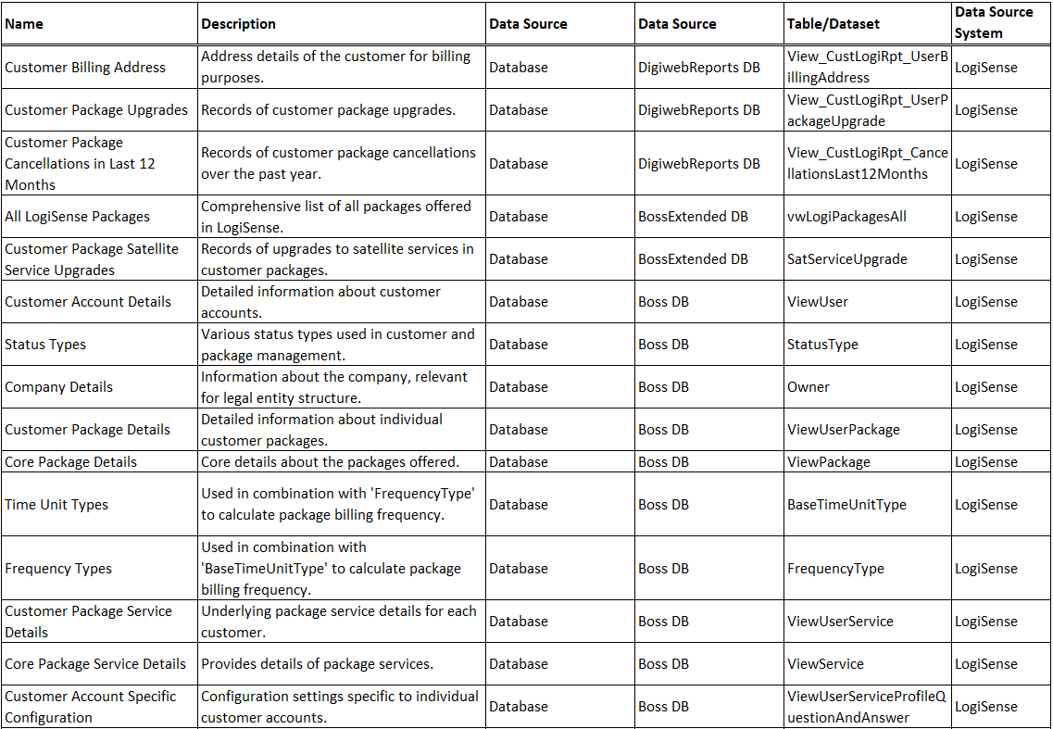

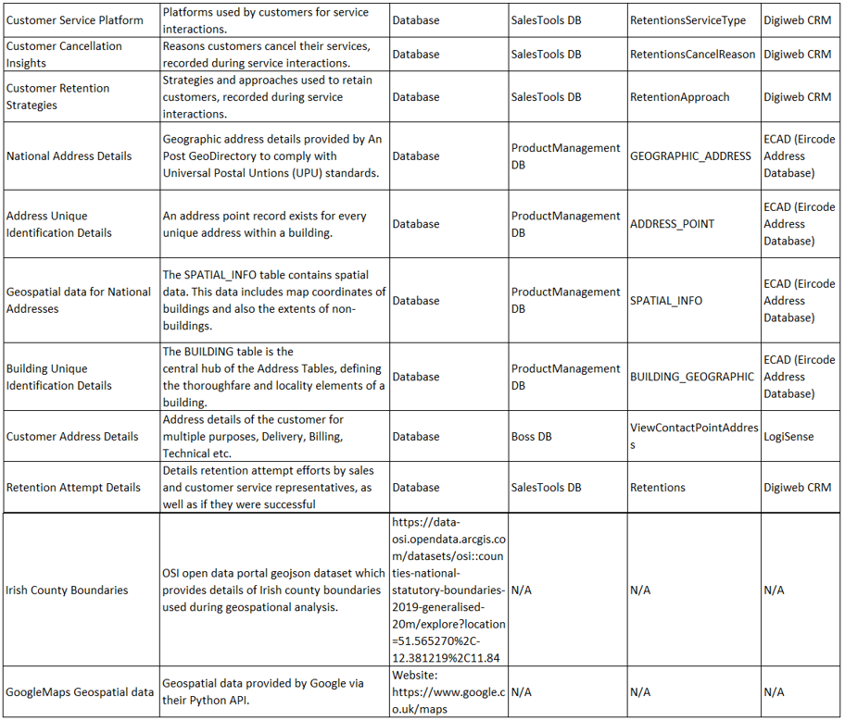

## Timeframe and Supervisor Meetings

The project timeline was from 3rd July 2024 to 27th September 2024. During this period tasks were planned and executed using the CRISP-DM project management framework in a predominantly sequential manner to address the research objectives outlined in this study. This structured approach ensured that all tasks were completed prior to the final artefact generation. Supervisor meetings were conducted on 8th July, 12th August, 5th September and 20th September with no additional guidance necessary. Each meeting focused on reviewing the current status of the research and outlining requirements for upcoming stages. Topics discussed included the research question, literature review, methodology and evaluation to ensure that tasks were successfully completed within the proposed timeframe.

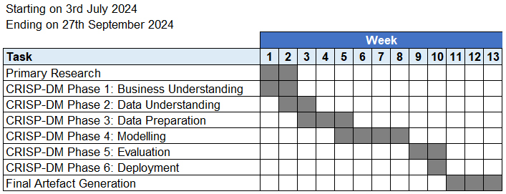

Figure : Project Timeline

## Research Validity

Middleton (2019) defined research validity as the extent to which the results accurately measure what they report to measure, with research reliability defined as the extent to which the results can be reproduced when the research is repeated under the same conditions. The section below outlines how different forms are validity were addressed during this research from both a primary and secondary data perspective.

### Face Validity

Elias (2024) defines face validity as how valid your results seem based on what they look like.

**Primary Data:** Interview questions should appear relevant and straightforward for understanding factors influencing churn and retention.

**Secondary Data:** Selected features should appear appropriate for predicting churn based on common Telecom industry factors for example service usage patterns, contract details.

### Content Validity

Elias (2024) defines content validity as whether or not the measure used in the research covers all of the content in the underlying construct.

**Primary Data:** Interview questions should cover all relevant topics to achieve the research objectives ensuring no significant areas are overlooked.

**Secondary Data:** The dataset should include a complete range of customer related features that are available and relevant for understanding and predicting churn in Telecoms.

### Construct Validity

Defined by Elias (2024) as the degree to which research measures the research construct.

**Primary Data:** Constructs of interest for example churn dynamics or reasons for churn should be clearly and consistently measured across all interviews to obtain an accurate understanding of theoretical concepts.

**Secondary Data:** Features used in analysis should accurately represent their theoretical constructs, for example time since latest customer contact, or customer complaints.

### Internal Validity

Defined by Elias (2024) as the extent to which the independent variable can accurately be stated to produce the observed effect.

**Primary Data:** Primary research design should be designed to control for confounding variables, defined by Thomas (2020) as variables other than ones being studied that could influence the outcome of the research.

**Secondary Data:** Analysis of secondary data should also control for confounding variables, this ensures that incorrect conclusions are not drawn from analysis, for example conflating correlation with causation.

### External Validity

Defined by Elias (2024) as the extent to which the results of a study can be generalized beyond the sample:

**Primary Data:** Several interview participants are currently employed at VTG, meaning the ability to generalise primary data to other Telecom companies or customers may be limited.

**Secondary Data:** Secondary data includes active Digiweb customers as of 17th June 2024, as well as customers who cancelled their services during the period of 1st January 2023 to 17th June 2024. This timeframe was selected to increase data validity, ensuring that is current and now. However, this may limit the generalisability of research findings to other time periods.

## Ethics, Legal and Regulatory Considerations

This section addresses the ethical, legal and regulatory considerations of this research in relation to primary research and the use of secondary data.

### Informed Consent

Informed consent was sought and obtained from participants in compliance with Articles 4(11) and 7 GDPR of the European Ethics and Data Protection act (EDPS) (2024) by clearly explaining the purpose of the research and interview process ensuring that participants’ understood that their participation was voluntary and they can withdraw at any time. Additionally, participants were asked to consent to an audio recording being made for the purpose of transcription, with written assurance provided that this would be destroyed upon transcription completion. Respondent validation, as advocated by Torrance (2012) was used to validate the findings. Participants were provided with interview transcripts to review and validate, ensuring that the data obtained accurately represented their views which mitigated any misinterpretation on behalf of the interviewer.

### Data Privacy and Confidentiality

Several primary research participants belong to a vulnerable group due to their current employment at VTG, whereby private, or potentially confidential and commercially sensitive information could be revealed during the interview process. To address these concerns anonymisation of any Personally Identifiable Information (PII) was implemented in compliance with GDPR laws as per EDPS (2024). Additionally, PII measures were taken to ensure that any secondary data related to customers doesn’t include any PII, with anonymisation applied where required.

### Data Security

Research data was contained within VTG’s internal systems, where it remained at all times for data security purposes, which utilised both user encryption and authentication via VTG’s company Virtual Private Network (VPN), in compliance with art.32 GDPR of the EDPS (2024).

### Bias and Fairness

Several bias and fairness considerations were relevant when undertaking this research, which relate to both primary and secondary data.

#### Primary Data

The use of non-probability sampling could introduce selection bias based on judgement rather than random selection, potentially limiting research findings generalisability. Mitigation efforts were taken to include a diverse range of participants from VTG, as well as the inclusion of an external SME to counteract potential bias of the participants in the vulnerable group. To minimise this impact of both interviewer and participant bias, a predefined structured interview guide was used to maintain a level of consistency across interviews, ensuring similar questions were asked in a consistent manner. This helped to mitigate potential bias that could arise during the semi-structured interviews prompt-and-probe process, which could be influenced by either the interviewers conscious or unconscious bias, or participants consciously or unconsciously withholding information that could reflect poorly on themselves or the organisation and skew primary data results.

#### Secondary Data

As identified in research (Sina and Amiri, 2022) churn datasets can suffer from class imbalance, therefore there is a risk of ML models developing bias towards a particular class, or where the dataset is not representative of the entire customer base which can lead to unfair outcomes if model predictions over or underrepresent specific customer cohorts. To mitigate potential bias, class resampling methods were implemented as outlined during subsequent chapters. Additionally, feature selection can introduce bias and fairness concerns, for example features that correlate with sensitive customer attributes such as race, gender or socioeconomic status. Which if included in ML models, can lead to biased or unfair predictions against members of vulnerable groups, or if predictions unintentionally reinforce existing biases present in the training dataset. Historical bias is another consideration which could reflect historical inequalities inherent in the company’s operational structure or previous customer interactions, for example if certain customer groups have historically received lower quality customer service, they could be classified as having a higher likelihood of churn. This could lead to reputational damage if customers of this specific nature are targeted based on model predictions. Finally, it is important that all stakeholders, including customers are able to understand how and why certain ML model predictions are made. This is of importance where predictions could lead to actions, such as targeted marketing strategies or changes in service delivery.

### Regulatory and Compliance Considerations

This research complied with relevant Irish anti-discrimination laws and regulations, such as those outlined by the Irish Human Rights and Equality Commission (IHREC) (2024), which ensures that model does not lead to discriminatory practices against protected groups based on race, gender, age or other PII.

## Tools and Technologies

All computations in this project were performed on Dell Latitude 3530 with 12th Gen Intel Core i5-1235U processor, 32GB RAM, running Windows 11. SQL Server Management Studio 19 along with Python code implemented in Jupyter Notebook were used in this research. The Git version control system was used to track and manage changes to files, which were uploaded to a private GitHub repository for security purposes. Tools and technologies are outlined in Table 9 below.

Table : Tools and Technologies

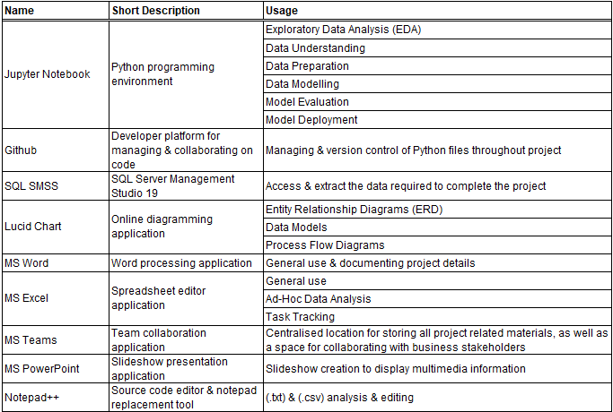

## Project Management Framework

The CRISP-DM model (Shearer, 2000) was tailored for the requirements of this research, with details of its implementation outlined in Figure 38 below.

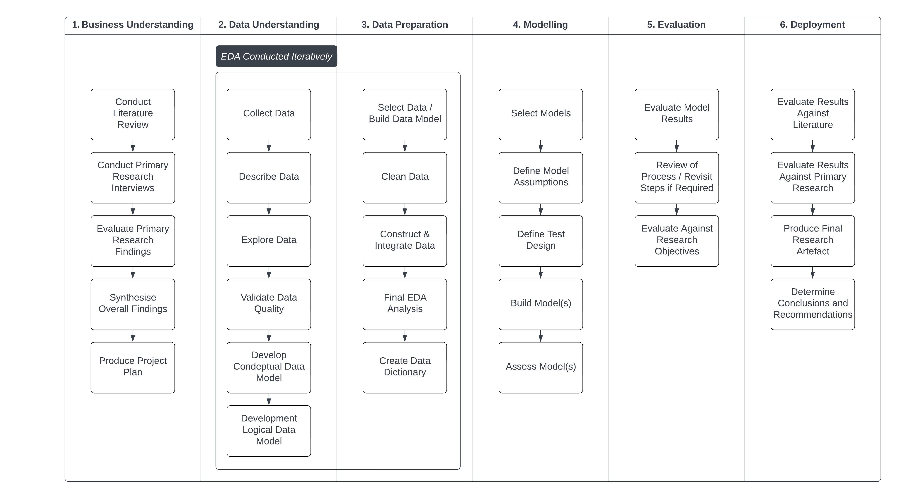

Figure : Tailored CRISP-DM Research Implementation

## Data Understanding and Preparation

This section synthesises and presents key primary research findings, which were used to guide the data understanding and preparation process. Details of the tasks and activities undertaken during the first three CRISP-DM phases, Business Understanding, Data Understanding and Data Preparation are outlined in accordance with addressing the primary research objectives, specifically RO1 and RO2:

**RO1**: Investigate and identify the key factors resulting in Telecom churn at Viatel Technology Group (VTG), by focusing on leveraging data currently available within VTG’s existing data infrastructure.

**RO2**: Develop an optimised and generalised ML model to predict customer churn at VTG and evaluate its effectiveness using appropriate performance comparison metrics and techniques.

### Primary Research Findings

#### Churn Management Dynamics in Telecoms

COO acknowledged that whilst churn has been recognised as a significant concern, efforts have historically focused more on new customer acquisition than on existing customer retention, noting that the company’s investment and focus has been aimed towards “the roughly two thirds two-thirds of new business that is coming in, giving less time and effort to the third that's going out”. HOS emphasised the challenge of addressing churn at Digiweb, primarily due to fragmented systems, data integration and processes, that impede a proactive approach to churn management, outlining that “current systems don’t support enough knowledge or communicate a clear message across the full organisation”. CCM supported this claim, describing the limitations and challenges of churn management given the manual nature of processes which aren’t set up to manage churn effectively.

#### Key Factors for Churn and Retention

CCM emphasised price as a primary reason for churn, noting that “based on the calls we would take, the primary reason people leave us would be cost, just down to the base reason, especially in the last few years”, as well as describing technical issues customers might experience as a key factor. However, CCM contends that in the context of Digiweb customers don’t leave due to the level of customer service they receive, noting that “customer service representatives never really hear them (customers) saying, I'm leaving because I didn't like your attitude, or I didn't like how slow it was to respond. So we don't lose customers from that point of view.” HOO supported this argument, highlighting that a highly trained onshore call centre staff and customer centric approach differentiates Digiweb from other tier one Telecom providers, which HOO believes is a key factor as to why customers both sign up and stay with the company. HOS outlined that pricing, service quality and older technologies like Wireless and Part-Fiber have been significant contributors to churn. Furthermore, HOS emphasised the disproportionate impact on churn statistics that previous company acquisitions introduced, noting “the churn rate for Wireless products is currently standing at roughly 25%, though that's not necessarily the real churn because we bought businesses that we should’ve known would be churning faster”. HOS described that older platforms in particular are experiencing the highest churn rates, as customers switch to providers offering newer technologies such as Full-Fiber services. COO identified the competitive market landscape as a significant challenge, noting that Digiweb often struggles to compete with larger operators in the domestic Telecom market. Moreover, COO noted that such tier one providers are able to offer lower prices for similar products, and possess more substantial marketing budgets, which can leave Digiweb at a disadvantage for customers who make decisions based primarily on price. Additionally, COO also outlined the importance of brand loyalty and building stronger customer relationships as a measure to prevent customers leaving for competitors.

#### Proactive vs. Reactive Churn Management

Both COO and HOS acknowledged the reactive nature of Digiweb’s churn management activities, which are typically triggered only after a customer has initiated contact to cancel their service. Moreover, COO highlighted that whilst the company has tried to implement proactive measures to address churn, such as outbound campaigns to encourage customers to switch to more recent technologies, that efforts have historically been hampered by resource constraints due to competing priorities. HOO outlined a proactive initiative that involved migrating customers from older, declining platforms to newer more sustainable services in an attempt to retain customers prior to churn. Noting that the company has “good systems in place that as soon as we know Fiber to the Home (FTTH) is available for one of these Legacy customers, we want to be the first one speaking to them and getting them migrated across to Fiber”. However, HOO contended that proactive initiatives are not without challenge and complexity, highlighting the costly and time-consuming nature of the migration process, particularly when dealing with legacy platforms with deeply entrenched systems. Furthermore, HOS described another proactive initiative which focused on improving customer profiling at the Point of Sale (POS) by obtaining additional data relating to their length of stay with a previous provider, the type of previous provider, types of packages and demographic details. Moreover, HOS highlighted the initiatives success by outlining that “a few years back we learned that a lot of customers from Cobh and Tallaght were more likely to cancel”. Additionally, CCM discussed several initiatives which increased customer payment and billing option flexibility, such as the introduction of additional manual payment options such as Payzone, as well as weekly billing service plans, which helped to reduce churn of customers who experienced financial difficulties.

#### Data and System Infrastructure

SME underscored the importance of a thorough understanding of the underlying business and data landscape when developing ML models and strategies for CCP, though cautioned against the impact of poor data quality and problem understanding that can hamper a projects ability to deliver effective ML strategies for addressing churn. Additionally, SME described a comparative project which was utilised ML to predict commodity prices in financial markets, noting “whilst the model developed was accurate at predicting when to enter and exit commodity markets… the model wasn’t appropriate for trading in a ‘live’ environment”. Furthermore, HOS outlined significant limitations that Digiweb face due to a lack of centralised omnichannel system that can manage and leverage all customer-related data and activities. HOS detailed the current data and system infrastructure at Digiweb, which relies on two primary systems, LogiSensewhich is the billing system used across VTG for B2C and B2B invoicing, and Digiweb’s in-house Sales CRM system which is the primary POS for the B2C business where customer related interactions are recorded. Moreover, HOS emphasised that the lack of integration and data communication between internal systems has resulted in opportunities to prevent churn being missed. Additionally, CCM also noted the limitations of current data and system infrastructure, specifically the manual nature of many processes, contrasting those with previous experience working at another Telecom competitor Vodafone. CCM detailed that Vodafone utilised automated systems to provide real-time data insights into customer value and churn risk, arguing that currently a lot of this information isn’t readily available within Digiweb, which can slow down decision-making and limits the ability to act in a timely manner to prevent churn.

#### The Role of Data Analytics in Churn Management

SME emphasised the importance of analysing historical customer data to identify features and predictors of churn, which enable companies to anticipate which customers are at risk of leaving. Furthermore, SME highlighted the use of advanced DA techniques and statistical modelling such as Cox Proportional-Hazards (PH) metric, alongside more conventional ML classification models such as Random Forests and XGBoost as effective methods when addressing problems such as customer or staff attrition. Moreover, SME outlined the importance of feature selection and dimensionality reduction techniques such as Principal Component Analysis (PCA), feature engineering and regularisation techniques to help optimise performance and generalisation capabilities whilst reducing the likelihood of model overfitting. Outlining that performance measurement metrics such as accuracy, recall and precision are important for evaluating model performance, ensuring that models are both accurate and efficient, and provide reliable predictions that can inform data-driven retention strategies. Additionally, SME highlighted the exponential growth in AI and ML capabilities due to advancements in computing power, noting that ML algorithms can increasingly train on vast datasets at reduced computational cost, which can make it possible to detect subtle patterns and fluctuations in data that were previously undetectable. However, SME argued that expertise is still required in the area of AI tools being leveraged, therefore careful thought and consideration is required during the development of ML models.

### Data Understanding

Shearer (2000) outlined the CRISP-DM data understanding phase as involving four steps, including the collection of initial data, the description of data, the exploration of data, and the verification of data quality.

#### Initial Data Collection

As identified during primary research, there was no centralised system that stores and manages all customer-related data and activities within VTG, therefore data was collected separately from several SQL databases, with the list of individual sources used during research outlined in the Secondary Data section.

* + - 1. Dataset Description

Upon data collection, a SQL metadata script was utilised to extract and examine the gross and surface properties of collected data, with the results stored in a comprehensive data description report, as shown in Figure 39.

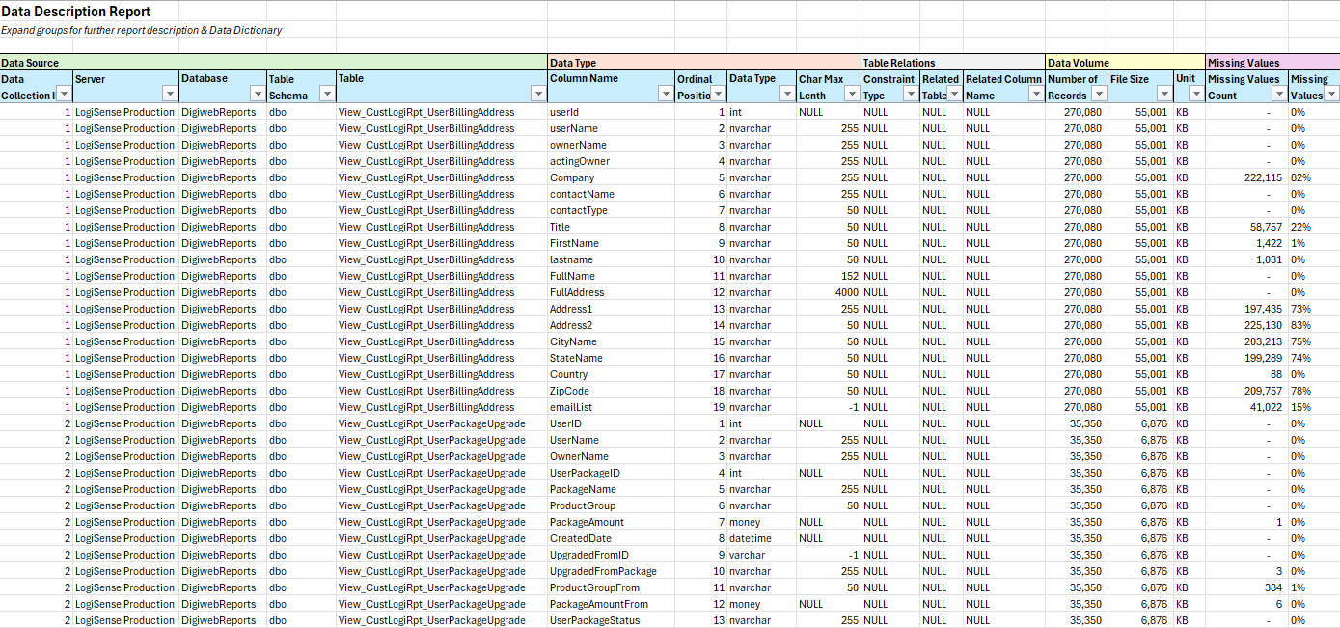

Figure : Data Description Report

#### Data Exploration and Quality Verification

Groves (2022) defines three levels of data modelling which help with understanding the structures, form, and relationships of information.

1. **Conceptual** – Represents entities, their attributes, and their relationships.
2. **Logical** – Represents an enriched version of a Conceptual model .
3. **Physical** – Represents how the model will be built in a database.

This structured data modelling approach was followed as shown in Figures 41, 42 with the exception of the physical data model which was not required to develop a dataset for future modelling purposes. The process of EDA was undertaken iteratively during the data understanding and preparation chapters, this involved initial data quality checks on around twenty-six individual datasets used during research, followed by more extensive EDA outlined in data preparation.

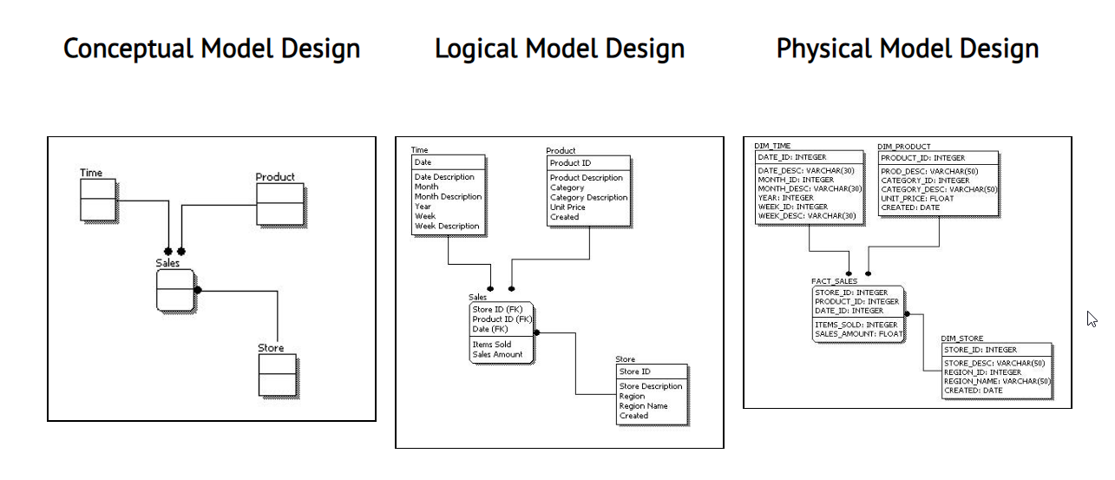

Figure : Conceptual, Logical and Physical Data Model | Source: Zohuri and Moghaddam (2017)

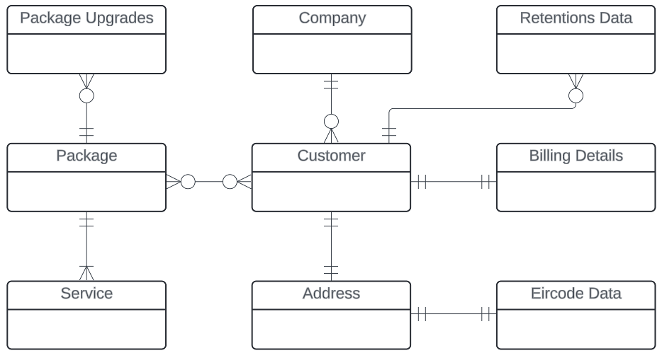

Figure : Conceptual Data Model

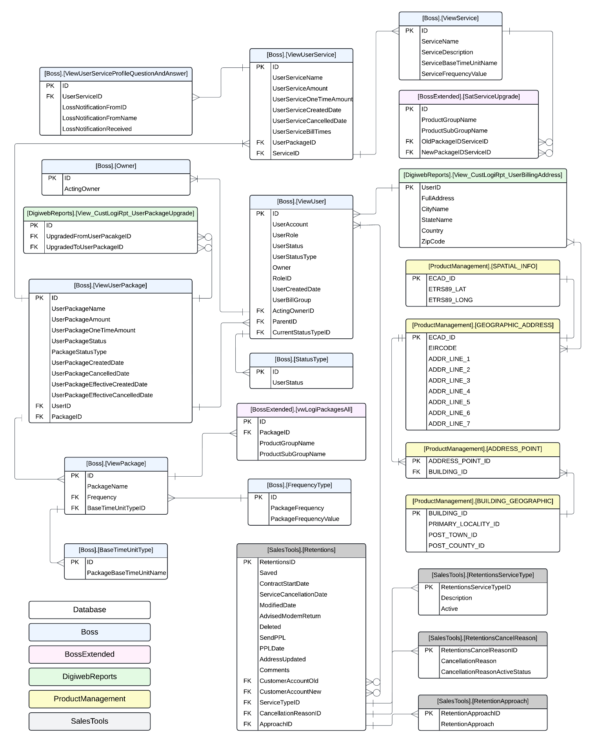

Figure : Logical Data Model

### Data Preparation

Shearer (2000) outlines the CRISP-DM Data Preparation phase as involving five steps, selection of data, cleansing of data, construction of data, integration of data, and formatting of data.

#### Data Selection

Data was selected based on the research scope criteria and details outlined within the Logical Data Model.

#### Data Cleaning

Several data cleaning steps were taken to ensure dataset quality and integrity as outlined below.

1. Removal of out-of-scope customers
2. Removal of duplicate records
3. Update of data types
4. Removal or replacement of invalid characters
5. Normalisation of primary and foreign keys to ensure successful data joins
6. Renaming of columns for improved comprehension
7. Removal of test data
8. Removal of records deemed invalid
9. Removal or transformation of outliers

#### Data Construction and Integration

A DerivedCustomerID was created to facilitate the integration between the two primary data source systems, LogiSense and Sales CRM. Upon integration several engineered features were developed based on the churn and retention factors identified during literature and primary research, summarised as per the below feature group categories:

1. Customer creation, cancellation dates, and account duration
2. Historical customer account information
3. Billing classification descriptors
4. Product and service classification descriptors
5. Package and service upgrade history
6. Loss notification records
7. Geospatial attributes
8. Frequency, nature and recency of customer interactions
9. Retention effort classification descriptors

### Exploratory Data Analysis (EDA)

Key findings from the EDA process are detailed below which include customer behaviour, product usage, cancellation reasons and retention trends which informed subsequent modelling and decision making processes. In accordance with Tufte’s (2001) principles of data visualisation, careful consideration was taken to ensure that data presentation was clear, concise and effective in communicating the research findings. Steps included the selection of visual elements, the removal of unnecessary complexity and the emphasis of data-driven storytelling, which allowed only the most important information to be easily understood by the reader.

#### Customer Lifecyle Analysis

Several long-standing customers were identified with a creation date in 2008, however the median value of 2020 and negative data skew indicate that the majority of customers have signed up for services in the past approximately four years, as shown in Figure 43.

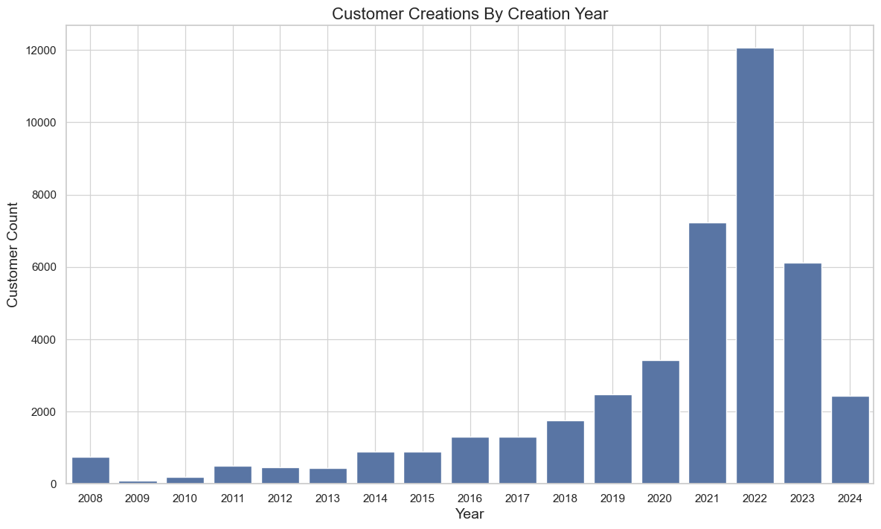

Figure : Customer Creations by Creation Year

Average customer tenure was identified as approximately five years, with a deviation of around four years, underscoring the variability in the customer lifecycle, as shown in Figure 44.

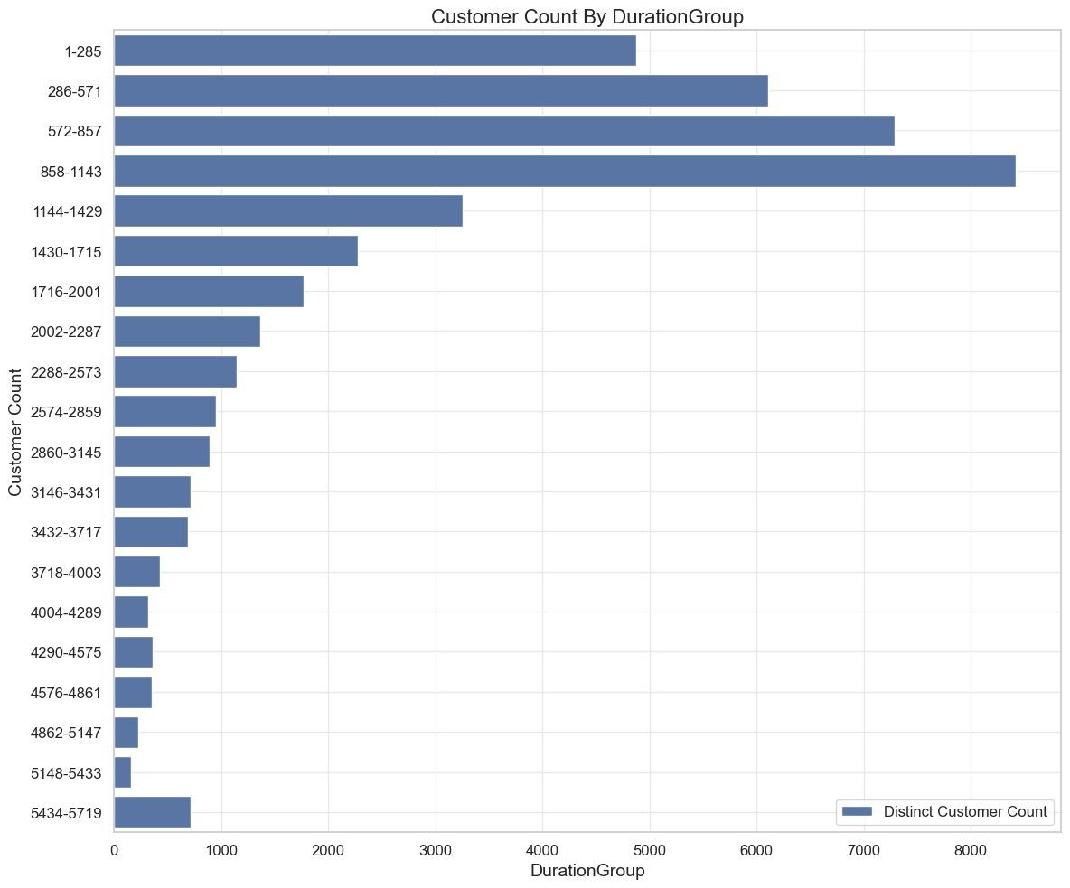

Figure : Customer Count by Duration Group

Analysis of customer cancellations found no obvious correlation between the YearMonth and number of cancellations, with the negative linear correlation anticipated given research scope only considered recent cancellations, as shown in Figure 45.

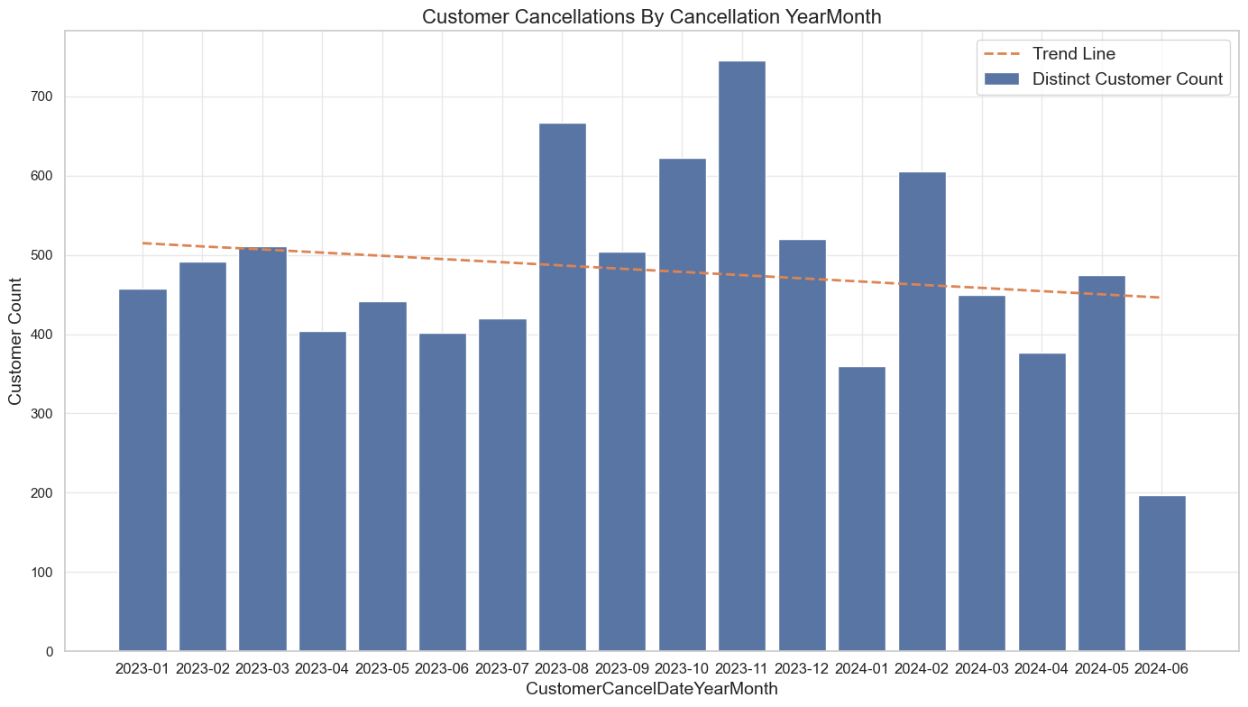

Figure : Customer Cancellations by Cancellation YearMonth

#### Customer Geographic Analysis

Geospatial analysis found that the company has significant national coverage, with particular areas of concentration around major population centres such as Dublin and Dundalk, as shown in Figures 46, 47.

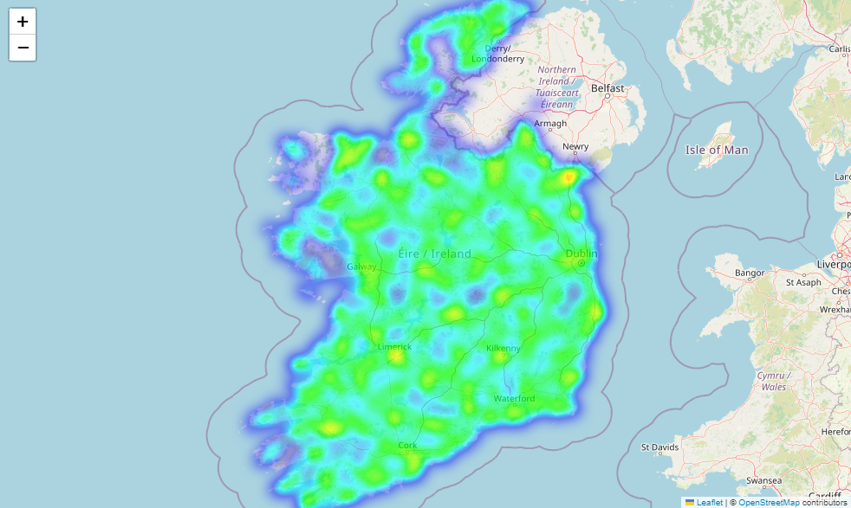

Figure : National Heatmap of Active Customers

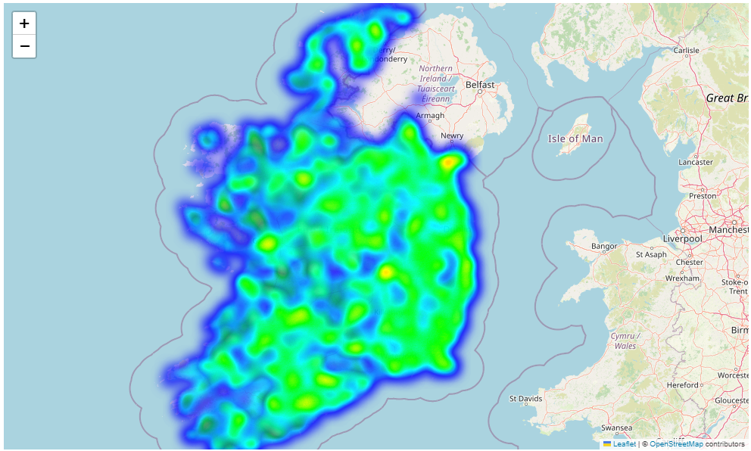

Figure : National Heatmap of Cancelled Customers

Furthermore, geospatial trends per county and province, found similar trends in the top ten counties for both active and cancelled customers, with counties in Leinster accounting for the majority of observations, as shown in Figures 48-51.

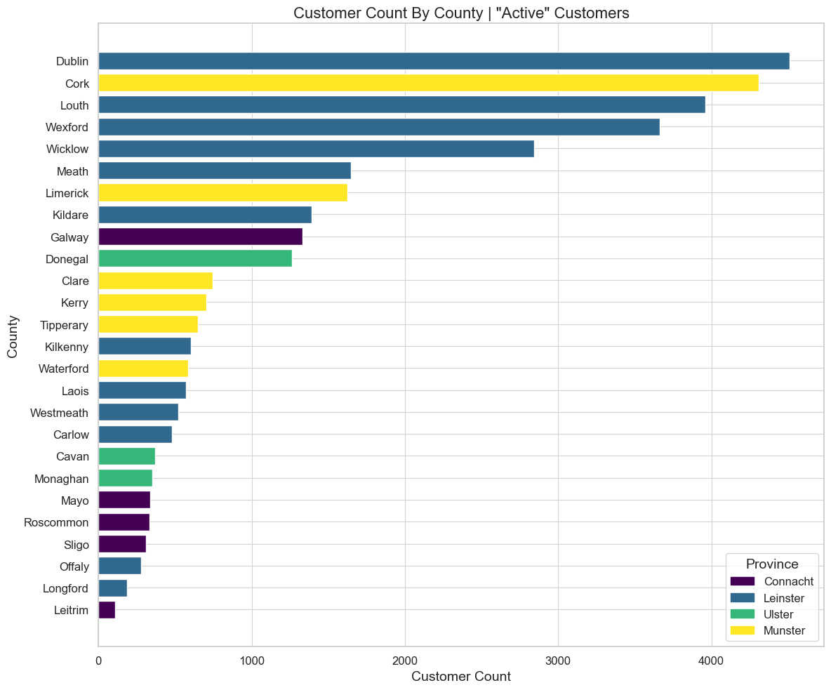

Figure : Active Customer Count by County

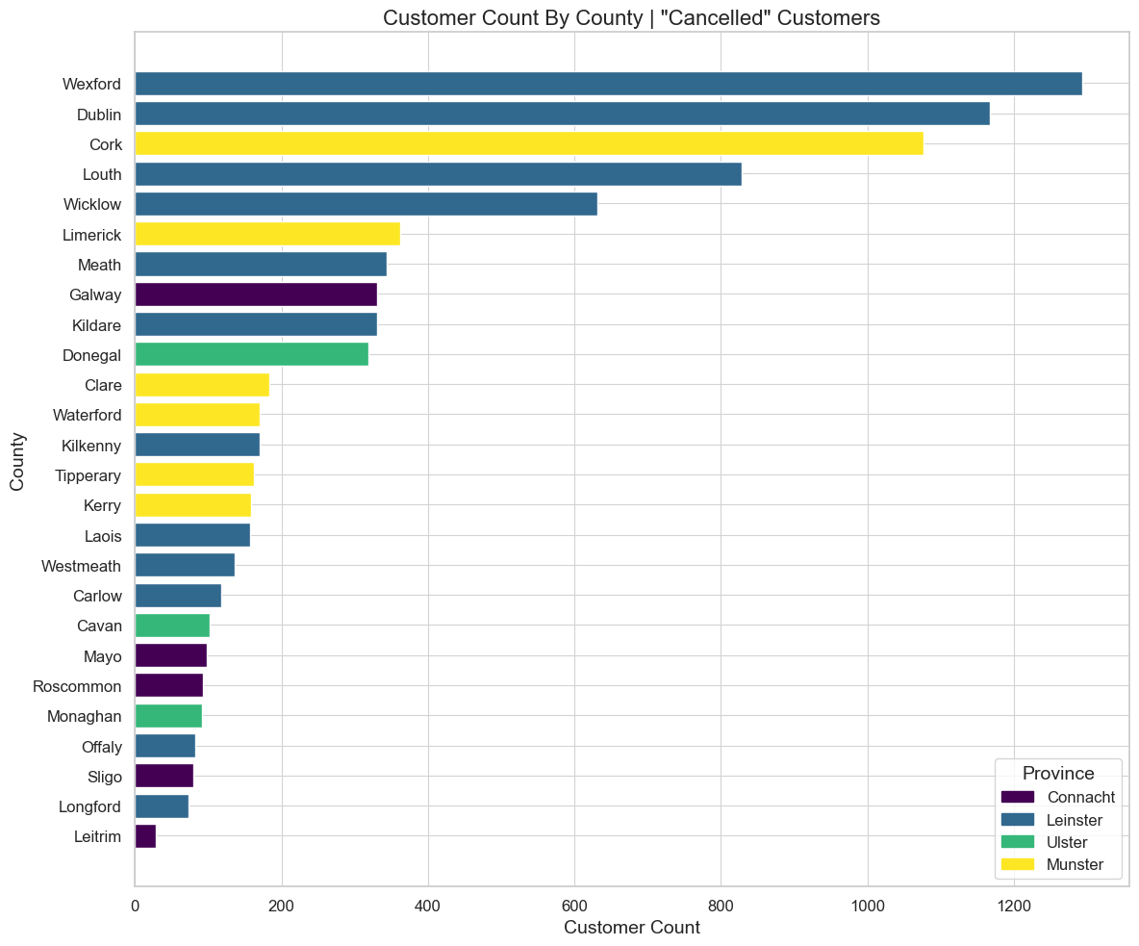

Figure : Cancelled Customer Count by County

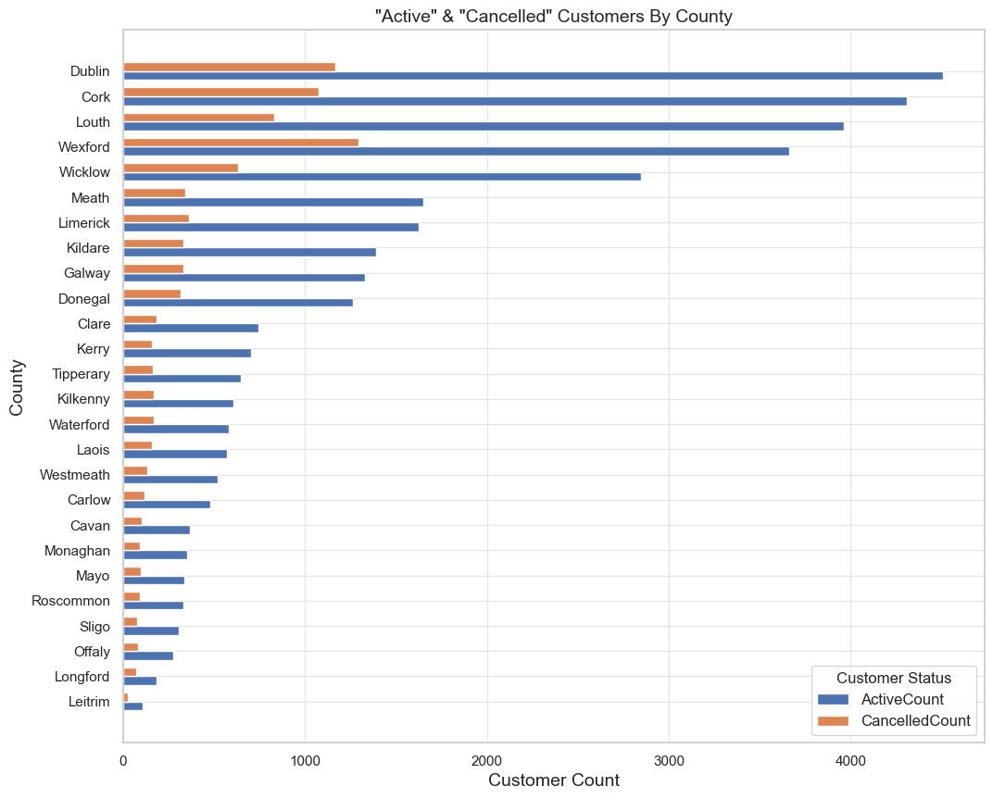

Figure : Active and Cancelled Customer Count by County

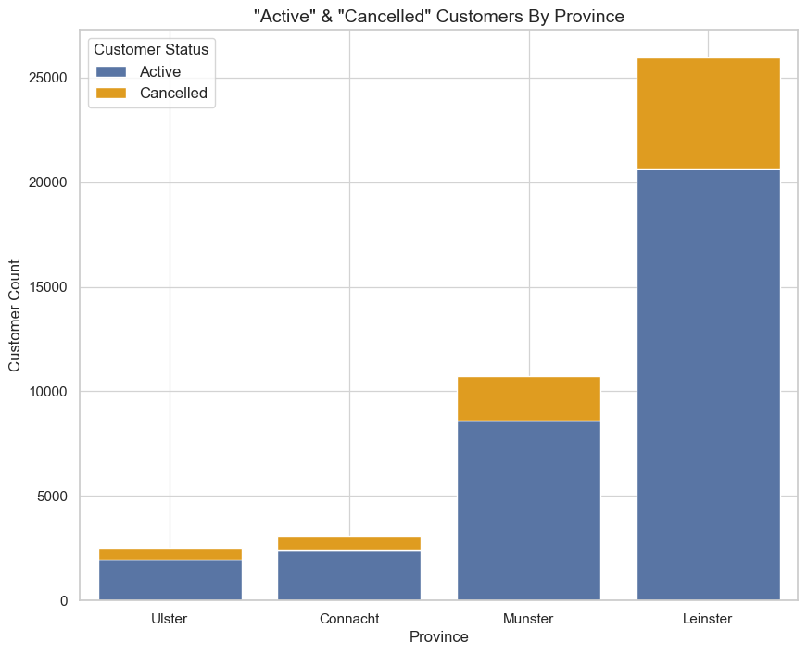

Figure : Active and Cancelled Customer Count by Province

Choropleth maps found counties on the east coast of Ireland exhibited the majority of active and cancelled customers, with the exception of large population centres such as Cork, Galway and Limerick. Given that Digiweb is based in county Louth, this could potentially explain geographic proximity trends, as shown in Figures 52, 53.

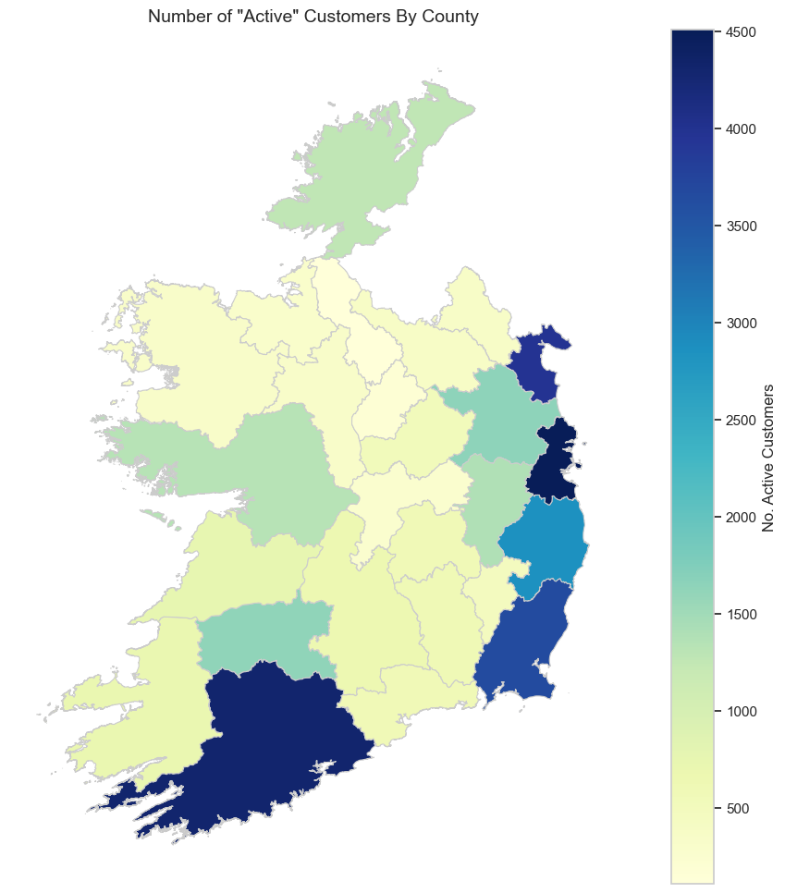

Figure : Choropleth Map No. Active Customers by County

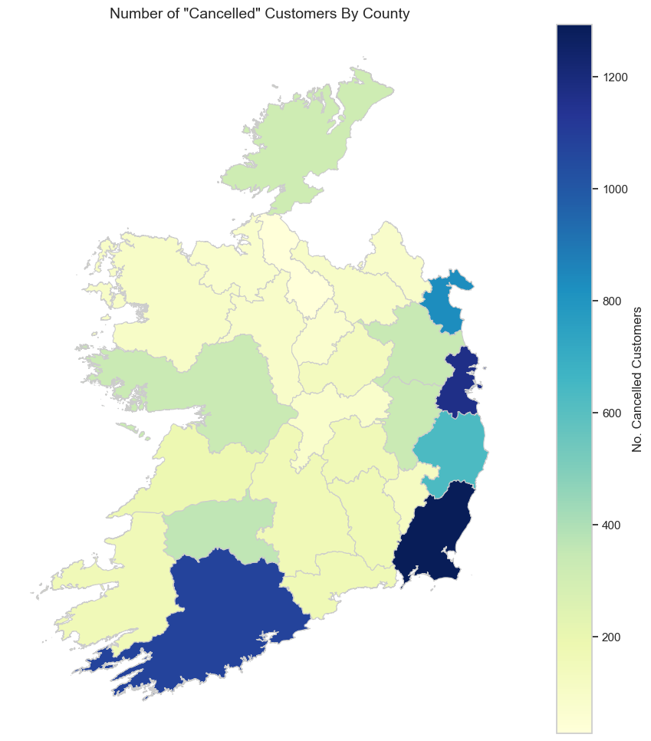

Figure : Choropleth Map No. Cancelled Customers by County

A choropleth map of the ratio of cancelled versus active customers identified a notable trend in less populated counties, specifically with counties in the Irish midlands exhibiting a higher ratio of cancelled customers, as shown in Figure 54.

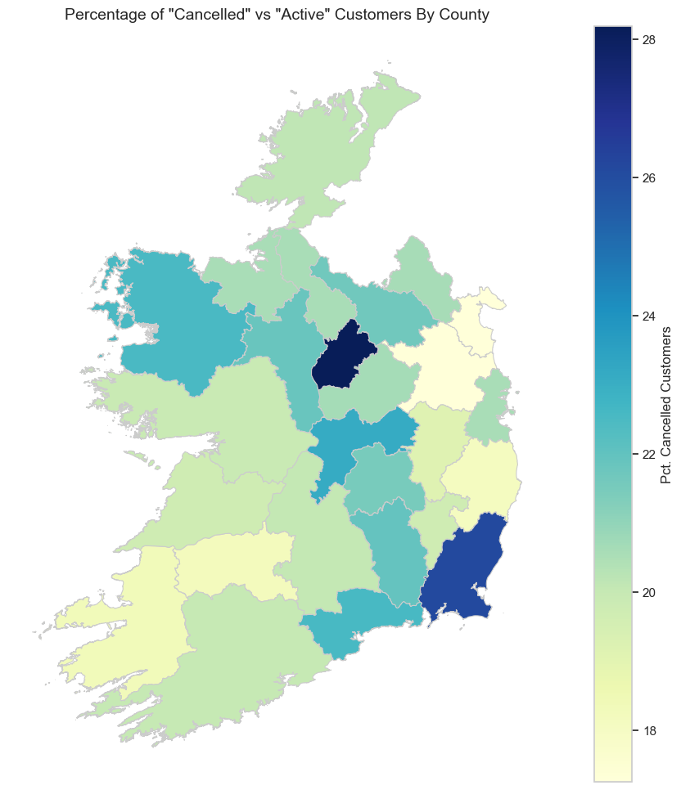

Figure : Choropleth map of Pct. Cancelled vs Active Customers by County

#### Customer Billing and Payments Analysis

Analysis of customer bill groups found that customers with the manual payment method Electronic Funds Transfer (ETF) accounted for approximately 91% of cancellations, vastly outweighing their automatic payment counterparts Credit Card and Direct Debit, as shown in Figure 55.

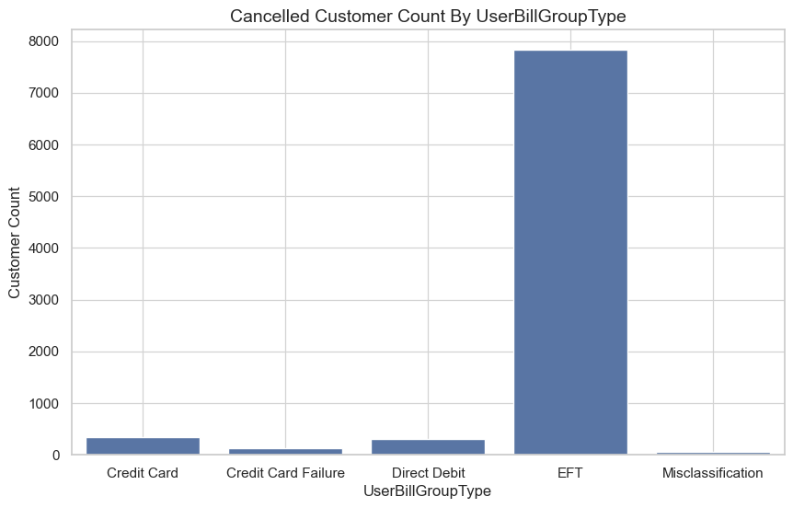

Figure : Cancelled Customer Count by Customer Bill Group Type

#### Product Group Analysis

Analysis of product groups found that the same top five product groups for both active and cancelled customers, though in a slightly different ranking order. Notably, higher cancellations in the Wireless product group align with primary research findings (HOS, 2024; HOO, 2024) as this technology is being phased out, as shown in Figures 56, 57.

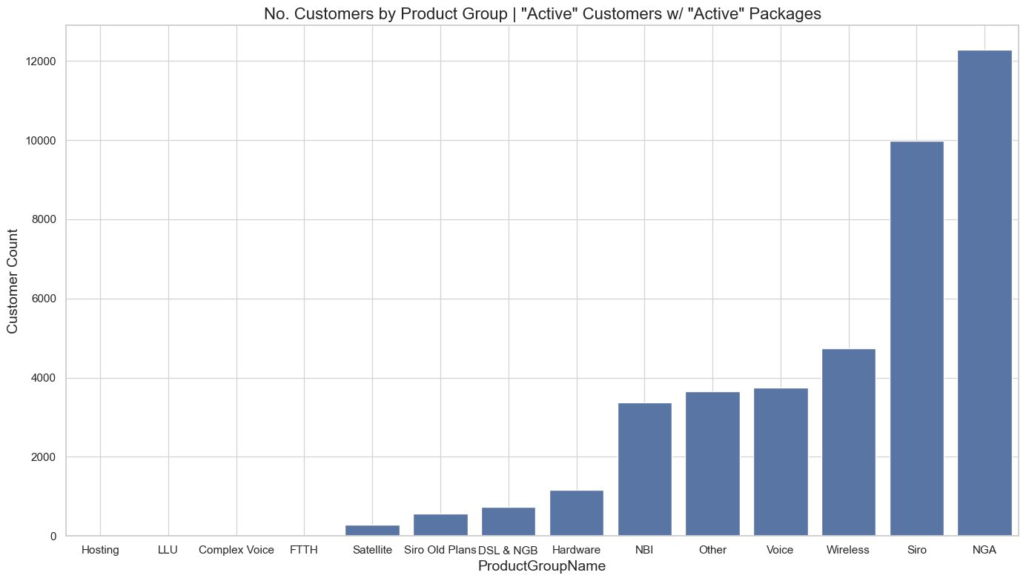

Figure : Active Customer Count by Product Group

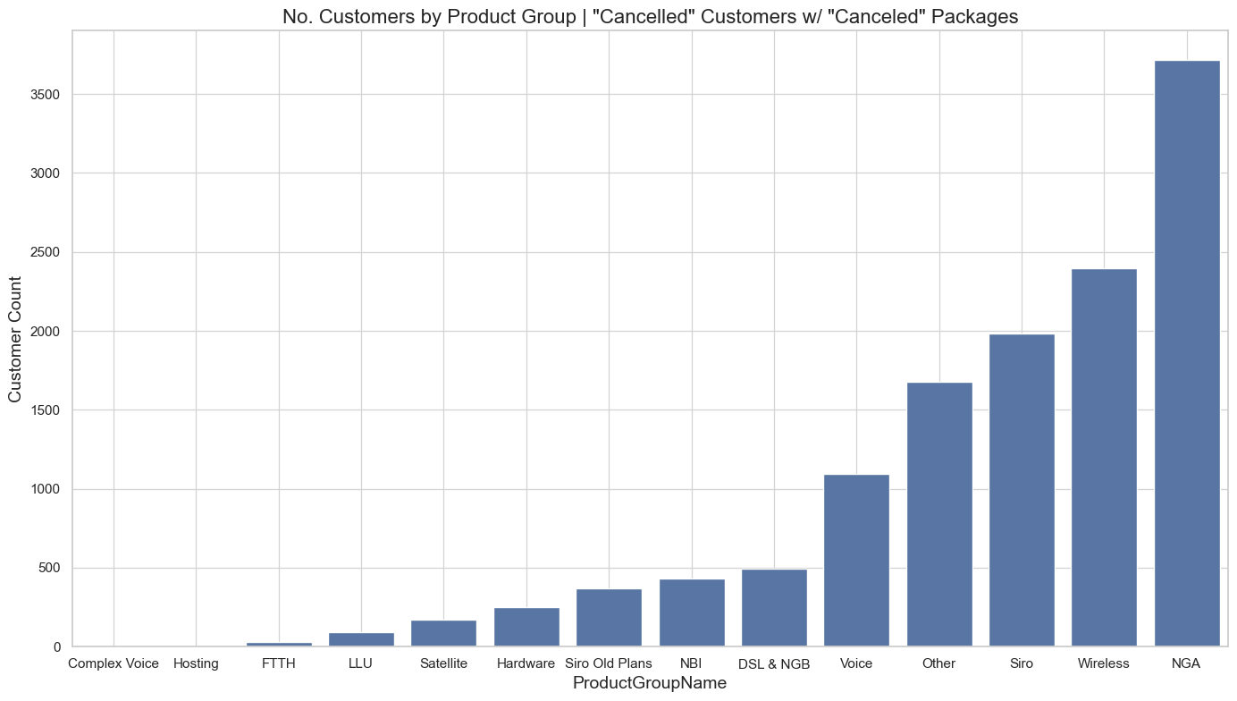

Figure : Cancelled Customer Count by Product Group

#### Customer Cancellation Reason

The top five most reasons recorded for cancellation were due to a competitor offer at around 33%, relocation at about 29%, price issue at around 17%, service issue at about 9% and technical issue at around 8%, as shown in Figure 58.

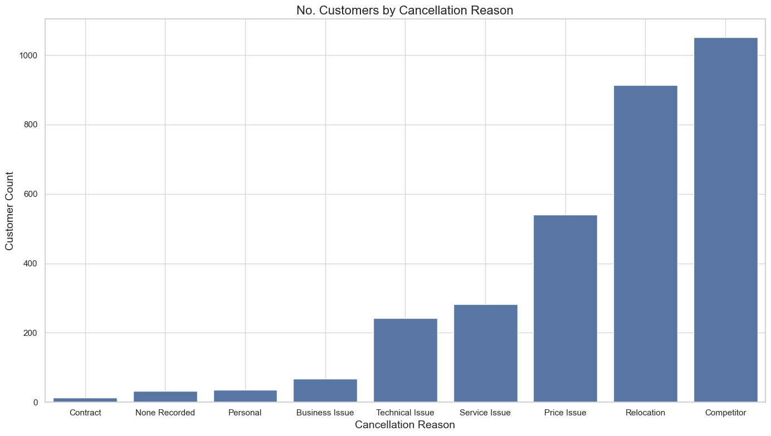

Figure : No. Customer Cancellations by Cancellation Reason

#### Customer Retention Approach

The top five successful retention approaches recorded where a customer was saved were service changes at around 60%; other at about 18%; none recorded at around 13%; relocation at about 6% and customer credits at around 4%, as shown in Figure 59.

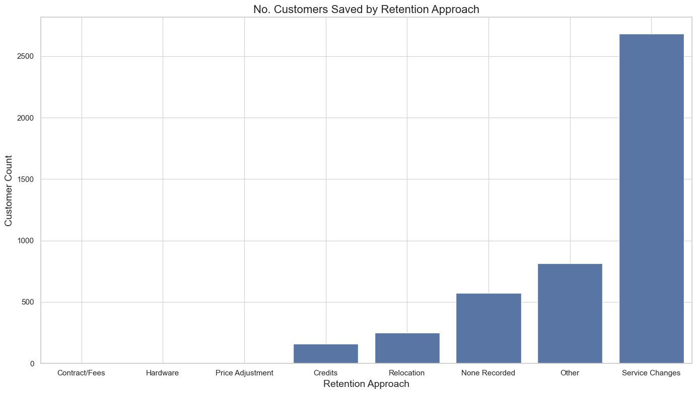

Figure : No. Customers Saved by Retention Approach

#### Data Dictionary

The data dictionary outlines the features that were contained within the final dataset that was used for modelling.

Table : Data Dictionary

|  |  |  |
| --- | --- | --- |
| **Field** | **Field Group** | **Description** |
| CustomerID | Customer Lifecycle | Unique identifier for the customer. |
| CustomerStatus | Customer Lifecycle | Indicates the current status of the customer (e.g. Active, Cancelled). |
| CustomerDuration | Customer Lifecycle | The length of time the customer has been with the company. |
| UserIDCount | Customer Lifecycle | Number of user accounts linked to the customer. |
| Addon | Products & Services Offering | General field indicating whether the customer has add-ons. |
| Addon Additional Charge | Products & Services Offering | Additional charges related to the customer's add-ons. |
| Addon Discount | Products & Services Offering | Discount applied to any customer add-ons. |
| Addon Discount Satellite | Products & Services Offering | Discount specific to satellite add-ons. |
| Addon Discount Siro | Products & Services Offering | Discount specific to Siro add-ons. |
| Addon Hardware | Products & Services Offering | Customer add-on hardware information. |
| Addon IP Address | Products & Services Offering | IP address associated with the customer's add-ons. |
| Addon LLU | Products & Services Offering | Local loop unbundling (LLU) add-on service information. |
| Addon Metro Traffic | Products & Services Offering | Traffic data related to Metro add-on services. |
| Addon Voice | Products & Services Offering | Add-on related to voice services. |
| Ancillary | Products & Services Offering | Any additional ancillary services associated with the customer. |
| DSFA | Products & Services Offering | Data Services for all (DSFA) associated with the customer. |
| DSL | Products & Services Offering | Indicates whether the customer uses Digital Subscriber Line (DSL) service. |
| DSL Business | Products & Services Offering | Business-specific DSL service information. |
| DSL Setup | Products & Services Offering | Information related to DSL service setup. |
| Data | Products & Services Offering | Data usage or plans associated with the customer. |
| Discount Voice | Products & Services Offering | Discount applied to voice services. |
| FTTH | Products & Services Offering | Indicates whether the customer uses fibre to the Home (FTTH) services. |
| Fibre | Products & Services Offering | General field indicating fibre optic service information. |
| Fibre Dedicated | Products & Services Offering | Dedicated fibre service details for the customer. |
| Fibre Setup | Products & Services Offering | Information related to fibre service setup. |
| Fibre TTC | Products & Services Offering | Time-to-connect details for the fibre service. |
| Fibre TTC Setup | Products & Services Offering | Setup details related to fibre to-the-cabinet (TTC). |
| Fibre TTH Eir | Products & Services Offering | Fibre to the Home (TTH) service with Eir. |
| Fibre TTH Siro | Products & Services Offering | Fibre to the Home (TTH) service with Siro. |
| Fibre TTH Smart Vision | Products & Services Offering | Fibre to the Home (TTH) service with Smart Vision. |
| Hardware | Products & Services Offering | Information on hardware associated with the customer. |
| Homewave Airspan | Products & Services Offering | Airspan technology used in Homewave service. |
| Hosting | Products & Services Offering | Hosting services utilised by the customer. |
| LLU | Products & Services Offering | Local loop unbundling (LLU) service information. |
| Line Rental | Products & Services Offering | Line rental charges for the customer. |
| Metro | Products & Services Offering | Metro service details for the customer. |
| Metro Business | Products & Services Offering | Business-specific Metro service information. |
| Metro Install | Products & Services Offering | Installation details for Metro services. |
| NBI | Products & Services Offering | National Broadband Ireland (NBI) service information. |
| NGA | Products & Services Offering | Next-Generation Access (NGA) service information. |
| NGB | Products & Services Offering | Next-Generation Broadband (NGB) service information. |
| NGB Business | Products & Services Offering | Business-specific Next-Generation Broadband (NGB) information. |
| Other | Products & Services Offering | Miscellaneous or other services associated with the customer. |
| Rate Card | Products & Services Offering | Rate card details for services provided. |
| Rate Card Business | Products & Services Offering | Rate card for business services. |
| Rate Card CPS | Products & Services Offering | Call path service (CPS) rate card details. |
| Rate Card DSL Broadband Bundle | Products & Services Offering | Rate card for DSL broadband bundle services. |
| Rate Card Fibre TTC Bundle | Products & Services Offering | Rate card for fibre to-the-cabinet (TTC) bundles. |
| Rate Card Line Rental Bundle | Products & Services Offering | Rate card for bundled line rental services. |
| Rate Card Line Rental POTS | Products & Services Offering | Rate card for line rental plain old telephone service (POTS). |
| Rate Card NGB Broadband Bundle | Products & Services Offering | Rate card for NGB broadband bundle services. |
| Rate Card Siro | Products & Services Offering | Rate card for Siro services. |
| Rate Card Voice Addon | Products & Services Offering | Rate card for voice add-on services. |
| SIP Trunk | Products & Services Offering | Session Initiation Protocol (SIP) trunk service details. |
| Satellite | Products & Services Offering | Satellite service information for the customer. |
| Satellite Business | Products & Services Offering | Business-specific satellite service details. |
| Satellite Setup | Products & Services Offering | Setup information for satellite services. |
| Setup | Products & Services Offering | General setup information for customer services. |
| Siro | Products & Services Offering | Siro service details for the customer. |
| Siro Setup | Products & Services Offering | Setup details for Siro services. |
| VDSL | Products & Services Offering | Indicates whether the customer uses Very-high-bit-rate Digital Subscriber Line (VDSL). |
| VOIP | Products & Services Offering | Voice over IP (VOIP) service details for the customer. |
| Voice\Bus\Dual | Products & Services Offering | Dual-use voice business service information. |
| Voice\Bus\OnNet | Products & Services Offering | On-network voice business service details. |
| Wireless | Products & Services Offering | Wireless service information for the customer. |
| NoPackages | Products & Services Offering | Number of packages or services subscribed to by the customer. |
| LossNotificationFlag | Loss Notifcation | Indicates if there is a notification for potential service loss. |
| UpgradeUpgradeFlag | Customer Discounts & Upgrades | Indicates if the customer is flagged for an upgrade. |
| CustomerSaved | Customer Service & Retention Efforts | Indicates if the customer was saved from churn. |
| NoCustomerContacts | Customer Service & Retention Efforts | Number of customer contact instances. |
| DaysSinceLastContact | Customer Service & Retention Efforts | Number of days since the last customer contact. |
| UserAccountChanged | Customer Service & Retention Efforts | Flag indicating whether the user account has changed. |
| CreationYear | Customer Lifecycle | The year the customer's account was created. |
| CreationMonth | Customer Lifecycle | The month the customer's account was created. |
| UserBillGroupClassification_Auto | Customer Billing & Pricing | Automatic classification of user billing group. |
| UserBillGroupClassification_Manual | Customer Billing & Pricing | Manually assigned classification of user billing group. |
| UserBillGroupType_Credit Card | Customer Billing & Pricing | Credit card payment type classification. |
| UserBillGroupType_Credit Card Failure | Customer Billing & Pricing | Classification indicating credit card payment failure. |
| UserBillGroupType_Direct Debit | Customer Billing & Pricing | Direct debit payment type classification. |
| UserBillGroupType_EFT | Customer Billing & Pricing | Electronic funds transfer (EFT) payment type classification. |
| County_Carlow | Customer Location - County | Indicates if the customer is from County Carlow. |
| County_Cavan | Customer Location - County | Indicates if the customer is from County Cavan. |
| County_Clare | Customer Location - County | Indicates if the customer is from County Clare. |
| County_Cork | Customer Location - County | Indicates if the customer is from County Cork. |
| County_Donegal | Customer Location - County | Indicates if the customer is from County Donegal. |
| County_Dublin | Customer Location - County | Indicates if the customer is from County Dublin. |
| County_Galway | Customer Location - County | Indicates if the customer is from County Galway. |
| County_Kerry | Customer Location - County | Indicates if the customer is from County Kerry. |
| County_Kildare | Customer Location - County | Indicates if the customer is from County Kildare. |
| County_Kilkenny | Customer Location - County | Indicates if the customer is from County Kilkenny. |
| County_Laois | Customer Location - County | Indicates if the customer is from County Laois. |
| County_Leitrim | Customer Location - County | Indicates if the customer is from County Leitrim. |
| County_Limerick | Customer Location - County | Indicates if the customer is from County Limerick. |
| County_Longford | Customer Location - County | Indicates if the customer is from County Longford. |
| County_Louth | Customer Location - County | Indicates if the customer is from County Louth. |
| County_Mayo | Customer Location - County | Indicates if the customer is from County Mayo. |
| County_Meath | Customer Location - County | Indicates if the customer is from County Meath. |
| County_Monaghan | Customer Location - County | Indicates if the customer is from County Monaghan. |
| County_Offaly | Customer Location - County | Indicates if the customer is from County Offaly. |
| County_Roscommon | Customer Location - County | Indicates if the customer is from County Roscommon. |
| County_Sligo | Customer Location - County | Indicates if the customer is from County Sligo. |
| County_Tipperary | Customer Location - County | Indicates if the customer is from County Tipperary. |
| County_Waterford | Customer Location - County | Indicates if the customer is from County Waterford. |
| County_Westmeath | Customer Location - County | Indicates if the customer is from County Westmeath. |
| County_Wexford | Customer Location - County | Indicates if the customer is from County Wexford. |
| County_Wicklow | Customer Location - County | Indicates if the customer is from County Wicklow. |
| Province_Connacht | Customer Location - Province | Indicates if the customer is from Connacht Province. |
| Province_Leinster | Customer Location - Province | Indicates if the customer is from Leinster Province. |
| Province_Munster | Customer Location - Province | Indicates if the customer is from Munster Province. |
| Province_Ulster | Customer Location - Province | Indicates if the customer is from Ulster Province. |
| RetentionApproach_Contract/Fees | Customer Service & Retention Efforts | Retention approach using contract/fees adjustments. |
| RetentionApproach_Credits | Customer Service & Retention Efforts | Retention approach using credits. |
| RetentionApproach_Hardware | Customer Service & Retention Efforts | Retention approach using hardware changes. |
| RetentionApproach_None Recorded | Customer Service & Retention Efforts | No retention approach recorded for the customer. |
| RetentionApproach_Not Applicable | Customer Service & Retention Efforts | Retention approach not applicable to the customer. |
| RetentionApproach_Other | Customer Service & Retention Efforts | Other retention approaches used for the customer. |
| RetentionApproach_Price Adjustment | Customer Service & Retention Efforts | Retention approach involving price adjustments. |
| RetentionApproach_Relocation | Customer Service & Retention Efforts | Retention approach involving service relocation. |
| RetentionApproach_Service Changes | Customer Service & Retention Efforts | Retention approach involving service changes. |

## Modelling

Shearer (2000) outlines the Modelling phase as involving four steps, selection of the modelling technique, the generation of test design, the creation of models, and the assessment of models. The model development decisions undertaken in this chapter are outlined in accordance with addressing the primary research objectives, specifically RO1 and RO2:

**RO1**: Investigate and identify the key factors resulting in Telecom churn at Viatel Technology Group (VTG), by focusing on leveraging data currently available within VTG’s existing data infrastructure.

**RO2**: Develop an optimised and generalised ML model to predict customer churn at VTG and evaluate its effectiveness using appropriate performance comparison metrics and techniques.

### Model Selection

Three SL ensemble classification models were selected for CCP modelling based on their proven effectiveness in literature (Kalirane, 2023; Sidiq et. al, 2023; Sina and Amiri, 2022) and primary research (SME). This novel approach included both bagging (RF) and boosting (LGBM, XGB) methods, each categorised by distinct tree-based splitting behaviours as shown in Table 11 below, which facilitated a comparative evaluation of model performance, and assisted with the determination appropriate ML models to address the research objectives.

Table : Model Selection Tree-Based Splitting Methods

|  |  |  |
| --- | --- | --- |
| RF | LGBM | XGB |
| Node-wise splitting | Leaf-wise splitting | Level-wise splitting |

#### Random Forest (RF)

Breiman (2001) define RF as a classifier consisting of a collection of tree-structured classifiers $\{h(x, k ), k = 1,...\}$ where the $\{\}$ are independent identically distributed random vectors and each tree casts a unit vote for the most popular class at input $x$ (p. 6). McGill (2024) provide a detailed breakdown of the mathematical steps of RF based on the concept of bagging/bootstrap aggregation as previously outlined (Sutton, 2005), whereby node-wise splitting leads to a reduction in variance and an enhancement in overall prediction robustness, as shown in Equation 12 below.

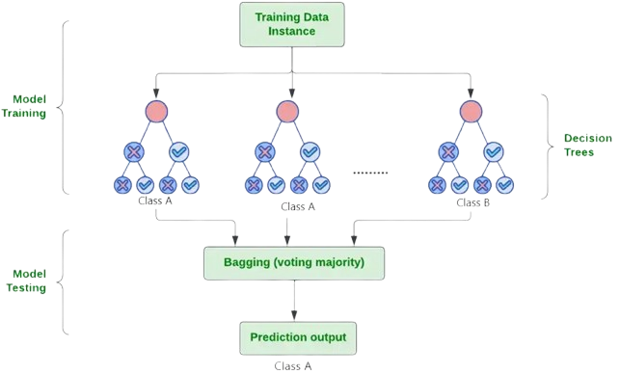

Figure : Random Forest Architecture Digram | Source: GeeksforGeeks (2024)

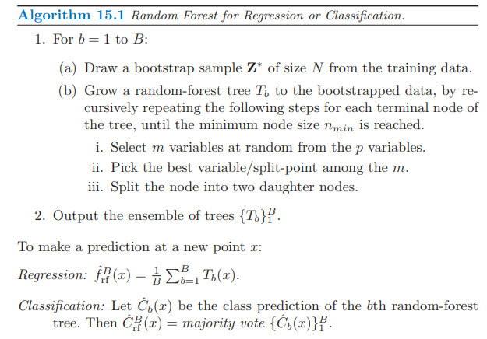

Equation : RF Algorithm Equation | Source: McGill (2024)

#### LightGBM (LGBM)

Bui et al. (2021) define LGBM as a Gradient Boosting Machine (GBM) created to improve predictive efficiency, handle large datasets, and reduce training time of tree-based learning algorithms (p. 2709), whereby, LGBM utilises leaf‐wise splits which create more complex trees that reduce loss more efficiently and improve accuracy. AcrGIS (2024) define LGBM as using a histogram-based method in which data is bucketed into bins using a histogram of the distribution, whereby the bins, instead of each data point, are used to iterate, calculate the gain, and split the data. Additionally, LGBM reduces dimensionality through Exclusive Feature Bundling (EFB) which results in a faster more efficient algorithm. Furthermore, AcrGIS (2024) outlines the use of Gradient-based One Side Sampling (GOSS) in LGBM, where data points with larger gradients are allocated higher weight during gain calculation, making better use of underutilised samples when compared to random sampling. Mohammed et al. (2021) provide a detailed breakdown of the mathematical steps of LGBM, as shown in Equation 13.

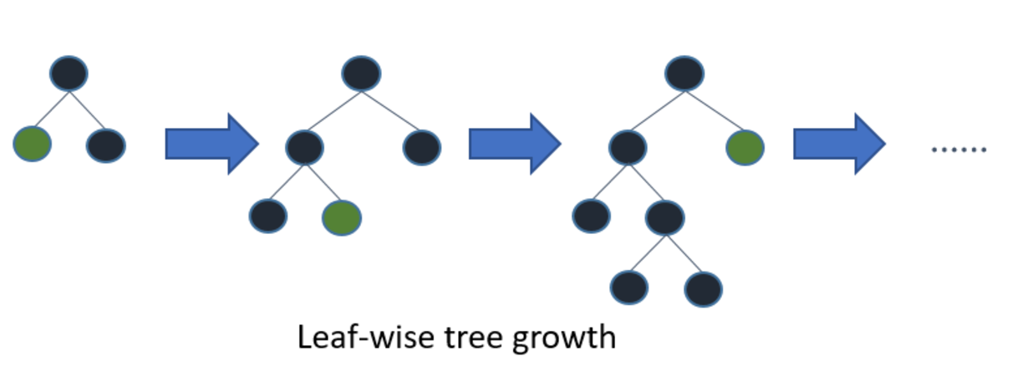

Figure : LGBM Architecture Diagram | Source: Mandot (2017)

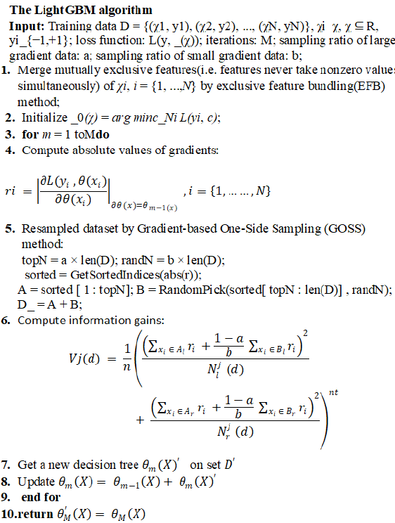

Equation : LGBM Algorithm Equation | Source: Mohammed et al. (2021)

#### XGBoost (XGB)

XGBoost (2024) define eXtreme Boosting (XGB) as a parallel tree boosting algorithm, also known as a Gradient Boosted Decision Tree (GBDT) or GBM that implements a level-wise pruning strategy that leverages deep searches for an optimal solution to minimise model error and the reduce the risk of overfitting. Rajora (2023) outlines that XGB builds high bias and low-variance trees, which are combined additively to reduce bias without altering the variance, which starts at the root note then creates a group of the data by splitting to maximise gain, this process is then repeated at every level of the decision tree. Furthermore, Rajora (2023) provides a detailed breakdown of the mathematical steps of XGB, as shown in Equations 14, 15 below.

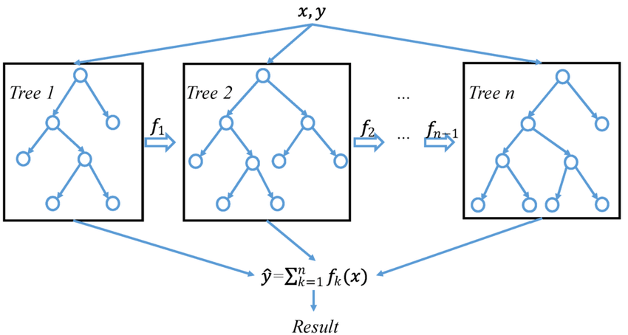

Figure : XGBoost Architecture Diagram in ML | Source: Wang et al. (2019)



Equation : XGBoost Model Error Equation | Source: Rajora (2023)

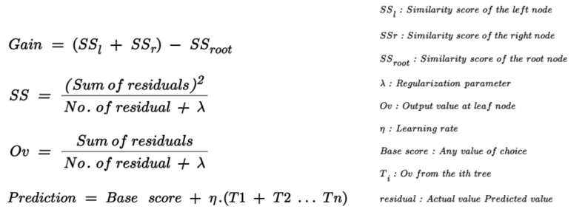

Equation : XGBoost Algorithm Equation | Source: Rajora (2023)

#### Model Selection Summary

As described in research (Jin et al., 2022; O’Reilly, 2024), different SL models come with distinct advantages and disadvantages, as shown in Figure 63. With the selection of varying tree-based splitting models, this research aims identify the best approach to addresses research objectives based on an evaluation of bagging and boosting classification algorithms.



Figure : Supervised ML Model Selection | Source: O'Reilly (2024)

### Model Assumptions

#### Handling Missing Values

Mitigation steps ensured the dataset was free of missing values to prevent bias and performance issues, however where values were missing for reasons deemed valid, for example no retention efforts were employed, then a default value was imputed.

#### Feature Independence

IBM (2023) outlines multicollinearity occurring when two or more independent variables are correlated, therefore mitigation steps were taken to remove highly correlated features which can negatively impact model performance for example CustomerCancelDate was removed as CustomerCreationDate and CustomerDuration already capture required information, as shown in Equation 16.

$$If the Customer Cancellation Date is not null: \\ Customer Duration=Customer Cancellation Date- Customer Creation \\ Otherwise: \\ Customer Duration=19th June 2024-Customer Cretaion Date$$

Equation : Customer Duration Equation

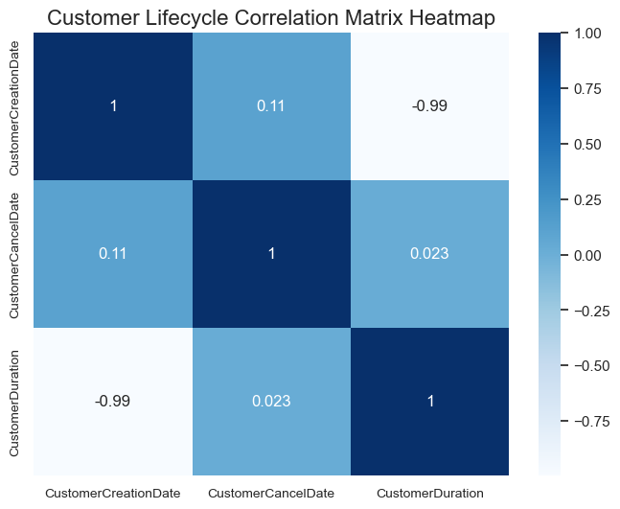

Figure : Customer Lifecycle Related Features Correlation Matrix Heatmap

#### Class Imbalance

Final dataset analysis identified approximately 80% of customers belonging to the majority (non-churn) class and 20% belonging to the minority (churn) class, as shown in Figure 65. Therefore mitigation steps to address this class imbalance were taken as outlined in the test design.

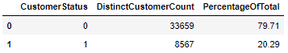

Figure : Dataset Class Distribution

#### Dimensionality Reduction

As identified in research (Codecademy, 2024), the assumption is that there are unnecessary features contained within the dataset, therefore steps were taken to reduce dataset dimensionality as outlined in the test design.

#### Categorical Feature Encoding

As identified by Datacamp (2024), one-hot encoding was applied to ensure that categorical data was converted into numerical vectors which was a requirement for selected models.

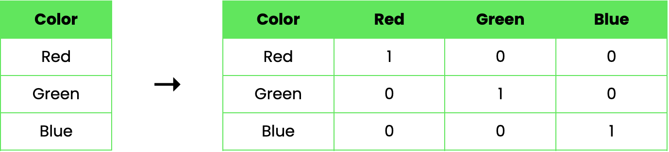

Figure : One-Hot Encoding Process | Source: Datacamp (2024)

## Test Design

The flowchart below captures the steps and sequence of model development that was implemented.

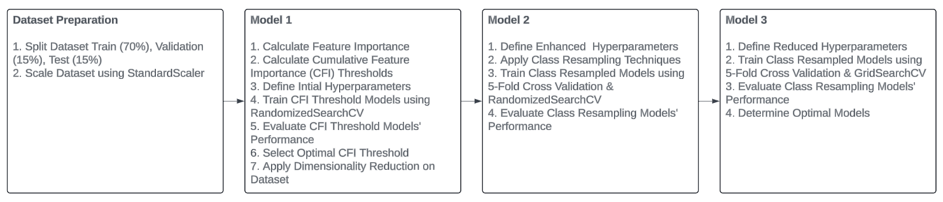

Figure : Test Design Implementation Flowchart

### Dataset Splitting

Sufficient training sample existed for the inclusion of a validation set, along with training and testing sets as outlined in research (Burkov, 2019; Pawluszek-Filipiak and Borkowski, 2020), therefore data was split into three sets with the following allocation, train: 70%, validation: 15% and test: 15%. Additionally, Sadaiyandi et al. (2023) outline the importance of Stratified Sampling as a method that ensures that each dataset maintains the same class proportionality, therefore this approach was applied, as shown in Figure 69.

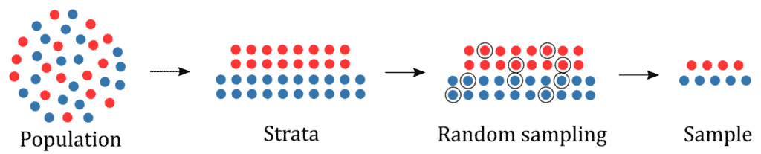

Figure : Stratified Sampling in Machine Learning | Source: Baeldung (2021)

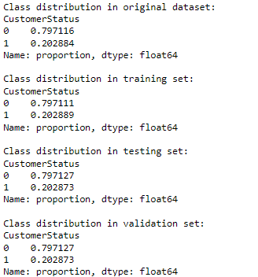

Figure : Dataset Split(s) Class Distribution

### Dataset Scaling

Scikit Learn (2024b) outline feature scaling as an important standardisation step, which involves rescaling each feature so that it has a standard deviation of 1 and a mean of 0, noting that whilst tree-based models are less sensitive to data scale, standardisation can still enhance model performance. Scikit Learn (2024c) outline the use of the Standard Scaler as a simple and effective method for rescaling data, therefore this method was employed to ensure consistent standardisation across models.

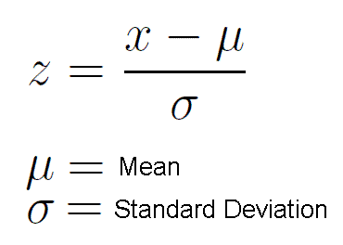

Equation : Standard Scaling Equation | Source: S R Gowtham (2022)

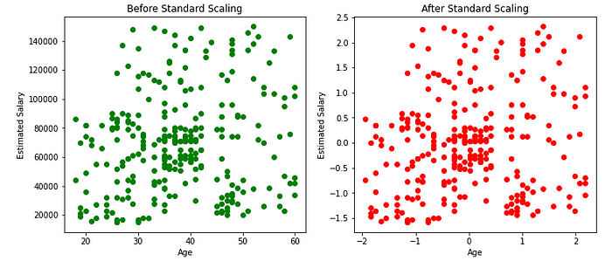

Figure : Standard Scaling Before and After Effects | Source: S R Gowtham (2022)

### Performance Evaluation Metrics

As identified in research (Sina and Amiri, 2022), a comprehensive suite of performance metrics are required to evaluate CCP in Telecoms, therefore a several performance metrics and techniques were utilised during model development as per the below.

1. Accuracy
2. Precision
3. Recall
4. F1-score
5. Log Loss
6. AUC
7. Time Taken (s)
8. Classification Table
9. Confusion Matrix

### Dimensionality Reduction

A novel approach was employed to evaluate several Cumulative Feature Importance (CFI) thresholds (80%, 85%, 90%, 95%, 99%) using each models in-built feature importance measurement, with Gini Index selected for its simplicity and speed in determining the optimal number of features (Aznar, 2020; Codecademy, 2024).

### Cross Validation Techniques

A five-fold cross validation was implemented during hyperparameter tuning given the class imbalance of the dataset, which balances computational cost with reliable performance estimation (Pawluszek-Filipiak and Borkowski, 2020).

### Class Resampling Methods

Several class resampling techniques were selected to addressing class imbalance (El-Amir and El-Henawy, 2024; Toor and Usman, 2022), which facilitated a comparative evaluation of each models predictive performance across SL models as per the below.

1. No balancing (baseline)
2. Oversampling – RandomOverSampler (ROS), SMOTE, ADASYN
3. Undersampling – RandomUnderSampler (RUS)
4. Combined Oversampling and Undersampling: SMOTEENN, SMOTETomek

### Hyperparameter Tuning

A comprehensive set of hyperparameters and regularisation techniques were utilised for each ML model. First, Randomized Search was used in M2 for its computational efficiency on a broad set of hyperparameters, following which GridSearchCV was used in M3 on a reduced set of hyperparameters based on a more targeted approach. As identified in research, these techniques are proven at being effective in optimising churn prediction models (Sina and Amiri, 2022; Burkov, 2019), to ensure that models were better generalised to unseen data whilst reducing overfitting. Hyperparameter values are detailed in Tables 12-20 below.

Table : RF-M1: CFI Threshold Feature Importance Evaluation Hyperparameters

|  |  |  |
| --- | --- | --- |
| **Hyperparameter** | **Hyperparameter Name** | **Hyperparameter Values** |
| n_estimators | N estimators | 100, 200, 300, 400, 500 |
| max_features | Max features | auto, sqrt, log2 |
| max_depth | Max depth | 5, 10, 15, 20 |
| min_samples_split | Min samples split | 5, 10 |
| min_samples_leaf | Min samples leaf | 5, 10 |
| bootstrap | Bootstrap | TRUE |
| class_weight | Class weight | balanced, balanced_subsample, {0: 1, 1: 4} |
| criterion | Criterion | gini, entropy |
| max_samples | Max samples | 0.8, 0.9, 1.0 |

Table : RF-M2: Class Resampling Randomized Search Evaluation Hyperparameters

|  |  |  |
| --- | --- | --- |
| **Hyperparameter** | **Hyperparameter Name** | **Hyperparameter Values** |
| **n_estimators** | N estimators | 100, 200, 300, 400, 500 |
| **max_features** | Max features | auto, sqrt, log2 |
| **max_depth** | Max depth | 5, 10, 15, 20, 25, 30 |
| **min_samples_split** | Min samples split | 2, 5, 10, 15 |
| **min_samples_leaf** | Min samples leaf | 1, 2, 5, 10 |
| **bootstrap** | Bootstrap | True, False |
| **class_weight** | Class weight | balanced, balanced_subsample, {0: 1, 1: 4} |
| **criterion** | Criterion | gini, entropy |
| **max_samples** | Max samples | 0.8, 0.9, 1.0 |

Table : RF-M3: Class Resampling Grid Search Evaluation Hyperparameters

|  |  |  |
| --- | --- | --- |
| **Hyperparameter** | **Hyperparameter Name** | **Hyperparameter Values** |
| n_estimators | N estimators | 200 |
| max_features | Max features | log2 |
| max_depth | Max depth | 10, 15 |
| min_samples_split | Min samples split | 5, 10 |
| min_samples_leaf | Min samples leaf | 5, 10 |
| bootstrap | Bootstrap | TRUE |
| class_weight | Class weight | balanced_subsample |
| criterion | Criterion | gini |
| max_samples | Max samples | 0.8, 0.9 |

Table : LGBM-M1: CFI Threshold Feature Importance Evaluation Hyperparameters

|  |  |  |
| --- | --- | --- |
| **Hyperparameter** | **Hyperparameter Name** | **Hyperparameter Values** |
| num_leaves | Num leaves | 20, 30, 40, 50 |
| max_depth | Max depth | 5, 10, 15 |
| learning_rate | Learning rate | 0.01, 0.05 |
| n_estimators | N estimators | 100, 200, 300, 400, 500 |
| min_split_gain | Min split gain | 0.1, 0.2, 0.3 |
| min_child_weight | Min child weight | 0.01, 0.1, 1 |
| colsample_bytree | Colsample by tree | 0.6, 0.7, 0.8 |
| subsample | Subsample | 0.6, 0.7, 0.8 |
| class_weight | Class weight | balanced, balanced_subsample, {0: 1, 1: 4} |
| lambda_l1 | Lambda L1 | 0.1, 0.5, 1.0 |
| lambda_l2 | Lambda L2 | 0.1, 0.5, 1.0 |
| subsample_freq | Subsample frequency | 1, 5, 10 |
| drop_rate | Drop rate | 0.1, 0.2, 0.3 |

Table : LGBM-M2: Class Resampling Randomized Search Evaluation Hyperparameters

|  |  |  |
| --- | --- | --- |
| **Hyperparameter** | **Hyperparameter Name** | **Hyperparameter Values** |
| num_leaves | Num leaves | 20, 30, 40, 50, 60 |
| max_depth | Max depth | 10, 15, 20, 25, 30 |
| learning_rate | Learning rate | 0.01, 0.05, 0.1 |
| n_estimators | N estimators | 100, 200, 300, 400, 500 |
| min_split_gain | Min split gain | 0.1, 0.2, 0.3 |
| min_child_weight | Min child weight | 0.01, 0.1, 1 |
| colsample_bytree | Colsample by tree | 0.6, 0.7, 0.8, 0.9, 1.0 |
| subsample | Subsample | 0.6, 0.7, 0.8, 0.9, 1.0 |
| class_weight | Class weight | balanced, balanced_subsample |
| lambda_l1 | Lambda L1 | 0.1, 0.5, 1.0 |
| lambda_l2 | Lambda L2 | 0.1, 0.5, 1.0 |
| subsample_freq | Subsample frequency | 1, 5, 10 |
| drop_rate | Drop rate | 0.1, 0.2, 0.3 |

Table : LGBM-M3: Class Resampling Grid Search Evaluation Hyperparameters

|  |  |  |
| --- | --- | --- |
| **Hyperparameter** | **Hyperparameter Name** | **Hyperparameter Values** |
| num_leaves | Num leaves | 30, 40 |
| max_depth | Max depth | 15, 20 |
| learning_rate | Learning rate | 0.03 |
| n_estimators | N estimators | 200 |
| min_split_gain | Min split gain | 0.2, 0.3 |
| min_child_weight | Min child weight | 0.1 |
| colsample_bytree | Colsample by tree | 0.7, 0.8 |
| subsample | Subsample | 0.6, 0.7 |
| class_weight | Class weight | balanced |
| lambda_l1 | Lambda L1 | 0.5 |
| lambda_l2 | Lambda L2 | 0.5 |
| subsample_freq | Subsample frequency | 5 |
| drop_rate | Drop rate | 0.2 |

Table : XGB-M1: CFI Threshold Feature Importance Evaluation Hyperparameters

|  |  |  |
| --- | --- | --- |
| **Hyperparameter** | **Hyperparameter Name** | **Hyperparameter Values** |
| max_depth | Max depth | 5, 10, 15 |
| learning_rate | Learning rate | 0.01, 0.05 |
| n_estimators | N estimators | 100, 200, 300, 400, 500 |
| gamma | Gamma | 0, 0.1, 0.2, 0.3 |
| min_child_weight | Min child weight | 0.01, 0.1, 1 |
| colsample_bytree | Colsample by tree | 0.6, 0.7, 0.8 |
| subsample | Subsample | 0.6, 0.7, 0.8 |
| scale_pos_weight | Scale pos weight | 1, 2, 3, 4 |
| reg_alpha | Reg alpha | 0.1, 0.5, 1.0 |
| reg_lambda | Reg lambda | 0.1, 0.5, 1.0 |
| tree_method | Tree method | auto |
| grow_policy | Grow policy | depthwise, lossguide |

Table : XGB-M2: Class Resampling Randomized Search Evaluation Hyperparameters

|  |  |  |
| --- | --- | --- |
| **Hyperparameter** | **Hyperparameter Name** | **Hyperparameter Values** |
| max_depth | Max depth | 5, 10, 15, 20 |
| learning_rate | Learning rate | 0.01, 0.05, 0.1, 0.2 |
| n_estimators | N estimators | 100, 200, 300, 400, 500 |
| gamma | Gamma | 0, 0.1, 0.2, 0.3 |
| min_child_weight | Min child weight | 0.01, 0.1, 1 |
| colsample_bytree | Colsample by tree | 0.6, 0.7, 0.8 |
| subsample | Subsample | 0.6, 0.7, 0.8, 0.9, 1.0 |
| scale_pos_weight | Scale pos weight | 1, 2, 5, 10 |
| reg_alpha | Reg alpha | 0.1, 0.5, 1.0 |
| reg_lambda | Reg lambda | 0.1, 0.5, 1.0 |
| tree_method | Tree method | auto |
| grow_policy | Grow policy | depthwise, lossguide |

Table : XGB-M3: Class Resampling Grid Search Evaluation Hyperparameters

|  |  |  |
| --- | --- | --- |
| **Hyperparameter** | **Hyperparameter Name** | **Hyperparameter Values** |
| max_depth | Max depth | 10, 15 |
| learning_rate | Learning rate | 0.02 |
| n_estimators | N estimators | 60 |
| gamma | Gamma | 0.2, 0.3 |
| min_child_weight | Min child weight | 0.1 |
| colsample_bytree | Colsample by tree | 0.7, 0.8 |
| subsample | Subsample | 0.7, 0.8 |
| scale_pos_weight | Scale pos weight | 5 |
| reg_alpha | Reg alpha | 0.5 |
| reg_lambda | Reg lambda | 0.5 |
| tree_method | Tree method | auto |
| grow_policy | Grow policy | depthwise |

## Conclusion

This chapter presented a detailed account of the research methodology adopted for this study, which employed a mixed method approach integrating both qualitative and quantitative data (George, 2021). Primary data was initially collected through semi-structured interviews (George, 2022), with participants selected using a non-probability sampling strategy. A set of predetermined questions guided a prompt and probe approach (Jiménez and Orozco, 2021; Robinson, 2023), which enabled the collection of information to support the attainment of research objectives. Upon primary data collection, a qualitative content analysis approach (Bengtsson, 2016) was employed to organise and elicit meaning from primary data in a structured and effective way. Additionally, the chapter provided a comprehensive overview of the secondary data sources used as part of quantitative analysis and model development, alongside the tools and technologies employed to ensure research validity and reliability. Moreover, a detailed discussion on research validity was included, addressing both primary and secondary data, as well as a discussion on the ethical, legal and regulatory considerations in compliance with European guidelines (EDPS, 2024), with an emphasis placed on bias and fairness concerns, alongside mitigation measures taken to minimise their impact. Finally, an overview of the project management framework was outlined based on a tailored version of CRISP-DM (Shearer, 2000), with a detailed description of the approach and methods taken as part of model development, including data understanding and preparation; modelling and test design.

# Evaluation

In the evaluation chapter, an overview of ML model results are presented which focus on the key results at each stage of model development. Following the model overview, a comparative analysis is performed to assess the models’ efficacy and suitability in addressing the study’s research objectives, specifically RO1 and RO2.

**RO1**: Investigate and identify the key factors resulting in Telecom churn at Viatel Technology Group (VTG), by focusing on leveraging data currently available within VTG’s existing data infrastructure.

**RO2**: Develop an optimised and generalised ML model to predict customer churn at VTG and evaluate its effectiveness using appropriate performance comparison metrics and techniques.

## Overview of Model Performance

### Random Forest Model Performance

#### RF Model 1: CFI Threshold Feature Importance Results

A CFI threshold of 85% (15 features) was found to be optimal for RF, with aggregate performance metrics deteriorating beyond this point. Additionally, validation and test results were closely aligned at this threshold indicating a strong model fit, as shown in Figures 71-73 below.

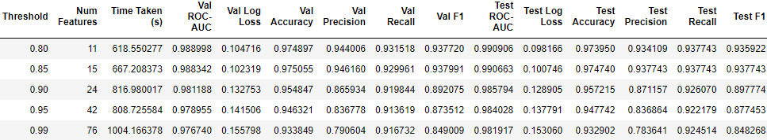

Figure : RF-M1: CFI Threshold Performance Metrics

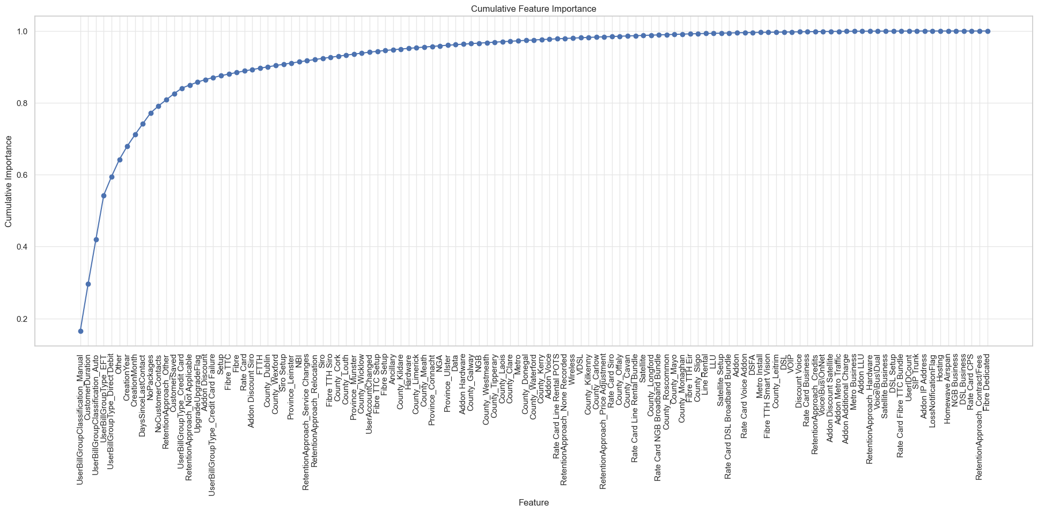

Figure : RF-M1: CFI Line Chart

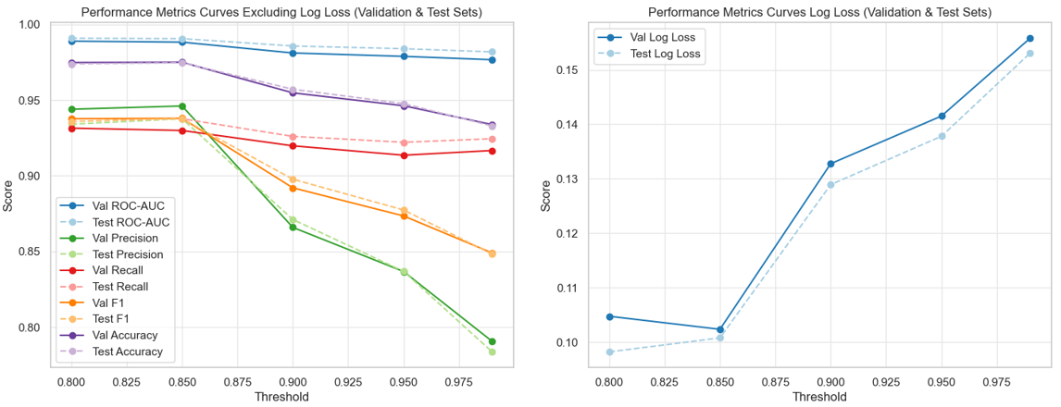

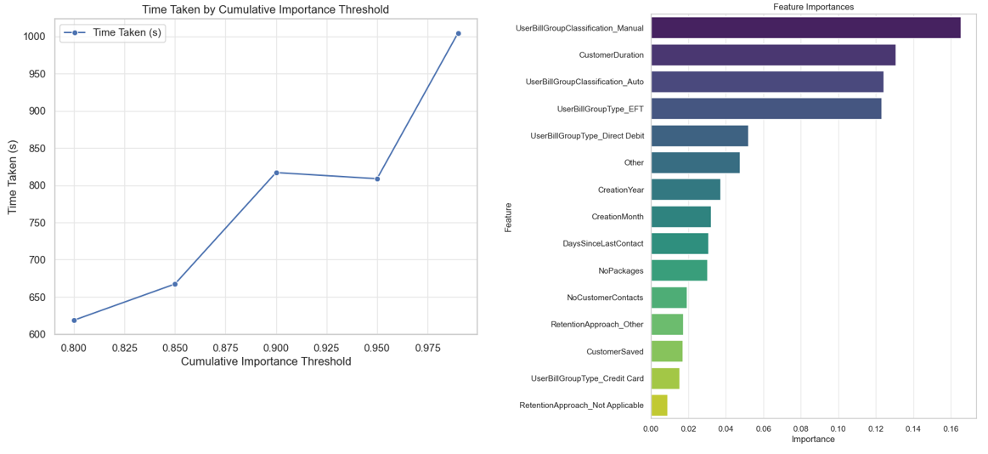

Figure : RF-M1: CFI Threshold Performance Metrics Charts

#### RF Model 2: Class Resampling Randomized Search Results

Class resampling methods were applied to the reduced dimensional dataset, followed by model training on a more comprehensive hyperparameter selection as outlined in the test design. Randomized Search and 5-fold cross-validation were employed, with model performance and optimal parameters documented, as shown in Figures: 74-76 below.

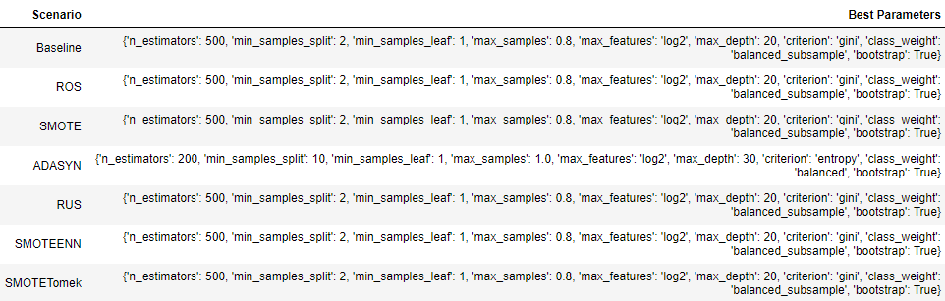

Figure : RF-M2: Class Resampling Randomized Search Best Parameters

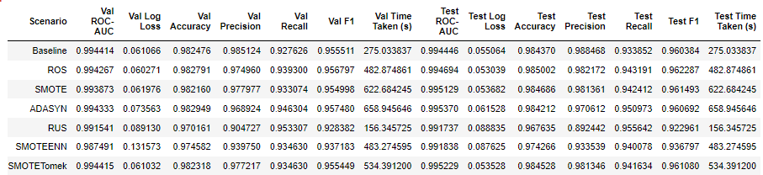

Figure : RF-M2: Class Resampling Randomized Search Performance Metrics

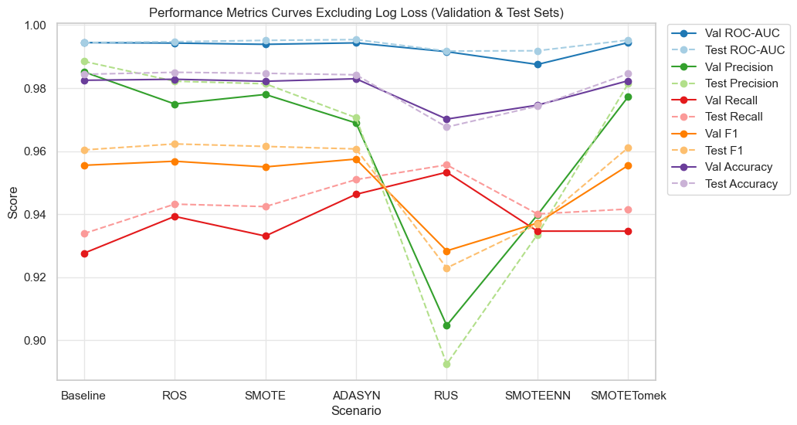

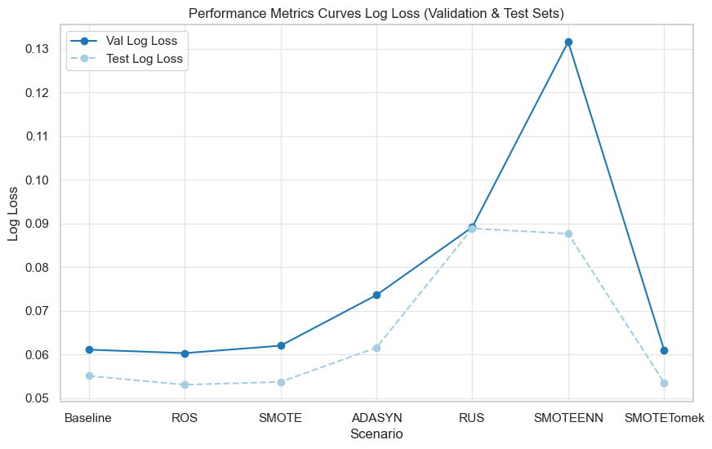

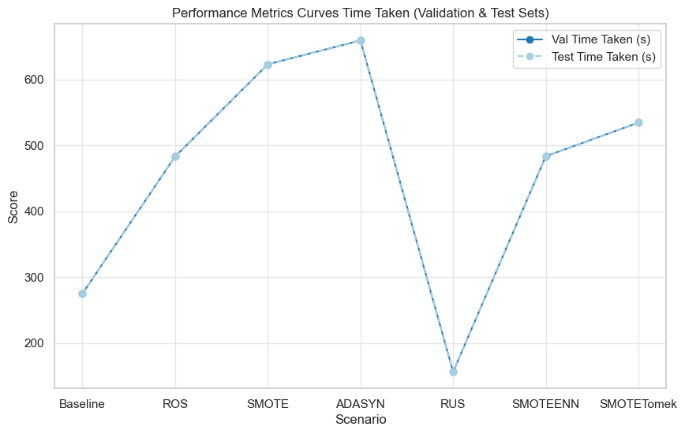

Figure : RF-M2: Class Resampling Randomized Search Performance Charts

#### RF Model 3: Class Resampling Grid Search Results

Model hyperparameters were refined as outlined in the test design to reduce model complexity and enhance generalisability. Grid Search and 5-fold cross-validation were employed, with model performance and optimal parameters documented, as shown in Figures: 77-80 below.

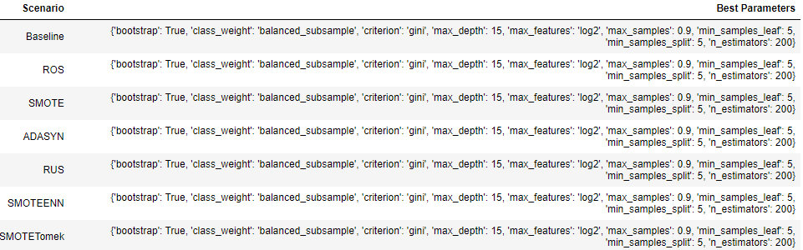

Figure : RF-M3: Class Resampling Grid Search Best Parameters

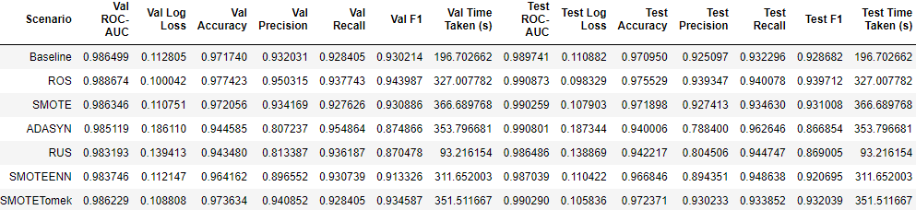

Figure : RF-M3: Class Resampling Grid Search Performance Metrics

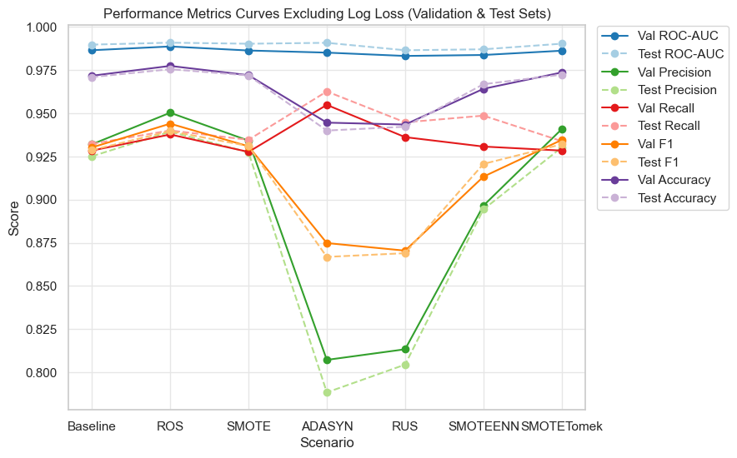

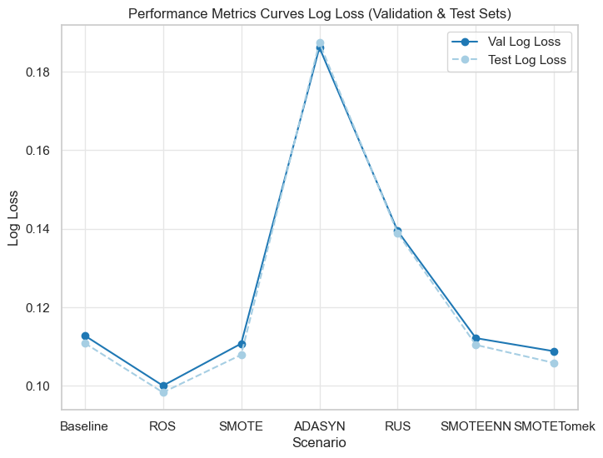

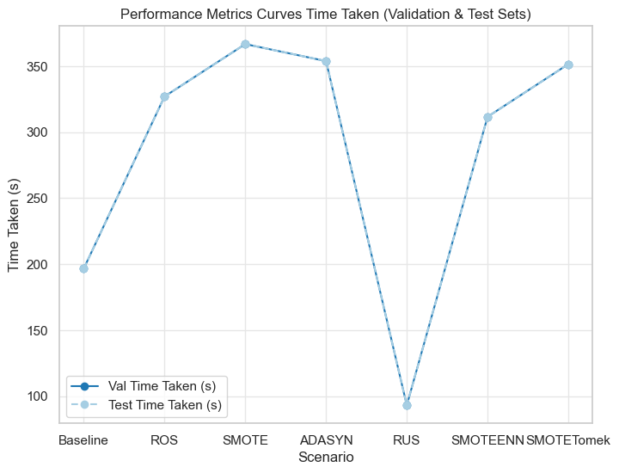

Figure : RF-M3: Class Resampling Randomized Search Performance Charts

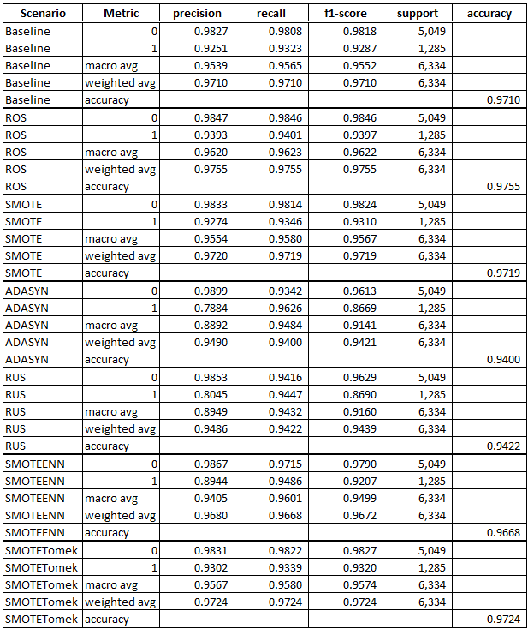

Figure : RF-M3: Class Resampling Grid Search Test Set Classification Report

### LightGBM Model Performance

#### LGBM Model 1: CFI Threshold Feature Importance Evaluation

A CFI threshold of 85% (15 features) was found to be optimal for LGBM, with aggregate performance metrics deteriorating beyond this point. Additionally, validation and test results were closely aligned at this threshold indicating a strong model fit, as shown in Figures 71-83 below.

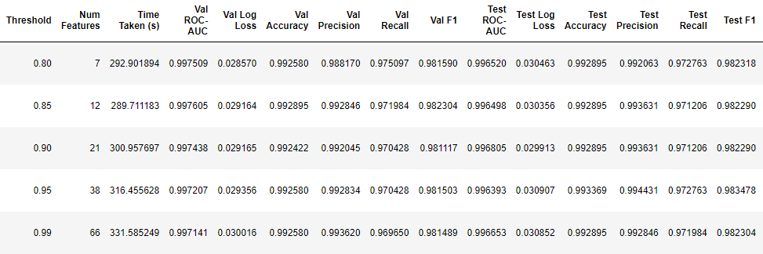

Figure : LGBM-M1: CFI Threshold Performance Metrics

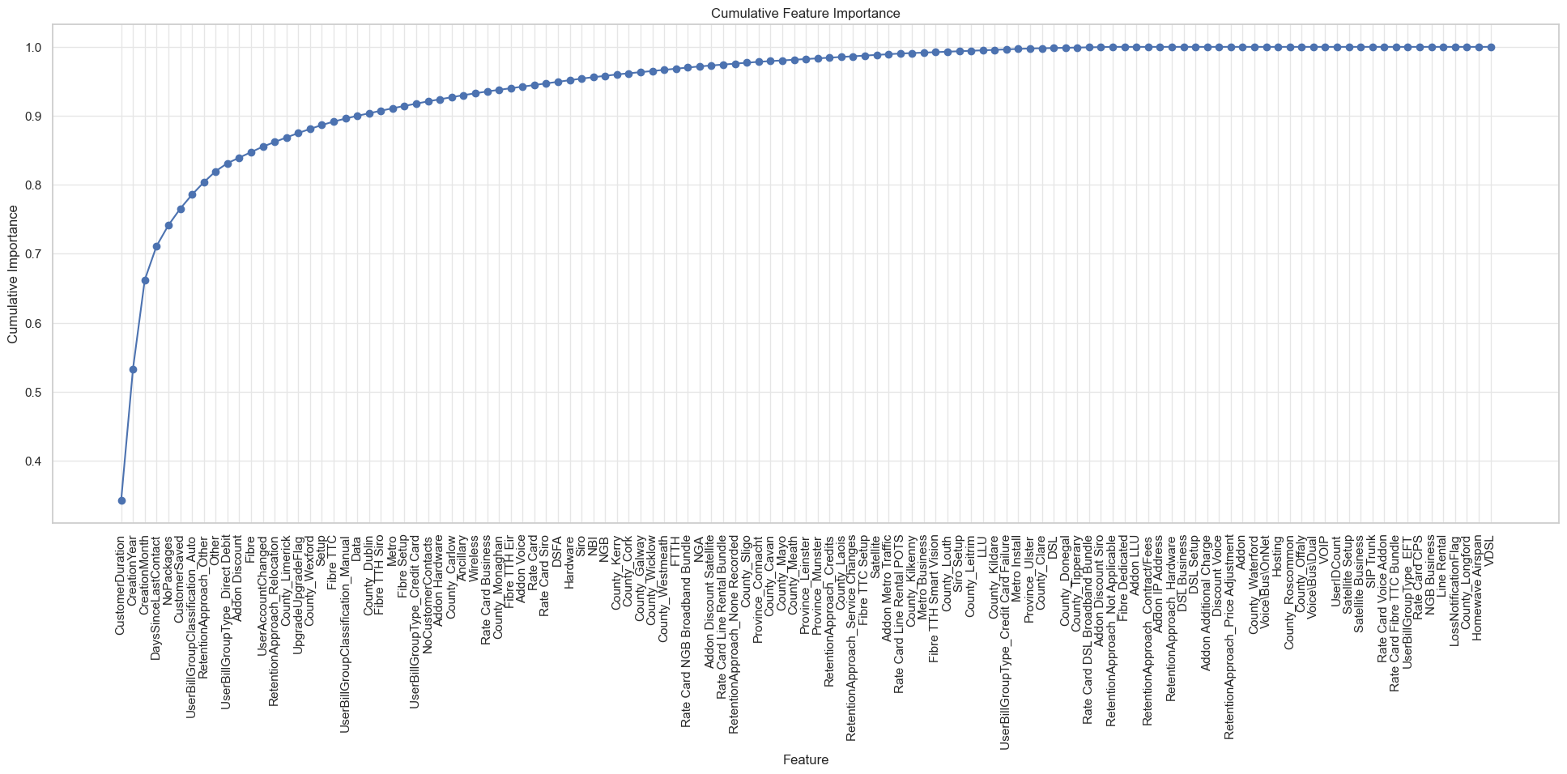

Figure : Figure 80: LGBM-M1: CFI Line Chart

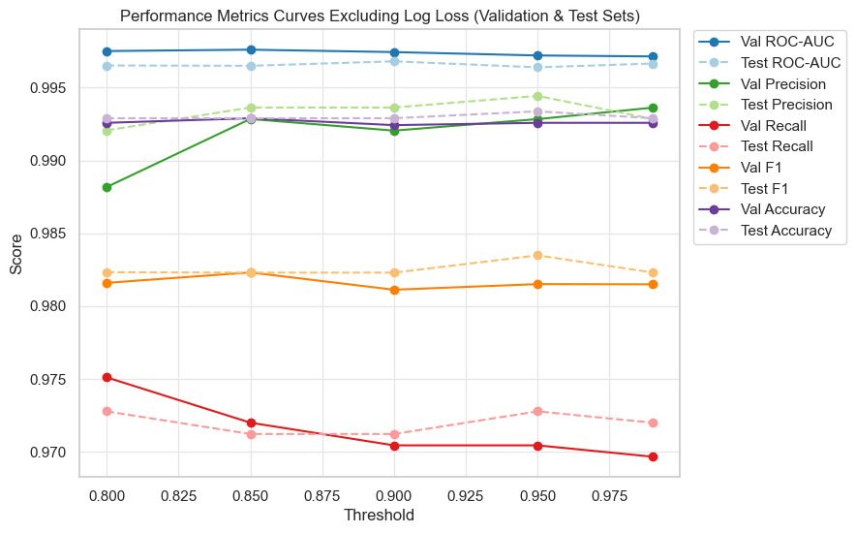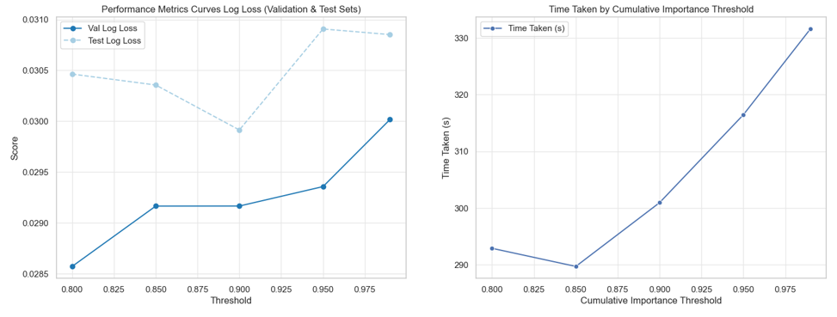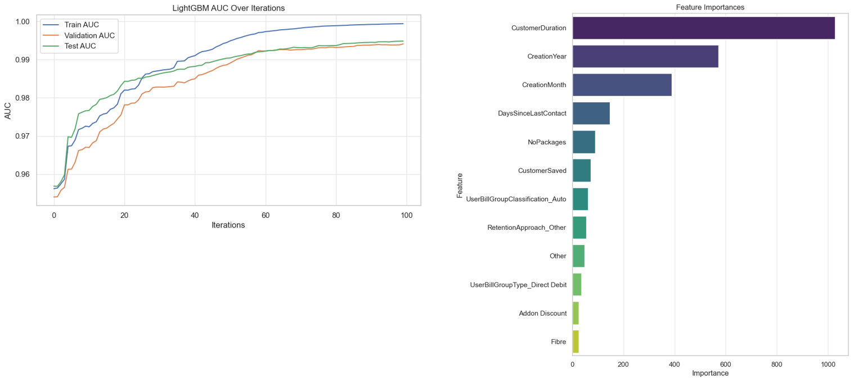

Figure : LGBM-M1: CFI Threshold Performance Metrics Charts

#### LGBM Model 2: Class Resampling Randomized Search Evaluation

Class resampling methods were applied to the reduced dimensional dataset, followed by model training on a more comprehensive hyperparameter selection as outlined in the test design. Randomized Search and 5-fold cross-validation were employed, with model performance and optimal parameters documented, as shown in Figures: 74-76 below.

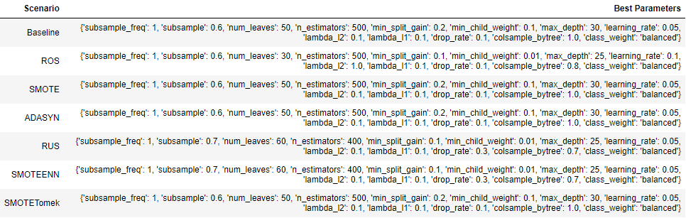

Figure : LGBM-M2: Class Resampling Randomized Search Best Parameters

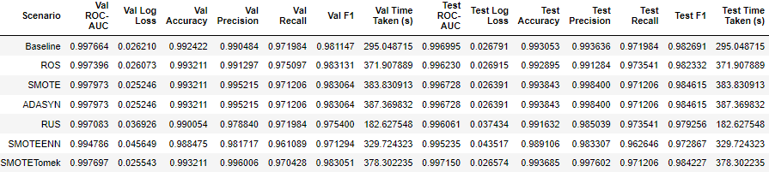

Figure : LGBM-M2: Class Resampling Randomized Search Performance Metrics

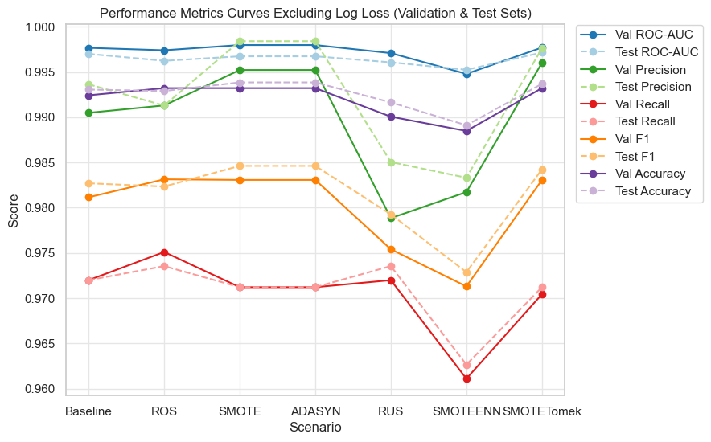

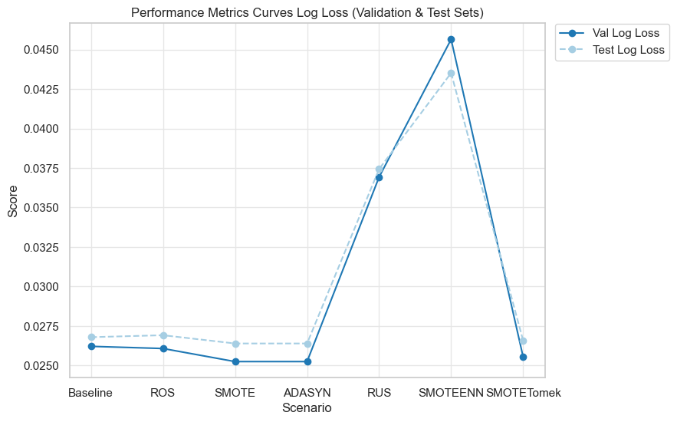

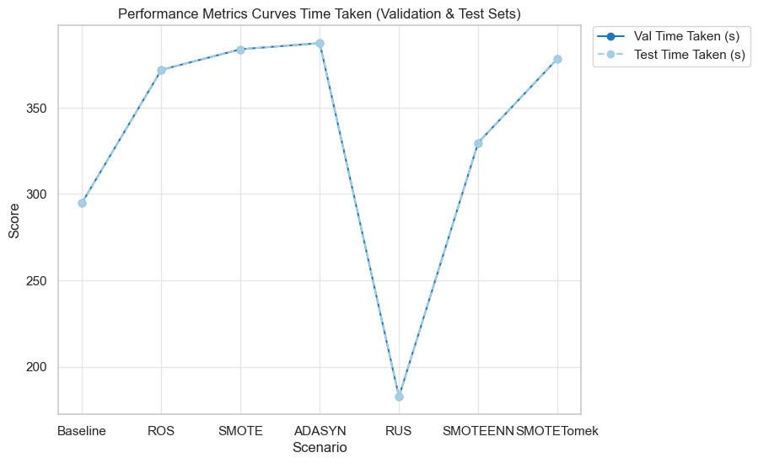

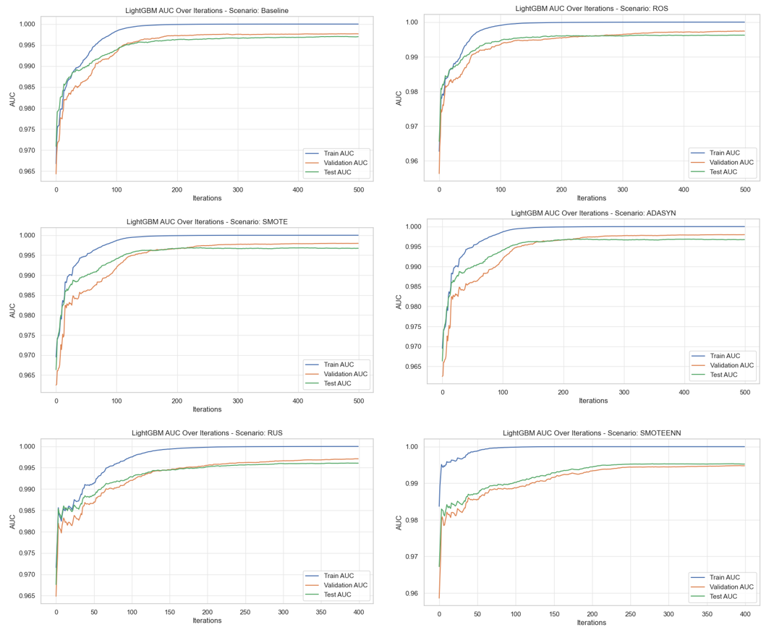

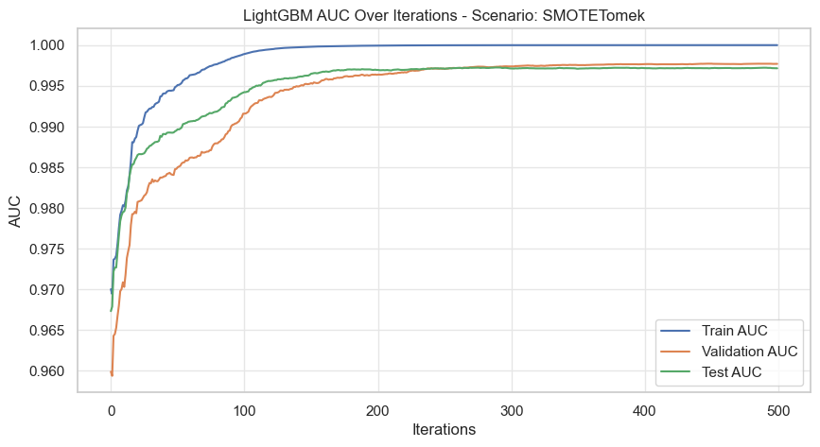

Figure : LGBM-M2: Class Resampling Randomized Search Performance Charts

#### LGBM Model 3: Class Resampling Grid Search Evaluation

Model hyperparameters were refined as outlined in the test design to reduce model complexity and enhance generalisability. Grid Search and 5-fold cross-validation were employed, with model performance and optimal parameters documented, as shown in Figures: 87-91 below:

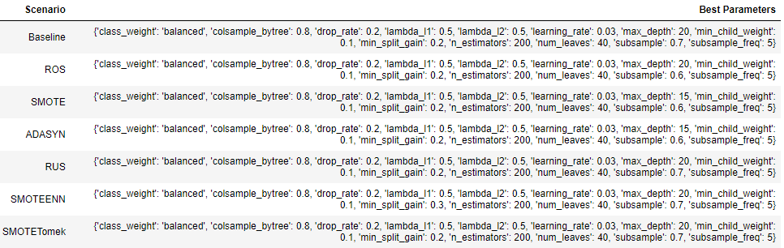

Figure : LGBM-M3: Class Resampling Grid Search Best Parameters

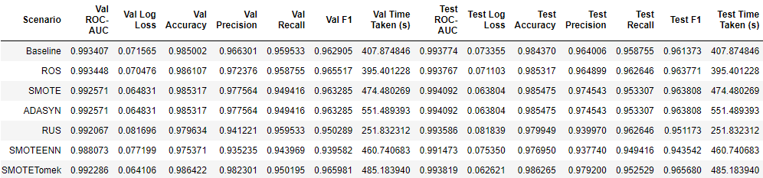

Figure : LGBM-M3: Class Resampling Grid Search Performance Metrics

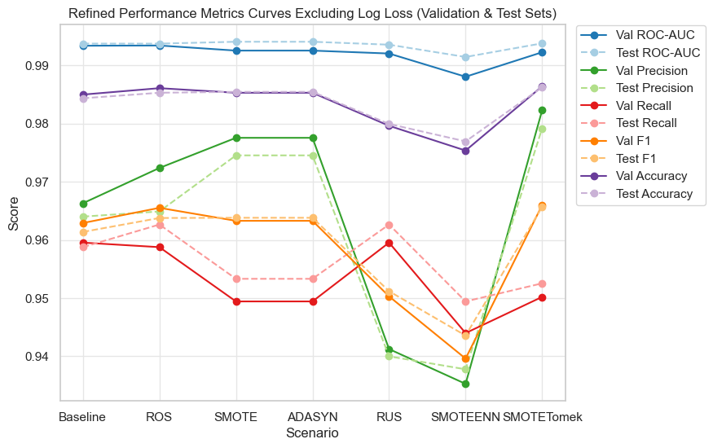

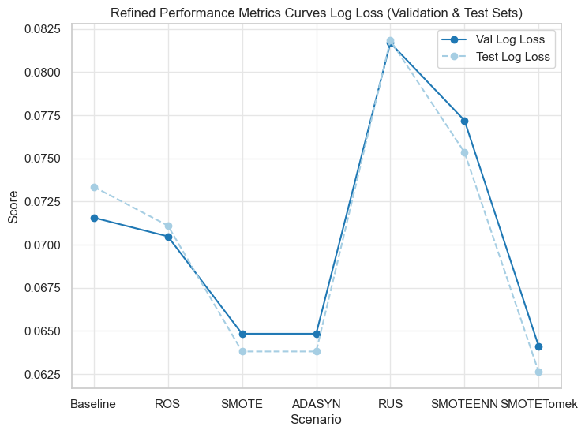

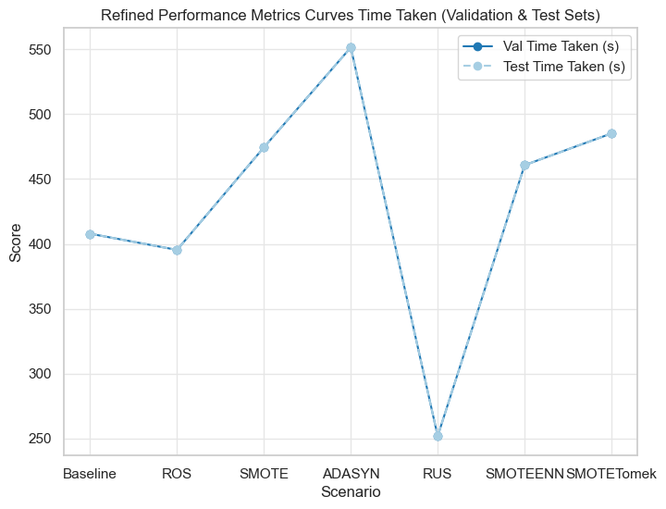

Figure : LGBM-M3: Class Resampling Randomized Search Performance Charts

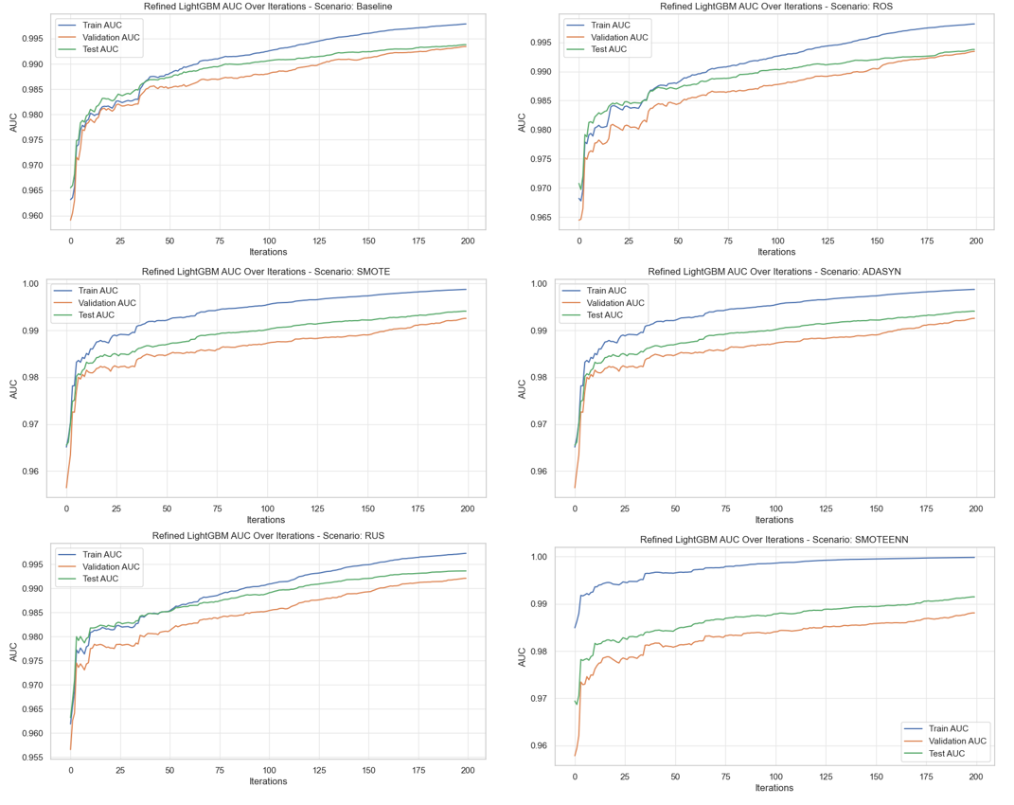

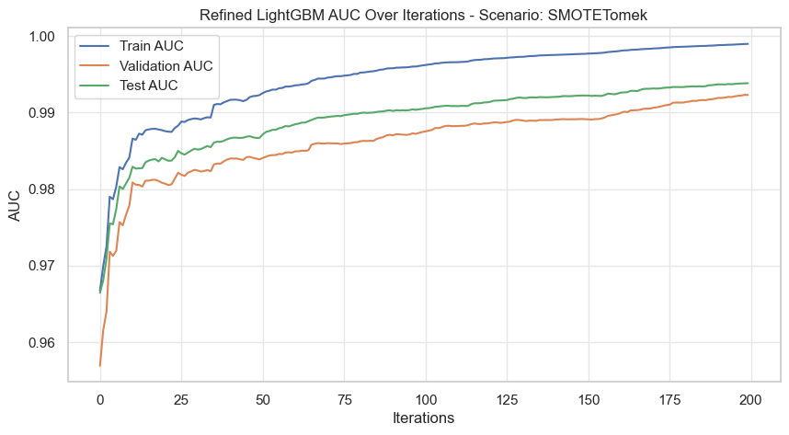

Figure : LGBM-M3: Class Resampling Randomized Search Performance Charts

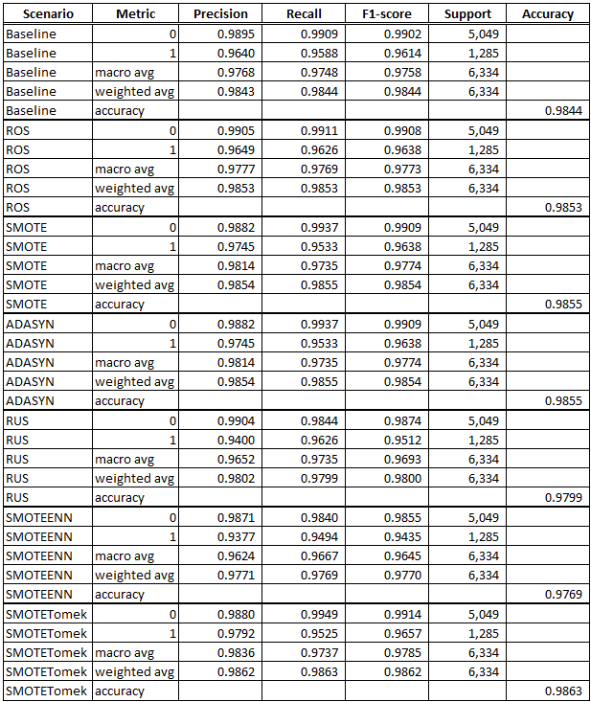

Figure : LGBM-M3: Class Resampling Grid Search Test Set Classification Report

### XGBoost Model Performance

#### XGB Model 1: CFI Threshold Feature Importance Evaluation

A CFI threshold of 85% (17 features) was found to be optimal for XGB, with aggregate performance metrics deteriorating beyond this point. Additionally, validation and test results were closely aligned at this threshold indicating a strong model fit, as shown in Figures 92-94 below.

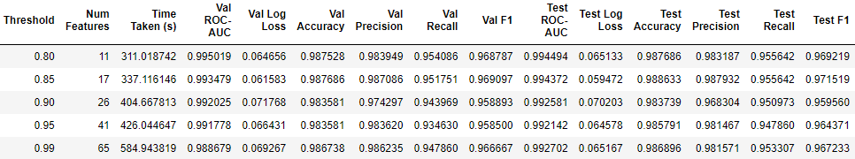

Figure : XGB-M1: CFI Threshold Performance Metrics

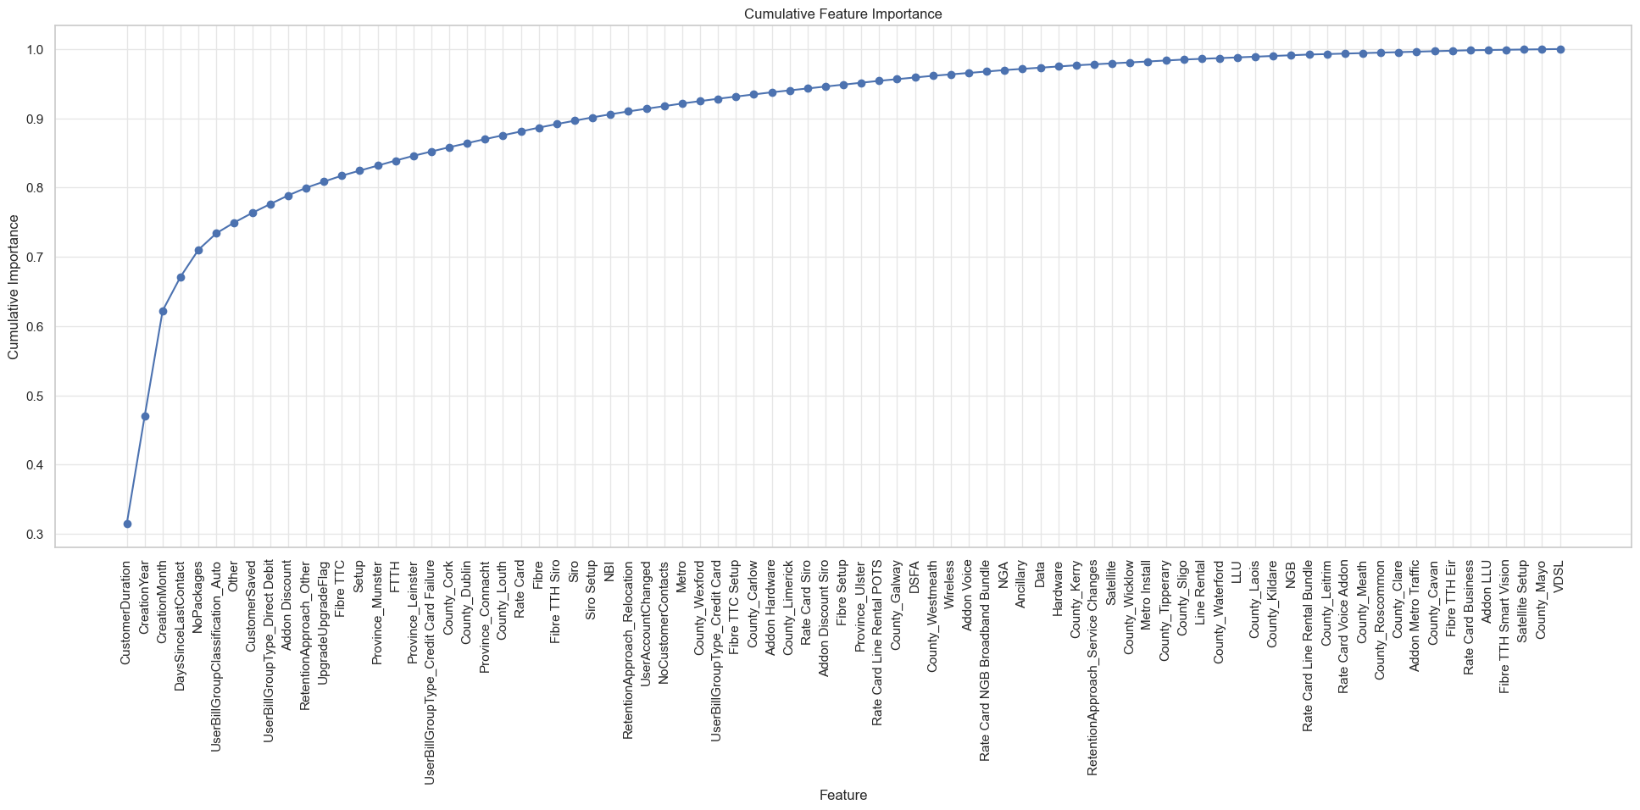

Figure : XGB-M1: CFI Line Chart

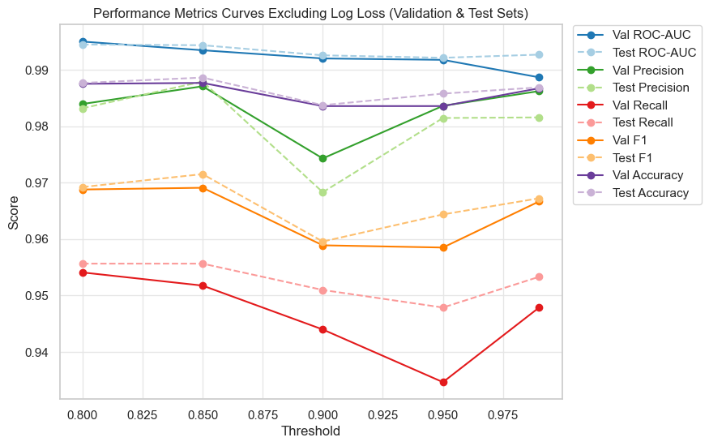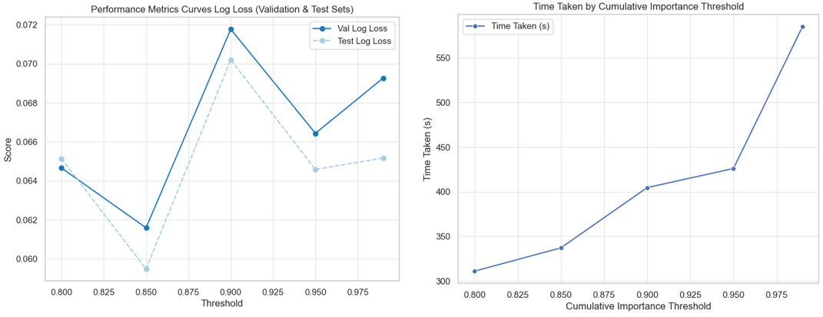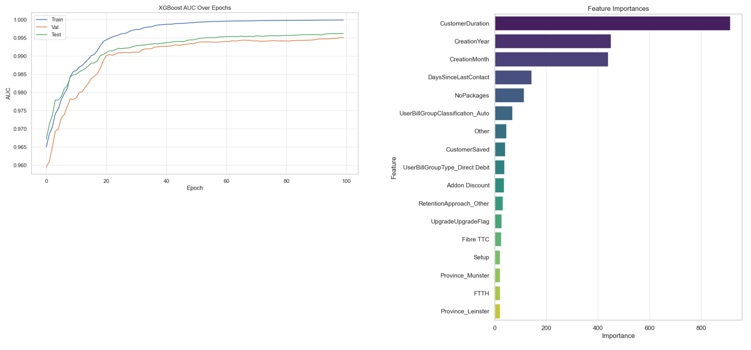

Figure : XGB-M1: CFI Threshold Performance Metrics Charts

#### XGB Model 2: Class Resampling Randomized Search Evaluation

Class resampling methods were applied to the reduced dimensional dataset, followed by model training on a more comprehensive hyperparameter selection as outlined in the test design. Randomized Search and 5-fold cross-validation were employed, with model performance and optimal parameters documented, as shown in Figures: 95-97 below.

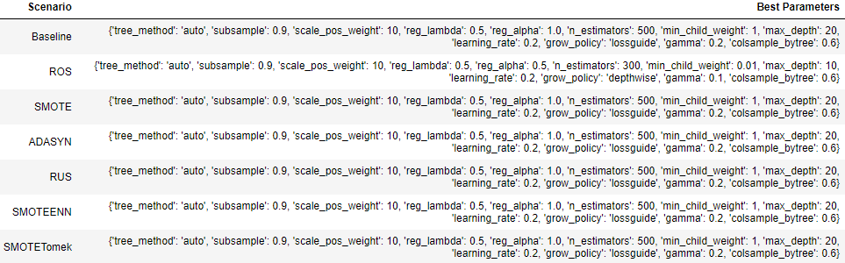

Figure : XGB-M3: Class Resampling Grid Search Best Parameters

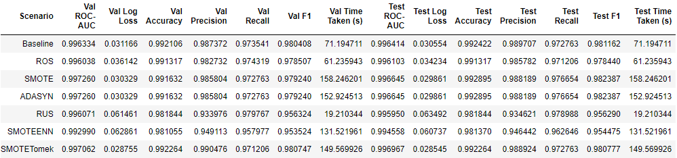

Figure : XGB-M3: Class Resampling Randomized Search Performance Metrics

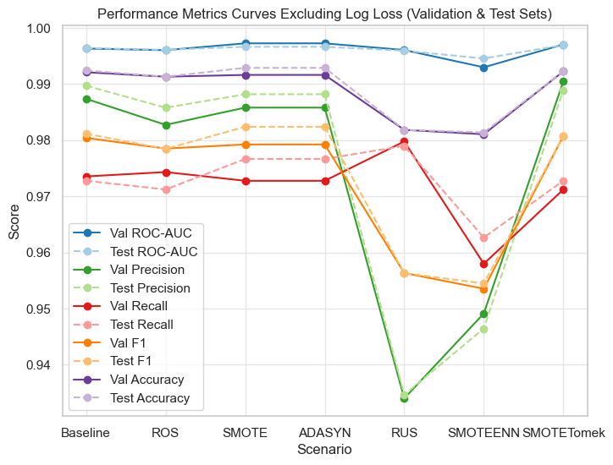

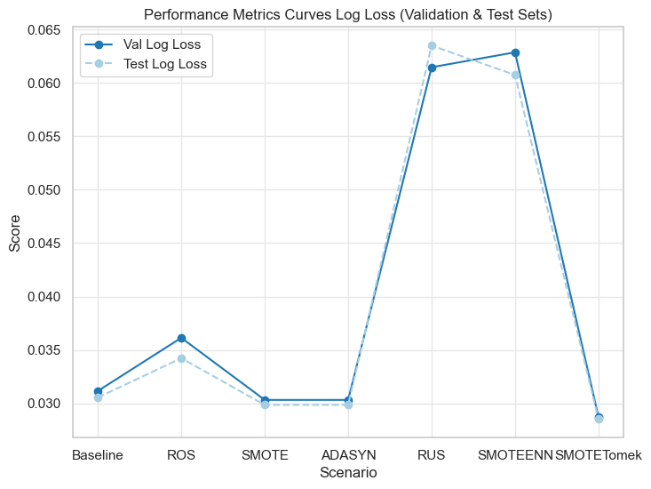

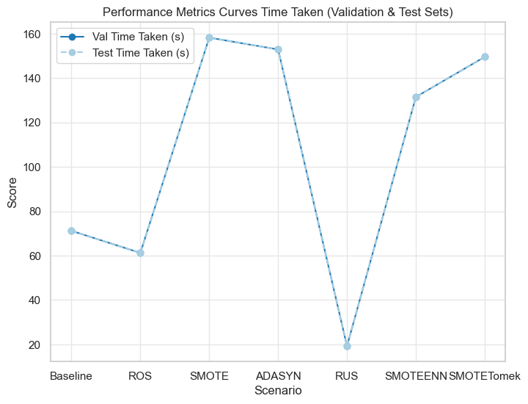

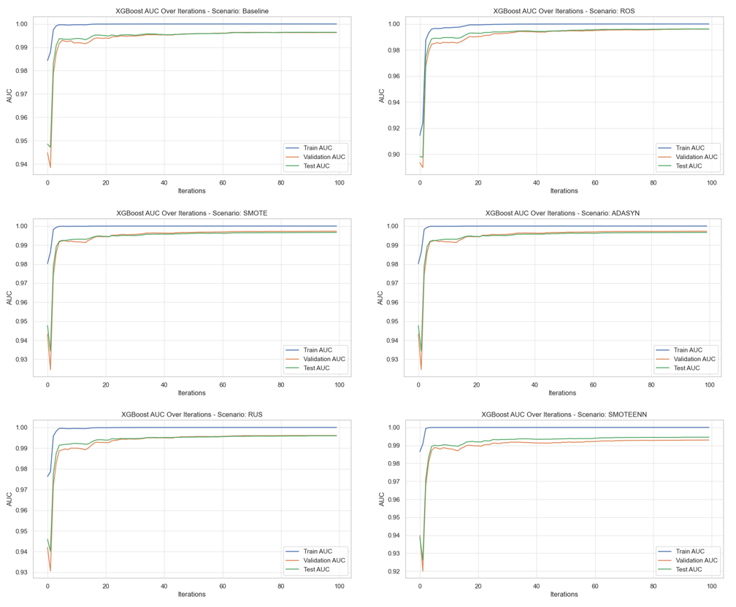

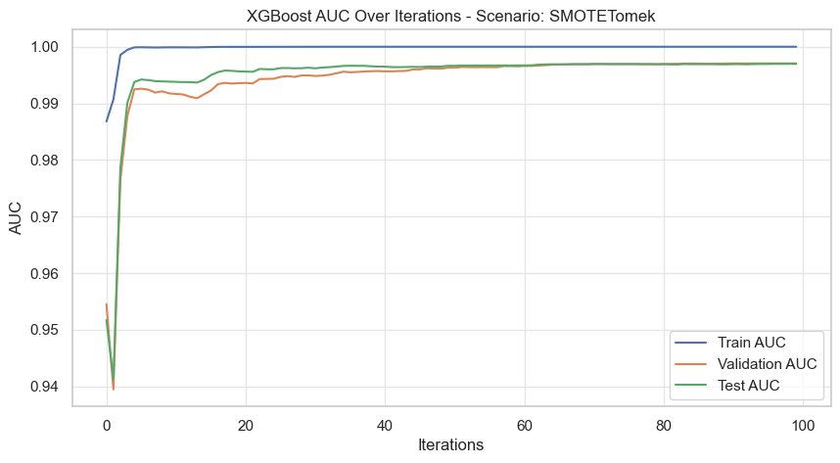

Figure : XGB-M2: Class Resampling Randomized Search Performance Charts

#### XGB Model 3: Class Resampling Grid Search Evaluation

Model hyperparameters were refined as outlined in the test design to reduce model complexity and enhance generalisability. Grid Search and 5-fold cross-validation were employed, with model performance and optimal parameters documented, as shown in Figures: 98-101 below.

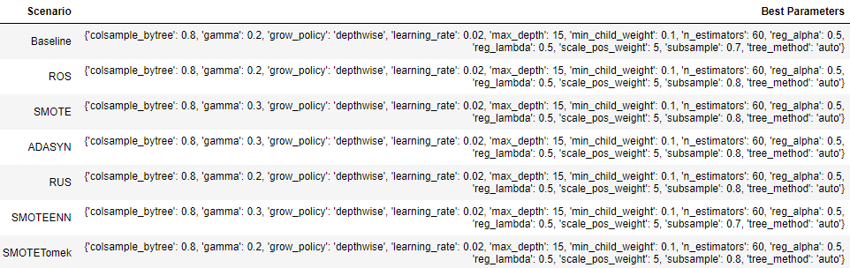

Figure : XGB-M3: Class Resampling Grid Search Best Parameters

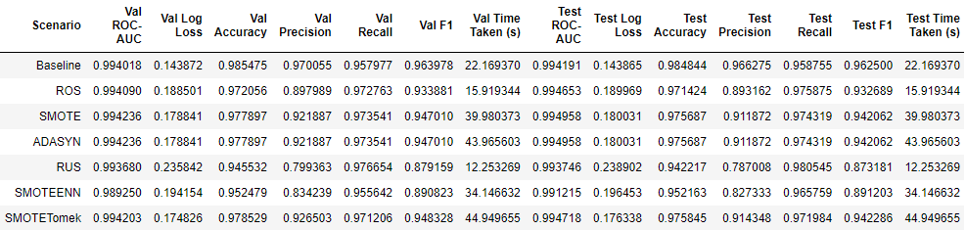

Figure : XGB-M3: Class Resampling Grid Search Performance Metrics

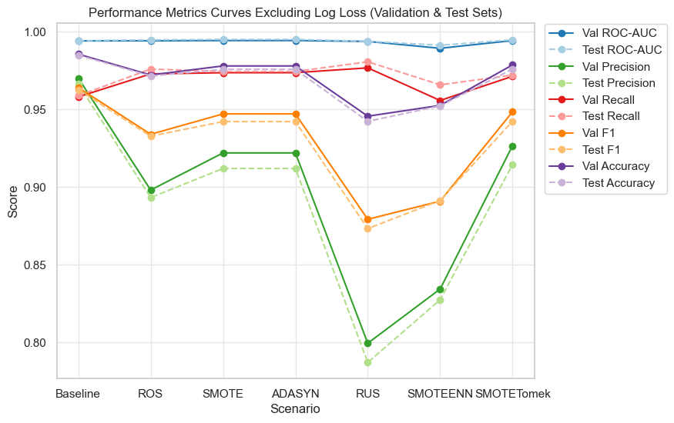

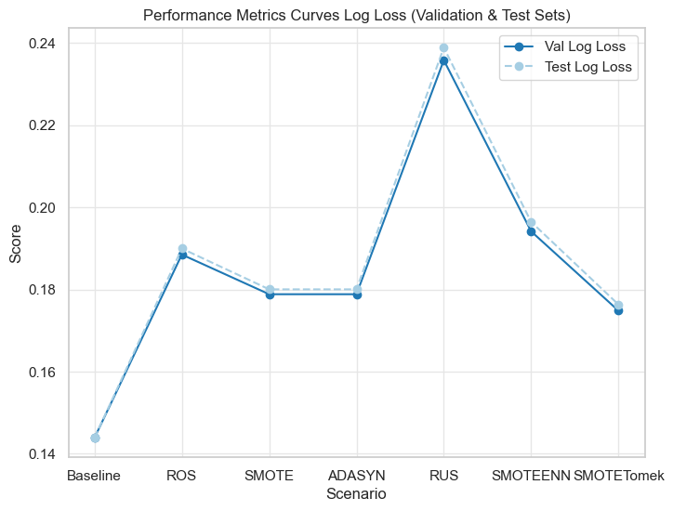

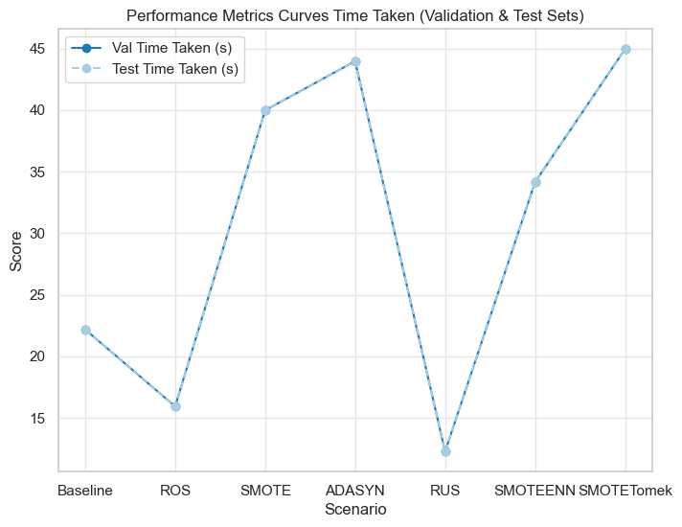

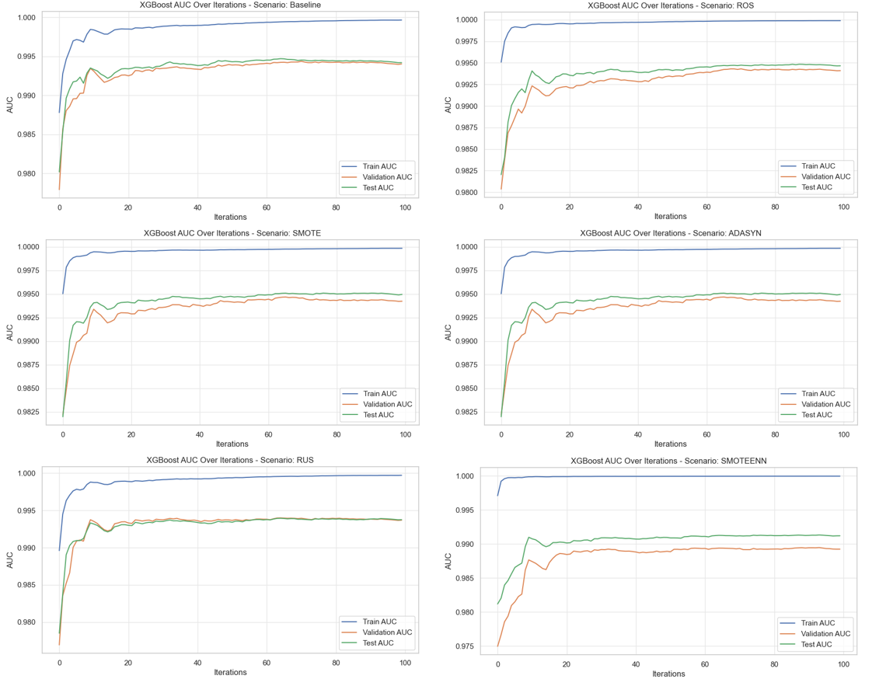

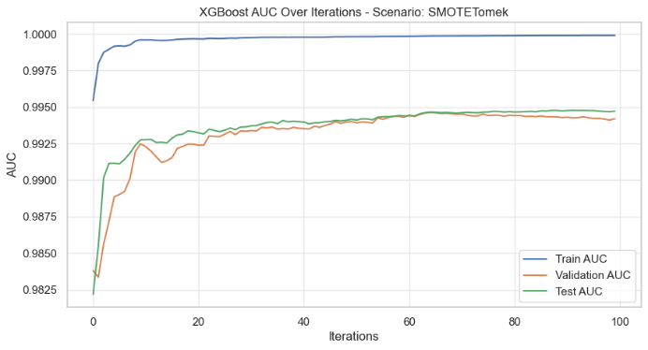

Figure : XGB-M3: Class Resampling Randomized Search Performance Charts

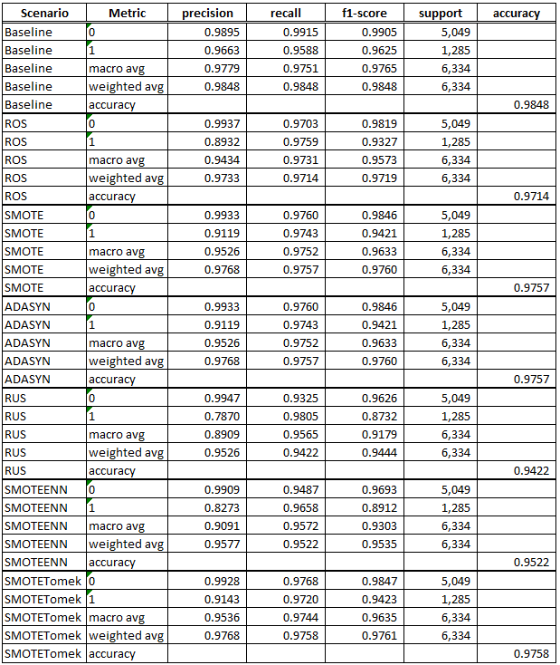

Figure : XGB-M3: Class Resampling Grid Search Test Set Classification Report

## Evaluation Summary

### Model 1 Evaluation Summary

Initial CFI evaluation found that RF, LGBM and XGB all captured a significant portion of feature importance within a small subset of features, with 85% selected as the optimal CFI threshold that balanced model performance and complexity whilst avoiding model performance deterioration observed at higher threshold. The average number of features at this threshold varied per model, with an average of approximately 14, with LGBM being the lowest at 12 features, followed by RF at 15 and XGB at 17. Comparison of specific features found approximately half (52%) were represented across models (23 out of 44), which indicated a small, consistent set of features that were significant in this research, as shown in Figure 102 below.

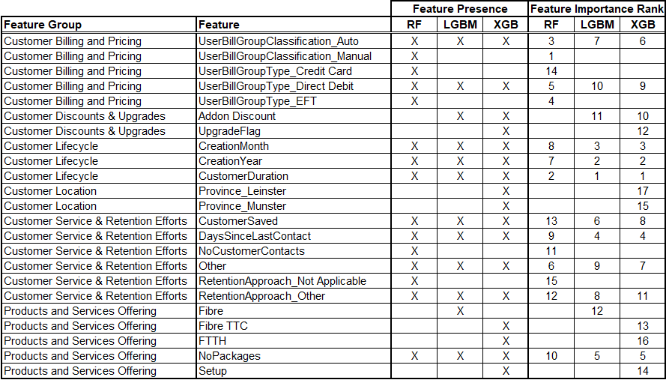

Figure : M1 Features at CFI 85% Importance Threshold

### Model 2 Evaluation Summary

M2 evaluation focused primarily on aggregate model performance in relation to test set data, with a more granular evaluation of model performance conducted in M3.

**AUC and Accuracy:**

All three ML models demonstrated promising test performance results following initial hyperparameter tuning, though with several key differences. All models recorded excellent overall aggregate AUC around 99%, and accuracy ranging from about 97% to 99%, making them well suited to predicting both the majority and minority class.

**Training Time:**

Model training time varied based on the combination of ML model and class resampling method, with XGB models recording the fastest training times on average at 106.27s, followed by LGBM at 332.69s and RF at 1,004.32s, which demonstrated the improved efficiency of boosting models when compared to bagging models. RUS was the quickest to train on average at 179.00s, followed by baseline 255.64s, combined sampling methods (SMOTEENN; SMOTETomek) around 553.15s and oversampling (ROS; SMOTE and ADASYN) about 608.91s. All XGB ML models recorded faster training times than LGBM and RF, with XGB-RUS the shortest at 19.21s and RF-ADASYN the longest to train at 1,557.03 which highlight a large disparity in training times.

**Precision:**

Several models demonstrated high precision, with baseline, oversampling (ROS, SMOTE, ADASYN) and SMOTETomek recording high precision across all models (RF, LGBM and XGB) at around 97% or greater, meaning that these models are proficient at limiting false positives when making predictions. RF and XGB models were considerably less precise when RUS and SMOTEENN resampling was used (RF-RUS at 89.24%; RF-SMOTEENN at 93.35%;, XGB-RUS at 93.46% and XGB-SMOTEENN at 94.64%). LGBM however didn’t demonstrate the same limitation with LGBM-RUS at 98.50% and LGBM-SMOTEENN at 98.33%, which indicated that LGBM models do not predict nearly as many false positives as their RF and XGB counterparts.

**Recall:**

RF models generally returned the highest number of false positives across different sampling methods, with RF-Baseline recording the lowest recall at 93.4%, followed by RF-ROS; RF-SMOTE; RF-ADASYN; RF-SMOTEEN and RF-SMOTETomek between approximately 94% and 95%. RF-RUS had the highest RF recall at 95.56% which indicated that it captured almost all instances of each class. LGBM and XGB were comparable, though XGB returned slightly higher recall with XGB-SMOTE; XGB-ADASYN and XGB-RUS around 98%, compared to LGBM-SMOTE; LGBM-ADASYN and LGBM-RUS at about 97%. However, minimal difference was observed among remaining models, with LGBM and XGB recording around 97% recall for baseline, ROS and SMOTETomek combinations and about 96% for SMOTEENN.

**F1-score:**

Whilst F1-score performance was generally high, RF returned the lowest scores on average across all resampling methods, with the lowest score recorded by RF-RUS at 92.30%, and the highest recorded by RF-ROS; RF-SMOTE; RF-ADASYN and RF-SMOTETomek at approximately 96%. LGBM and XGB models demonstrated comparable performance, with baseline, ROS; SMOTE; ADASYN and SMOTETomek methods all scoring around 98%. However, LGBM had a slight edge compared to XGB, specifically with RUS (LGBM-RUS at 97.93%; XGB-RUS at 95.63%) and SMOTEENN (LGBM-SMOTTEEN at 97.29% and XGB-SMOTEENN at 95.45%) methods.

**Log Loss:**

LGBM models recorded the most confident and reliable results, with the lowest log loss at 0.03057, followed by LGBM at 0.03961 and RF at 0.06476. Comparison of class resampling methods found SMOTEENN (0.06396) and RUS (0.06325) recording the highest loss on average, though at the lower end of results little difference was found with LGBM-SMOTE; LGBM-ADASYN; LGBM-SMOTETomek; LGBM-Baseline and LGBM-ROS all recording the lowest loss at around 0.026.

### Model 3 Evaluation Summary

M3 evaluation focused on granular analysis of model performance, specifically related to the predictive capabilities of the minority class. Evaluation found all three models demonstrated promising test performance results following further hyperparameter tuning aimed at improving model robustness and generalisation capabilities.

**Class 1 – Minority Class Prediction:**

**Precision:**

LGBM ML models demonstrated significantly higher precision on average with 96.21%, with both XGB and RF recording on average around 88%. Overall class resampling evaluation found baseline model performance was the best on average at 95.18%, followed by SMOTETomek at 94.13%, oversampling methods SMOTE, ROS around 93%, ADASYN at 89.16%, and the lowest performing, SMOTEENN at 88.65% and RUS at 84.38%. All seven of LGBM’s resampling methods were in the top nine out of twenty-one model combinations, with the top five models observed as LGBM-SMOTETomek (97.92%); LGBM-SMOTE (97.45%); LGBM-ADASYN (97.45%); XGB-Baseline (96.63%) and LGBM-ROS (96.49%). RF and XGB’s average precision was impacted by lower performing resampling methods, with the five least precise models being XGB-RUS (78.70%) RF-ADASYN (78.84%); RF-RUS (80.45%); SMOTEENN (82.73%) and ROS (89.32%). Overall scenario results are visualised in Figure 103 below.

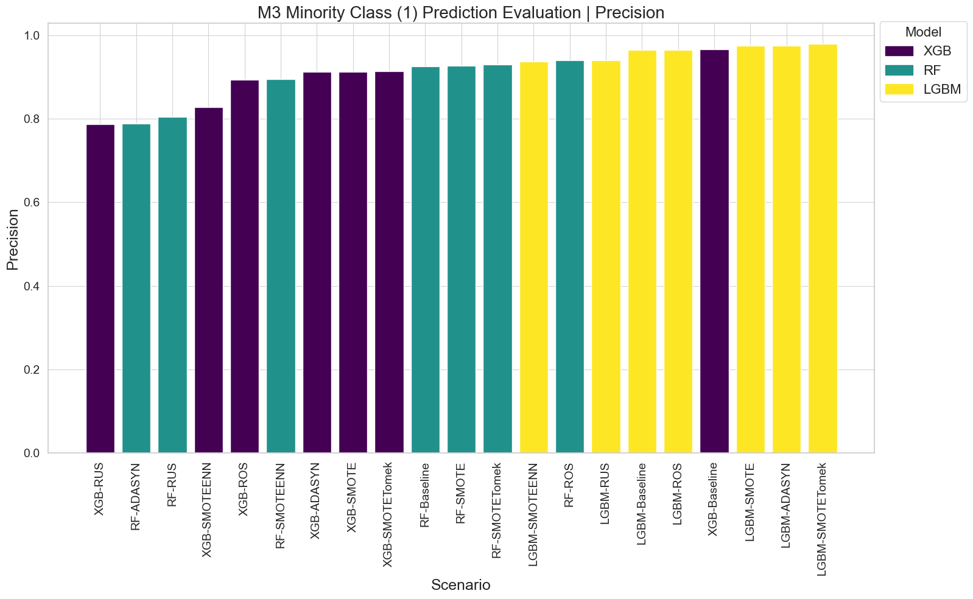

Figure : M3 Minority Class (1) Prediction Evaluation | Precision

**Recall:**

XGB demonstrated the performance on average at 97.17%, followed by LGBM at 95.61% and RF at 94.24%. Overall class resampling evaluation found ADASYN was the best on average at 96.34%, followed by RUS at 96.26%; ROS; SMOTEENN; SMOTE; SMOTETomek at about 95% and baseline at 94.99%. XGB had the top six performing models, with XGB-RUS predicting almost all instances of the minority class at 98.05%, oversampling methods (XGB-ROS; XGB-SMOTE; XGB-ADASYN and XGB-SMOTETomek averaged approximately 97%, with XGB-SMOTEENN at 96.58%, all of which outperformed XGB-Baseline performance of 95.88%. LGBM demonstrated competitive recall with LGBM-ROS and LGBM-RUS models at 96.26%, only slightly higher than LGBM-Baseline; LGBM-SMOTE; LGBM-ADASYN and LGBM-SMOTETomek at about 95%, with LGBM-SMOTEENN returning the lowest LGBM performance at 94.94%. Six of seven RF models were in the bottom seven performing models, RF-Baseline being the lowest at 93.23%, followed by RF-SMOTETomek and RF-SMOTE at around 93%; RF-ROS; RF-RUS; RF-SMOTEENN at about 94%, and a notable outlier RF-ADASYN at 96.26%. Overall scenario results are visualised in Figure 104 below.

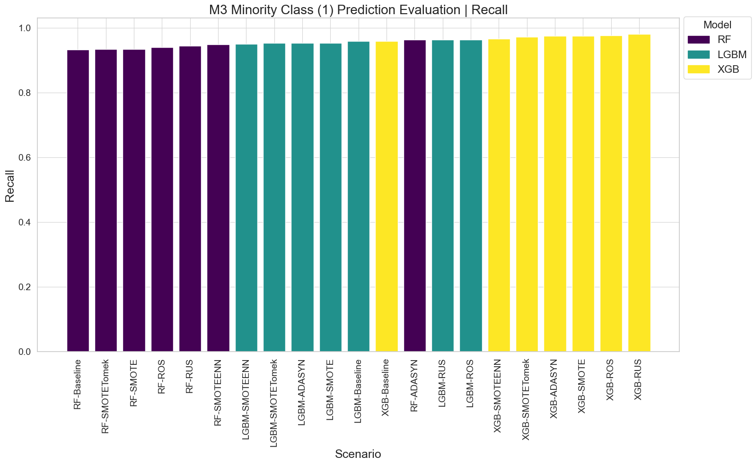

Figure : M3 Minority Class (1) Prediction Evaluation | Recall

**F1-score:**

LGBM models demonstrated the most balanced performance on average with a F1-score of 95.90%, followed by XGB at 92.66% and RF at 91.26%. Overall class resampling performance found baseline model performance was the best on average at 95.09%, followed by SMOTETomek; SMOTE and ROS at around 94%, ADASYN at 92.42%, with the lowest performing methods being SMOTEENN at 91.85% and RUS at 89.78%. LGBM models were in the top eight performing, with the top five models being LGBM-SMOTETomek (96.57%); LGBM-SMOTE (96.38%); LGBM-ADASYN (96.38%); XGB-Baseline (96.38%) and LGBM-Baseline (96.25%). RF and XGB’s average F1-score was impacted by lower performing resampling methods, with the five least precise models being RF-ADASYN (86.69%); RF-RUS (86.90%); XGB-RUS (87.32%); XGB-SMOTEENN (89.12%) and RF-ROS (92.07%). Overall scenario results are visualised in Figure 105 below.

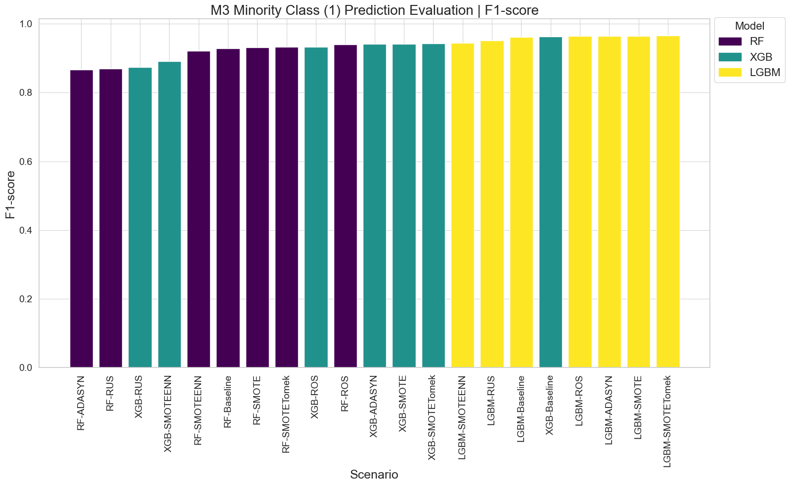

Figure : M3 Minority Class (1) Prediction Evaluation | F1-score

**Class 0 – Majority Class Prediction**

The majority of models demonstrated strong performance when predicting the majority class, with LGBM recording the highest F1-score on average at 98.96%, followed by XGB at 97.97% and RF at 97.64%. Overall class resampling performance evaluation found baseline models to be the best on average at 98.75%, followed by SMOTETomek; SMOTE; ROS at approximately 98%, and ADASYN; SMOTEENN; RUS at around 97%. Overall scenario results are visualised in Figure 106 below.

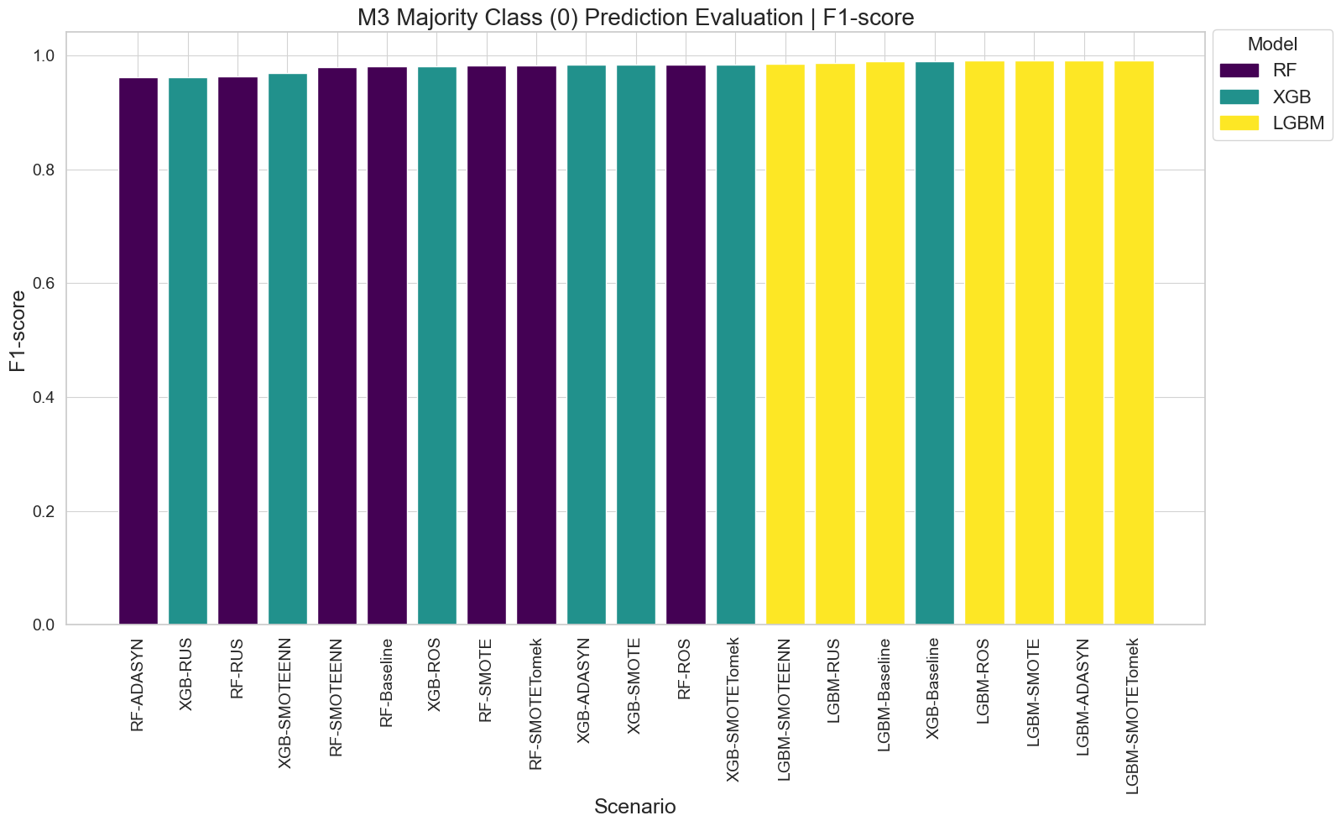

Figure : M3 Majority Class (0) Prediction Evaluation | F1-score

**Weighted Averages:**

The majority of models demonstrated strong performance when predictions of both majority and minority class predictions were considered. LGBM models recorded the best overall F1-score performance with an average of 98.34%, followed by XGB at 96.90% and RF at 96.34%. Overall class resampling performance evaluation of F1-score found baseline model performance to be the best on average at 98.01%, followed by SMOTETomek; SMOTE; ROS at approximately 97%, ADASYN and SMOTEENN at around 96% and RUS at about 95%. Overall scenario results are visualised in Figure 107 below.

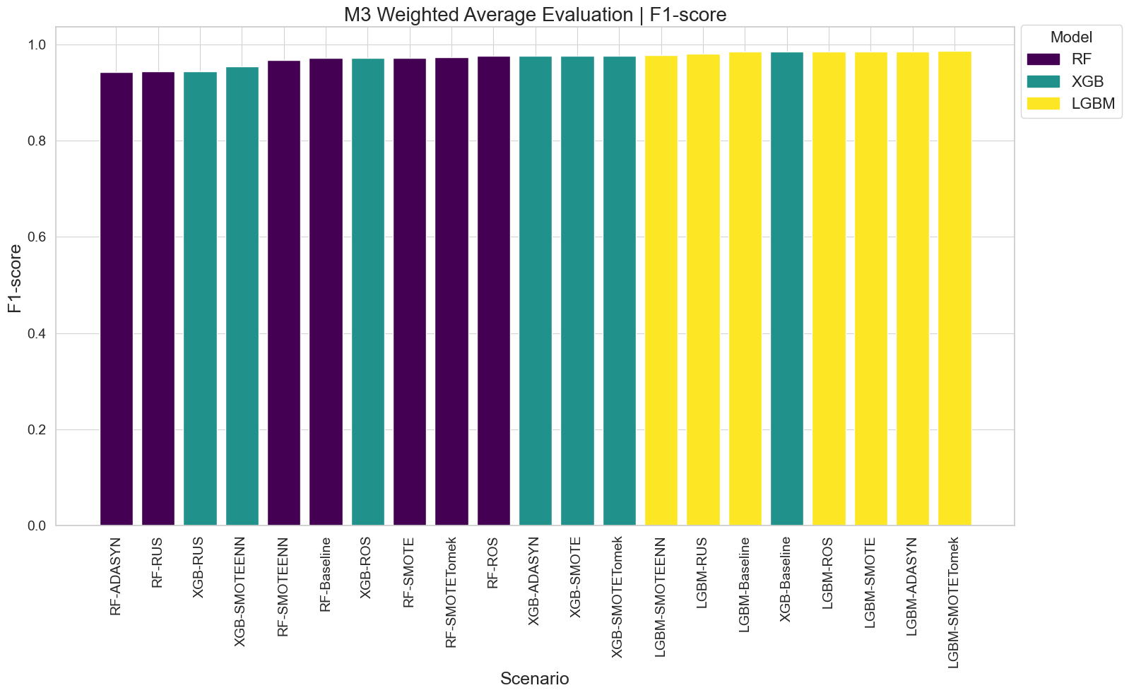

Figure : M3 Weighted Average Evaluation | F1-score

**Accuracy:**

The majority of models demonstrated strong accuracy when predictions of both majority and minority class predictions were considered. LGBM models recorded the best overall accuracy performance with an average of 98.34%, followed by XGB at 96.83% and RF at 96.28%. Overall class resampling performance evaluation of accuracy found baseline model performance to be the best on average at 98.01%, followed by SMOTETomek, SMOTE, ROS at approximately 97%, ADASYN and SMOTEENN at around 96% and RUS at 95.48%. LGBM-SMOTETOMEK was the most accurate model at 98.63%, with the least accurate model found to be RF-ADASYN at 94.00%. Overall scenario results are visualised in Figure 108 below.

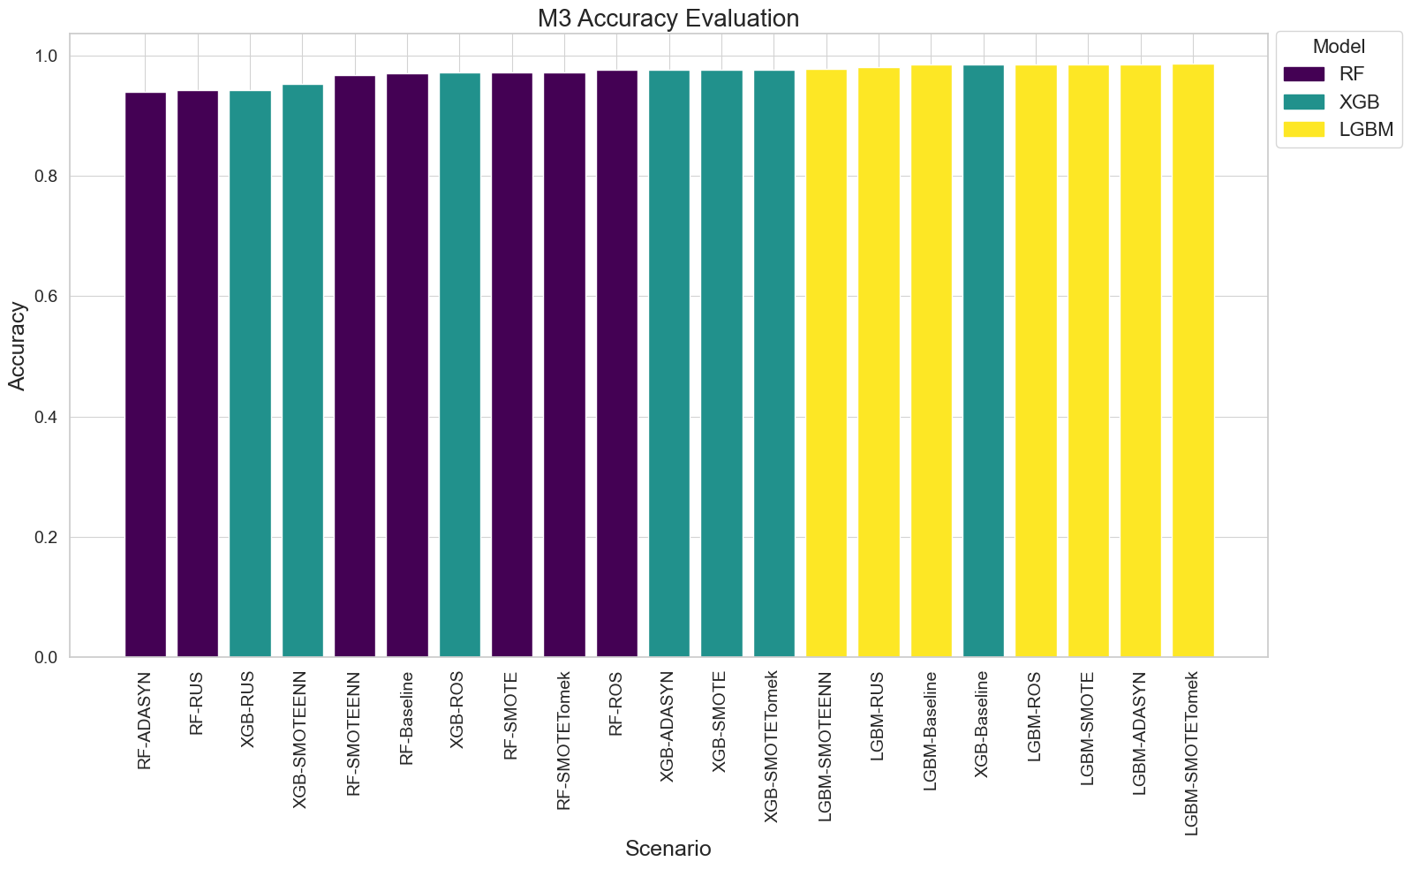

Figure : M3 Accuracy Evaluation

**Log Loss:**

Model log loss varied based on the combination of ML model and class resampling method, with LGBM models recording the lowest loss on average at 0.010038, followed by RF at 0.017543 and XGB at 0.026645, which demonstrated the superior training efficiency of LGBM when it comes to reliable and confident predictions. Baseline recorded the lowest loss on average at 0.015624, followed SMOTETomek, SMOTE at around 0.016, ROS at 0.017114, SMOTEENN at 0.018201, and ADASYN, RUS at about 0.02. All LGBM models recorded the lowest loss, with LGBM-SMOTETomek the lowest at 0.062621, and XGB-RUS the highest loss at 0.238902. Overall scenario results are visualised in Figure 109 below.

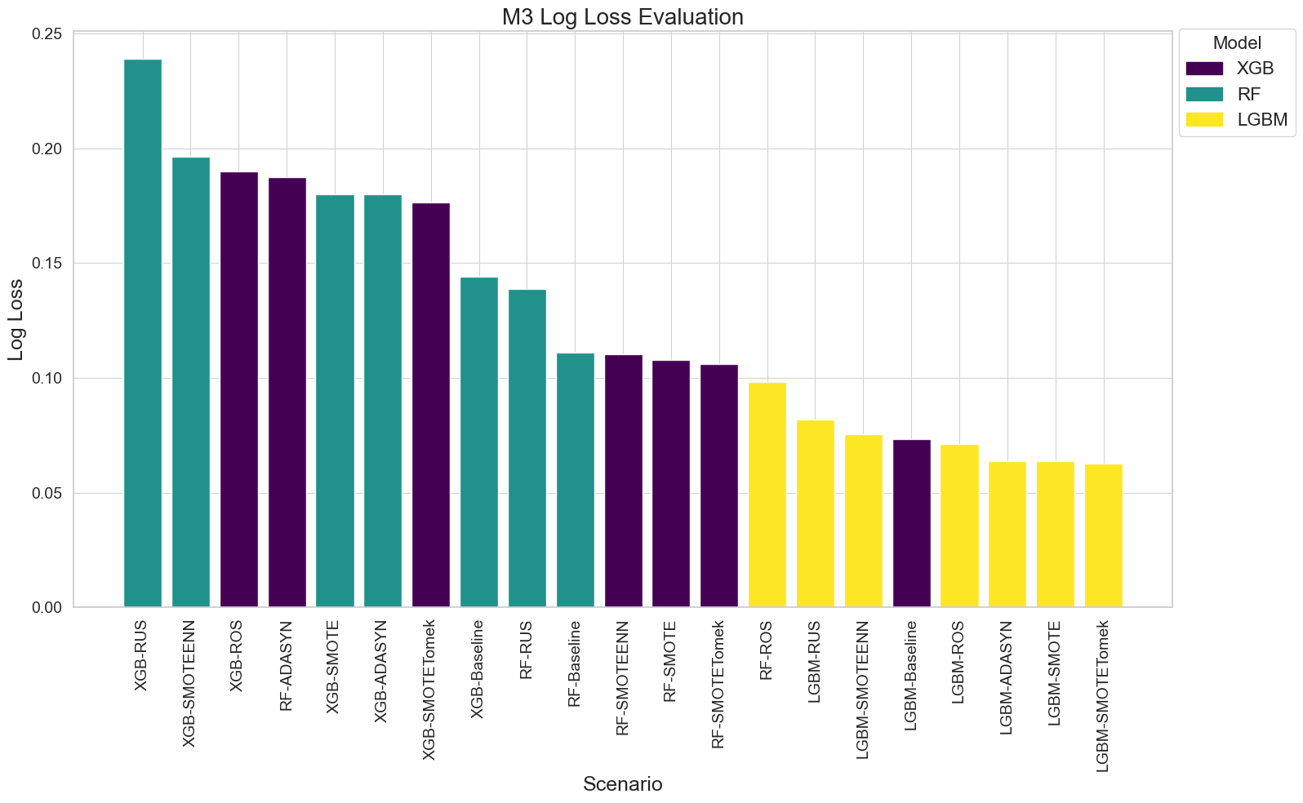

Figure : M3 Log Loss Evaluation

**Training Time:**

Model training time varied based on the combination of ML model and class resampling method, with XGB models recording the fastest training times on average at 30.48s, followed by RF at 285.80s and LGBM at 432.43s, which demonstrated the superior training efficiency of XGB. RUS was the quickest to train on average at 119.10s, followed by baseline at 208.92s, ROS at 246.11s, SMOTEENN at 268.85s, SMOTE and SMOTETomek at around 293s and the longest to train ADASYN at 316.42s. All XGB ML models recorded faster training times than LGBM and RF, with XGB-RUS the shortest at 12.25s and LGBM-ADASYN the longest to train at 551.49s which highlight a large disparity in training times. Overall scenario results are visualised in Figure 110 below.

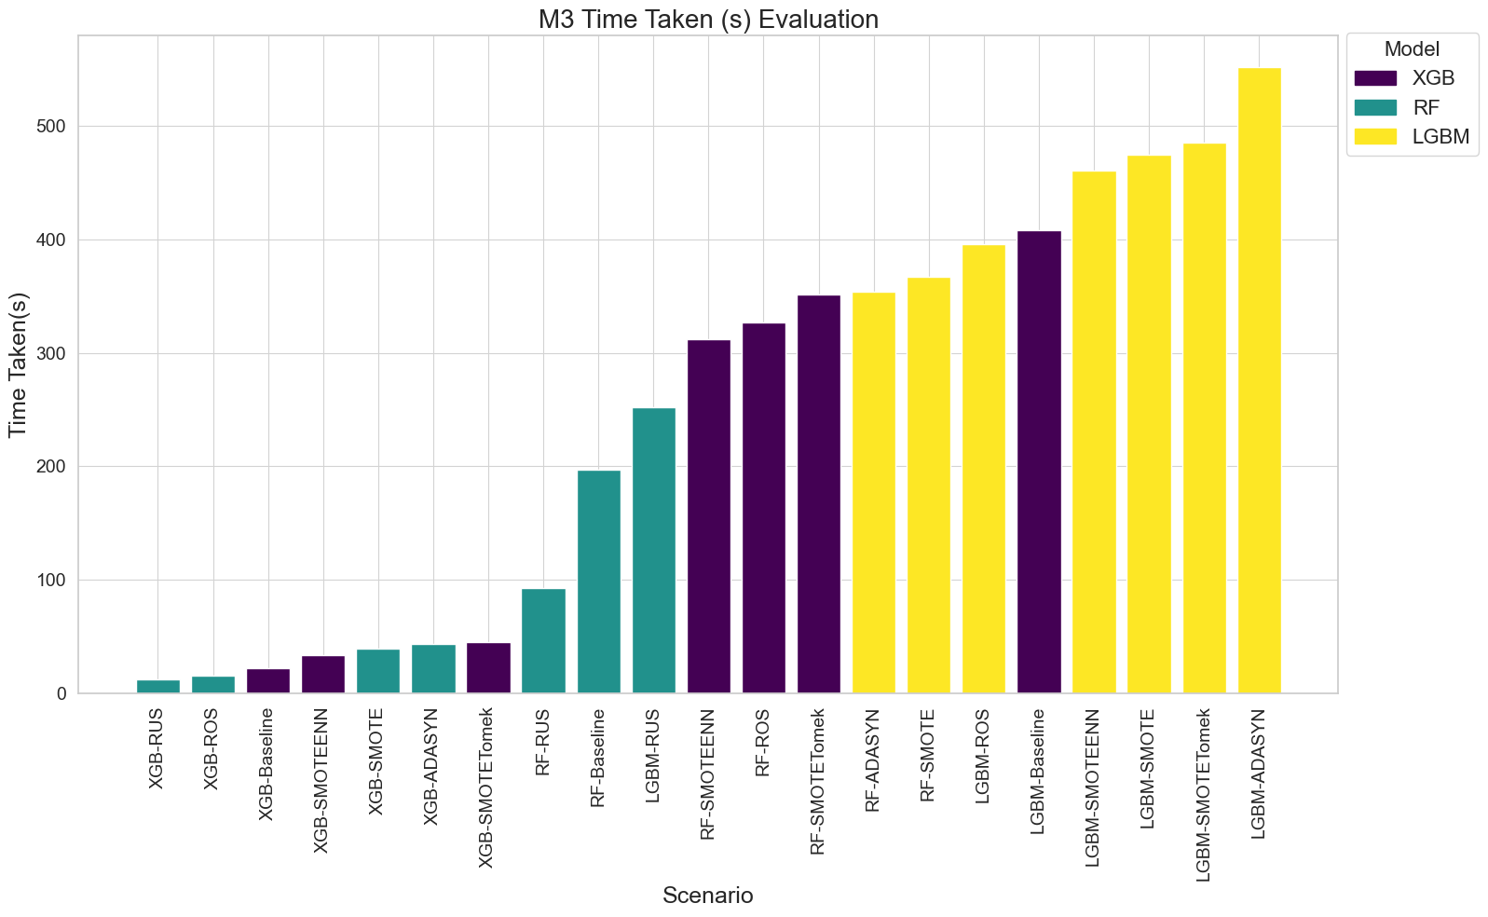

Figure : M3 Time Taken (s) Evaluation

## Conclusion

This chapter presented a detailed overview and evaluation of model performance throughout all phases of model development and refinement. In phase M1, each algorithm RF, LGBM and XGB was trained based on various feature subsets, determined by different CFI thresholds, whereby 85% was found to be the optimal threshold that balanced model performance and complexity by removing redundant features. Following dimensionality reduction, phase M2 focused on optimising hyperparameters using RandomizedSearch and 5-fold cross validation across multiple resampled datasets. Resampling techniques, including oversampling, undersampling and combined methods were evaluated to address the class imbalance inherent in the dataset, with baseline results from non-resampled data also compared. In phase M3, a more refined Grid Search was conducted using a reduced set of hyperparameters previously identified to be optimal, with the objective of reducing model complexity, improving generalisation capabilities and reducing the risk of overfitting. The focus of this final phase was on maximising model predictive performance, particularly for the minority class using a comprehensive set of performance metrics for evaluation.

# Research Findings and Discussion

The previous chapter thoroughly evaluated the key findings from each model using a comprehensive set of performance metrics and techniques. This chapter focuses on interpreting these research findings in relation to the research objectives outlined in this study, as well as a critical analysis of results against existing literature and primary research findings, highlighting inconsistencies and unexpected outcomes, as well as offering insights into the underlying factors which may have influenced results:

**RO1**: Investigate and identify the key factors resulting in Telecom churn at Viatel Technology Group (VTG), by focusing on leveraging data currently available within VTG’s existing data infrastructure.

**RO2**: Develop an optimised and generalised ML model to predict customer churn at VTG and evaluate its effectiveness using appropriate performance comparison metrics and techniques.

**RO3**: Formulate a cohesive, data-driven strategy for VTG that incorporates actionable recommendations for targeted customer retention based on insights derived from ML model predictions.

The development of the final dataset for modelling proved more challenging than anticipated, particularly in handling large data volumes, ensuring data integrity, and addressing missing or inconsistent data. A significant part of this process involved creating data features that aligned with insights from the literature review and primary research. However, several important factors such as market competition (Fareniuk et al., 2022) and outdated technologies (HOS, 2024) were not easily quantifiable and cannot be directly attributed to individual customers. In addition, research was limited by VTG’s existing data infrastructure, which restricted exploration of certain factors, and raises concerns about the validity and generalisability of model results. A notable achievement during data enrichment was the creation of a derived customer ID and status, which reflected the customer lifecycle across VTG’s systems and facilitated a more detailed analysis of customer-related features and their correlation with churn. The decision to exclude cancellation reason aimed to prevent model bias towards the minority class based whether a cancellation reason was present, regardless of customer retention success. However, despite potential bias concerns due to the manual nature of how this data was recorded by customer service staff, excluding this information may be considered a limitation as it omits valuable insights directly from customers about their reasons for attempting to cancel, which could provide important context for interpreting model’s findings. Future model iterations could explore ways to leverage this information within models, potentially refining model accuracy and interpretability.

Initial dimensionality reduction techniques identified on average approximately 14 features per ML algorithm that accounted for 85% CFI, representing about 12% of the total 117 dataset features, which is in line with literature findings in terms of the removal of irrelevant features (Codecademy, 2024). However, the scale of the dimensionality reduction was higher than anticipated based on researcher assumptions. This reduction raises important considerations regarding the validity and reliability of the research, as well as the interpretability and generalisability of model findings, given that models are trained on a relatively small subset of features. However, this reduction in dataset size led to significant improvements in model performance and computational efficiency across all three algorithms, aligning with RO2 which aimed to develop an optimised and generalised ML model to predict customer churn at VTG. Whilst the data preparation process had it challenges, steps taken ultimately contributed to the construction of a leaner and more efficient dataset, facilitating the development of models that were better suited to address the research objectives.

As we move from discussing the dataset’s development to the discussion of results it becomes essential to consider the significance of specific metrics used in model evaluation as outlined in literature (Sina and Amiri, 2022), to ensure they are closely aligned to the research objectives of this study. In the context of churn prediction, particular consideration must be given to the costs associated with false positives (incorrectly predicting that a customer will churn) and false negatives (failing to predict actual churn) such as a net reduction in the customer base as outlined in literature (Fishel, 2024). For instance, if the primary objective is to capture all instances of churn, regardless of the cost of generating false positives, then models which maximise recall of the minority class (churn) are preferable. Conversely, in scenarios where minimising unnecessary retention efforts is critical, precision may take precedence. Given a primary aspect of RO2 was to predict customer churn at VTG and evaluate the model's effectiveness, relying solely on aggregate performance metrics like AUC, accuracy and weighted averages as identified in research (Singh, 2022) were insufficient for a comprehensive interpretation of model results. Instead more nuanced metrics must be considered such as those outlined in literature (Burkov, 2019; Dembla, 2024; GoogleDevelopers, 2024; Scikit Learn, 2023), specifically in the context of predicting the minority class which is the primary focus on this discussion. In this context recall emerges as a critical metric which ensures that all potential churn cases are identified, therefore minimising the cost of false negatives and the negative implications of failing to predict churn. Likewise, the term ‘effectiveness’ suggests the importance of precision when predicting the minority class, which ensures that models correctly predict actual instances of churn without the generation of an excessive amount of false positives. Models that demonstrate both high recall and precision, result in high F1-scores which indicate a well-calibrated model that accurately predicts actual churn cases (GoogleDevelopers, 2024), therefore balancing the need to identify churners whilst minimising unnecessary retention efforts.

The second component of RO2 focused on the development and optimisation of a generalised ML model, which was addressed during M3 with the introduction of Grid Search in line with literature recommendations (Scikit Learn, 2024a; Sina and Amiri, 2022). This approach utilised a reduced set of hyperparameters, deliberately chosen to prevent models from becoming overly complex and from learning the intricate specifics of the dataset, therefore reducing overfitting and enhancing model robustness when applied to unseen data. Based on this understanding, several models demonstrated promising capabilities when tested on unseen data, with LGBM on average returning the highest average F1-score across resampling methods at 95.90%, with LGBM-SMOTETomek identified as the most balanced overall model at 96.57%, followed closely by oversampling methods LGBM-SMOTE; LGBM-ADASYN and LGBM-ROS at around 96.38%, and XGB-Baseline at 96.25%, making them an excellent choice for a balanced approach for CCP and addressing RO2. However, an unexpected finding was that baseline performance returned the highest average F1-score at 95.09%, followed closely by SMOTETomek, SMOTE and ROS at about 94% and ADASYN at 92.42%, which suggests that resampling methods aren’t always more effective than no their baseline counterpart.

When precision is the most important consideration, LGBM returned the highest performance on average at 96.21%, with LGBM-SMOTETomek identified as the most precise model at 97.92%, followed closely by LGBM-SMOTE and LGBM-ADASYN at about 97.45%, XGB-Baseline at 96.63% and LGBM-ROS at 96.49%, making them an excellent choice where the primary aim is reducing the impact of false positives. Similarly to unexpected findings in F1-score, baseline performance returned the highest average precision at 95.18%, followed closely by SMOTETomek at 94.13%, SMOTE at 93.79%, ROS at 93.25% and ADASYN at 89.16%. Conversely, when recall is the most important consideration, XGB returns the highest recall on average across resampling method at 97.17%, with XGB-RUS recording the highest recall at 98.05%, followed closely XGB-ROS at 97.59%, XGB-SMOTE and XGB-ADASYN at about 97.43% and XGB-SMOTETomek at 97.20%, making them an excellent choice where the primary aim is reducing the impact of false negatives. Equally, evaluation of resampling methods irrespective of model found that ADASYN returned the highest average recall at 96.34%, followed closely by RUS at 96.26%; ROS at 95.95%; SMOTEENN at 95.46% and SMOTE at 95.41%.

The final component where addressing RO2 is concerned relates to computational cost, where it was consistently found that LGBM had the longest model training times on average at 432.43s, followed by RF at 285.80s and XGB at 30.48s. Notably, the top six models in terms of training time were all LGBM variants, with LGBM-ADASYN being the most time-consuming at 551.49s and LGBM-ROS at 395.40, an exception to this trend was LGBM-RUS which demonstrated a more balanced training time of 251.83s. In contrast, XGB models were consistently quicker to train than all other models, with all seven XGB variants returning the fastest training times, ranging from the shortest XGB-RUS at 12.25s to XGB-SMOTETomek at 44.95s. This disparity in training times is a critical consideration when weighing computational performance against model accuracy. Whilst LGBM models may offer robust performance, they come at considerable computational cost, in contrast to XGB which demonstrated comparable accuracy in a number of instances, but at significantly reduced training times. This trade-off is essential to consider in situations where computational efficiency is a priority.

Whilst the comparison of resampling methods provided valuable insights into addressing class imbalance, the extensive range of methods explored in this research may have limited the depth of hyperparameter tuning for each model. This challenge was exacerbated by a constrained research timeframe and limited computational resources, given that the research was conducted on a protected company device to ensure data security. Identifying appropriate hyperparameters was particularly challenging due to number of model combinations, as well as the inclusion of additional methods to improve model performance as found in literature, such as dimensionality reduction (Aznar, 2020; Codecademy, 2024), class resampling (El-Amir and El-Henawy, 2024; Sina and Amiri, 2022; Toor and Usman, 2022), 5-fold cross validation (Burkov, 2019; GeeksforGeeks, 2017; Pawluszek-Filipiak and Borkowski, 2020) and regularisation techniques (Burkov, 2019; Sina and Amiri, 2022) being included which increased model refinement complexity in an attempt to address RO2 in developing an optimised and generalised model. Randomized Search was introduced in M2 to address RO2 following dimensionality reduction, however it was found that optimal hyperparameters often led to increasingly complex models. This can be attributed to the wide range of hyperparameters chosen, which permitted models to select values that optimised performance metrics without considering the risk of overfitting and complexity. In general models were found to prefer deeper trees (maximum depth between 20-30), minimal samples per leaf and split (1–2), lower learning rates (0.05–0.1) and larger tree ensembles (number of iterations 400–500). Whilst these parameters produced strong performance, they also resulted in longer training times and likely reduced the models’ robustness and generalisability when applied to unseen data, despite the close alignment of validation and test results in many instances.

To address this, Grid Search was implemented in M3 on a reduced set of hyperparameters to prevent models from becoming overly complex by learning the intricate specifics of the dataset. A notable limitation of this research is the lack of an additional supplementary test set of unseen data, which would have been ideal for testing additional model robustness. Given that 30% of available samples were already utilised for validation and test sets, this additional testing was not feasible and remains a gap that future research could explore. Consequently, whilst final models did not perform as well as their predecessors, it is assumed that with further testing they would prove to be more robust and generalisable. Although individual algorithm fine-tuning could have benefited from additional refinement, particularly for more complex models such as ADASYN, SMOTEENN and SMOTETomek which require precise hyperparameter tuning adjustments to achieve optimal performance (El-Amir and El-Henawy, 2024), several models demonstrated promising results in their ability to accurately predict churn, which provide a solid foundation for future research and development upon final selection.

When evaluating research results against literature and primary research findings, considerable correlation was identified (Copăceanu, 2021; CustomerGauge, 2022; Fareniuk et al., 2022; Kotler, 2023; MRS, 2024; Silver, 2023; TechSee, 2022; Wagh et al., 2024; Zdziebko et al., 2024) but with several notable differences. The below Table 21 summarises the key factors which were found to influence churn at VTG identified during primary research qualitative content analysis.

Table : Key factors influencing churn at VTG identified in Primary Data

|  |  |
| --- | --- |
| **Factor** | **Description** |
| Pricing and Value Perception | High costs are cited as a primary reason for churn (CCM, 2024; COO, 2024). |
| Service Quality | Technical issues with the service, particularly on older technologies like Wireless and Part-Fiber contribute to churn (HOS, 2024; CCM, 2024). |
| Outdated Technologies | Customers on older platforms are more likely to switch to newer services such as Full-Fiber provided by competitors (HOS, 2024; HOO, 2024) |
| Market Competition | Competitive market make it difficult for smaller companies to retain customers, as competitors can offer lower prices and have more substantial marketing budgets (COO, 2024). |
| Fragmented Systems and Processes | The reliance on manual processes and lack of centralised CRM system, impact decision-making speed and prevent timely interventions to prevent churn (HOS, 2024; CCM, 2024). |
| Limited Proactive Measures | Resource constraints and competing priorities limit the ability to implement proactive churn management strategies (COO, 2024; HOO, 2024). |
| Customer Profiling Gaps | Insufficient data at the Point of Sale (POS) and lack of detailed customer profiling make it challenging to predict and prevent churn (HOS, 2024). |
| Billing Flexibility | A lack of payment and billing flexibility was found to lead to churn, particularly for customers facing financial difficulties (CCM, 2024). |

Additionally, summarised below are the key factors which were found to lead to churn in Telecoms, as identified during the literature review.

1. Service Quality (Copăceanu, 2021; Kotler, 2023)
2. Billing (Wagh et al., 2024; Zdziebko et al., 2024)
3. Customer Service (MRS, 2024; Wagh et al., 2024)
4. Pricing and Value Perception (Copăceanu, 2021; Wagh et al., 2024)
5. Service Usage Patterns (Copăceanu, 2021; Fareniuk et al., 2022; Zdziebko et al., 2024)
6. Customer Feedback (CustomerGauge, 2022)
7. Contract and Commitment (Copăceanu, 2021; Wagh et al., 2024; Zdziebko et al., 2024)
8. Market Competition (Fareniuk et al., 2022)

Several common factors were identified when comparing the literature review with primary research findings, particularly related to pricing (Wagh et al., 2024; Zdziebko et al., 2024; CCM, 2024; COO, 2024), service quality (Copăceanu, 2021; Kotler, 2023, HOS, 2024; CCM, 2024), market competition (Fareniuk et al., 2022; COO, 2024), customer service (MRS, 2024; Wagh et al., 2024; COO, 2024; CCM, 2024), and billing (Wagh et al., 2024; Zdziebko et al., 2024; CCM, 2024) as key reasons for churn. However, where findings differed, primary research emphasised the impact of outdated technologies on churn (HOS, 2024; HOO, 2024), with customers more likely to switch when modern alternatives became available in their location. Additionally, the fragmentation of a company’s internal systems and manual processes was emphasised (HOS, 2024; CCM, 2024), which hampers the company’s ability to proactively address churn, as well as challenges noted in the level of customer data collected at POS (HOS, 2024), making it difficult to create accurate churn prediction models. Conversely, the literature review underscored the importance of customer feedback (CustomerGauge, 2022) and highlighted macro factors such as the impact of COVID-19 on remote working trends (Kotler, 2023; Silver, 2023), which have increased the significance and validity of service quality in churn prediction during current times. When compared against VTG’s secondary data, EDA revealed that the top five reasons for customer cancellation were due to a competitor offer at around 33%; relocation at about 29%; price issue at around 17%; service issue at about 9% and technical issue at around 8%. Similarly, the top five successful retention approaches recorded where a customer was saved were service changes at around 60%, other at about 18%, none recorded at around 13%, relocation at about 6% and customer credits at around 4%. These findings align with previously identified churn factors identified during the literature review and primary research as described in Table 21 and the previous paragraph, however relocation emerged as a significant reason not previously identified, and technically one where retention efforts may not be applicable and valid.

As outlined previously, integrating the features found to influence as identified in literature review and primary research into ML models posed a significant challenge. However, where features were available or could be engineered from VTG’s existing data infrastructure the following feature categories emerged as the most impactful during ML modelling, based on dimensionality reduction methods have been applied. These findings broadly align under high level categories with key factors identified previously as shown in Table 22 below.

Table : ML Modelling Most Important Churn Factor Categories

|  |  |  |
| --- | --- | --- |
| **Churn Factor** | **Alignment with Primary Research** | **Alignment with Literature Review** |
| Customer Billing and Pricing | CCM, 2024; COO, 2024 | Wagh et al., 2024; Zdziebko et al., 2024 |
| Customer Discounts and Upgrades | HOS, 2024; HOO, 2024 | Copăceanu, 2021; Wagh et al., 2024 |
| Customer Lifecyle |  | Copăceanu, 2021; Fareniuk et al., 2022; Zdziebko et al., 2024 |
| Customer Service and Retention Efforts |  | MRS, 2024; Wagh et al., 2024 |
| Products and Services Offering |  |  |

However, there are some notable differences between ML model findings and research, particularly in relation to the strength of correlation between customer billing preferences and customer lifecycle related features being the most important factors in predicting churn. Billing and payment flexibility were identified during primary research as a proactive measure to prevent churn (CCM, 2024), however research found that customers who paid their bill manually each month accounted to the vast majority of recorded cancellations at 91%. Furthermore, the vast majority of customers were found to have signed up for services only in the past approximately four years, with the average customer tenure around 5 years, with ML model results observing that as customer duration length increases, so does their propensity to churn. The significant importance of both these feature groups may have heavily biased model predictions towards those customers who preferred to pay their bill manually, or who have been with the company for longer than 5 years, which potentially limits the validity of research findings in being able to detect the subtle factors of churn, and being able to generalise model findings more broadly within the larger Telecom industry.

Furthermore, a gap that wasn’t identified during either the literature review or primary research was the impact of different retention methods on customer churn, whereby it was found that retention methods outside of norm correlated strongly with the likelihood of churn. However, causality cannot be inferred in this context as it could be that customer retention was not applicable in such instances. Additionally, customer discounts and upgrades were found as an important feature in CCP during modelling, which whilst important were not as strong when in comparison to other features. One nuance of the feature set was the prevalence of customers with no packages, which could be considered an abnormality without wider business context of why these instances occurred, and retrospective analysis could potentially find that their inclusion could have biased model predictions. Moreover, customer location was found to be a less important predictor of churn, though an important consideration in this regard is potential model bias towards predicting customer churn in locations that are at a closer geographical proximately to where VTG is based (Dundalk), which have been found to have a larger customer base.

# Conclusions and Recommendations

This research successfully investigated and identified the key factors contributing to churn at VTG, thereby addressing RO1. This process began with an exploration of churn in the Telecom’s industry, followed by a focused approach during primary research to uncover the specific dynamics of churn at VTG. These findings were instrumental in guiding the data analysis and ML modelling of secondary data within VTG’s existing data infrastructure, with the key factors identified as contributing to Telecom churn at VTG summarised as customer billing and pricing; discounts & upgrades; customer lifecycle; service & retention efforts and product offerings.

Whilst not a primary objective, a key limitation of this research is the ability to generalise these findings to the broader Telecom’s industry, both in Ireland and globally. The key factors identified are heavily influenced by the specific dynamics of operating a relatively small Telecom’s service provider, which accounts for no more than 3% market revenue share (Comreg, 2024) within the competitive Irish domestic Telecom’s market.

The second primary objective (RO2) was to develop an optimised and generalised ML model to predict customer churn at VTG and evaluate its effectiveness using appropriate performance comparison metrics and techniques. This objective was successfully achieved, with several supervised classification ML models selected based on their superior churn prediction capabilities in the Telecom industry (Rose et al., 2015; Sidiq et. al, 2023; Wagh et al., 2024; Zahid et al., 2020). Model performance was evaluated using a selection of metrics, with precision, recall and F1-score identified as the most appropriate for assessing the prediction accuracy of the minority (churn) class in line with established recommendations (Burkov, 2019; Sina and Amiri, 2022). Dimensionality reduction techniques (Aznar, 2020; Codecademy, 2024) effectively improved model performance by limiting the number of features in the final dataset whilst retaining 85% of feature importance. However the extent of this reduction was unexpected, with an average of only 14 features utilised in the final model, representing approximately 12% of the 117 dataset features. This finding raises potential limitations concerning the external validity of the research (Elias, 2024), particularly regarding its generalisability to the broader Telecom’s industry. Additionally, the significant reduction in features may limit the ability to understand more nuanced factors that influence model predictive performance, as many potentially relevant features were excluded from the modelling process.

Various model optimisation strategies were implemented with varying levels of success, including a novel approach that incorporated a diverse range of class resampling methods to effectively address the issue of class imbalance, found to be common in CCP (Sina and Amiri, 2022; Toor and Usman, 2022). Hyperparameter tuning was employed in line with literature findings (Scikit Learn, 2024a; Sina and Amiri, 2022) to develop both optimised and generalised models, however it was observed that when a comprehensive set of hyperparameters were provided to Randomized Search, models tended to favour more complex configurations therefore increasing the risk of overfitting, which ensemble models were selected to prevent (Kalirane, 2023) . Consequently, a reduced set of hyperparameters was selected and explored using Grid Search to reduce model complexity and enhance generalisability. However, it’s important to note the limitation of not having an additional test set to validate these assumptions on final model predictions. Of all the model combinations explored, the following were found to be top and lowest performing models in their respective predictive capabilities, as shown in Table 23 below.

Table : Highest and Lowest Performing ML Models

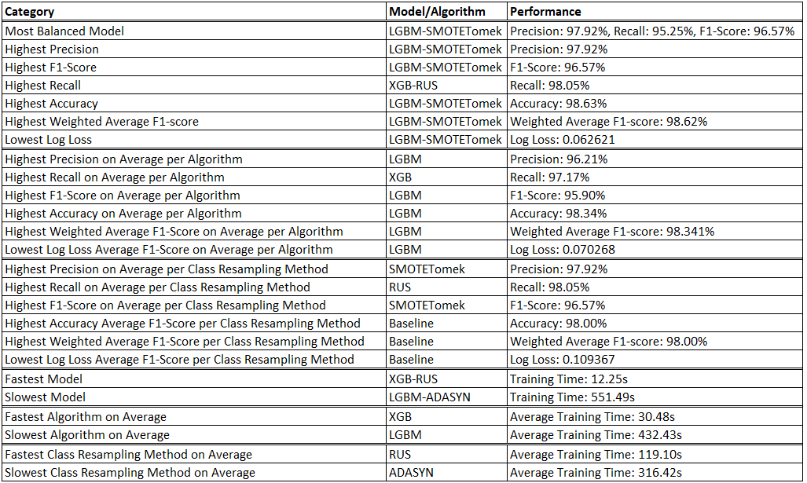

Based on overall research findings, several actionable recommendations can be derived from ML model predictions to address RO3, focusing on the formulation of a cohesive data-driven strategy at VTG for targeted customer retention. As the reasons for churn vary by customer, a segmentation approach is recommended based on the most important underlying characteristics of customer cohorts, with tailored retention strategies recommended for each segment in an effort to proactively reduce the likelihood of churn. The key customer segments and targeted retention strategies can be summarised as follows.

1. **Customer Billing and Pricing:** The correlation between manual billing methods and churn is highly significant, therefore actions could be taken to try to encourage or incentivise customers to migrate onto automatic payment methods which have been shown to be a lot less likely to churn.
2. **Customer Lifecycle:** The correlation between customer duration and churn is highly significant, therefore proactive retention methods towards recognising and potentially rewarding legacy customers could be employed, such as loyalty bonuses or additional customer courtesy engagement to reduce their propensity to churn.
3. **Customer Service and Retention Efforts:** Customers who frequently contacted customer service for any number of reasons, such as technical issues or requests to cancel were found to be more likely to churn, therefore a proactive strategy of engaging with these customers to ensure their needs are met could potentially reduce their likelihood of churn before these issues escalate.

When reviewed holistically, this research successfully achieved its primary and technical objectives. However, there is critical need for future research to explore these findings in the context of Telecom’s providers of different scales and geographic locations to determine if similar results are observed. Additionally, future studies could investigate the cross-industry application of Telecom CCP ML models in sectors such as retail or financial services, as well as delving deeper into the development of novel churn prediction models using advanced ML and AI technologies (Sun and Tan, 2022; Toor and Usman, 2022) that can capitalise on the vast amount of data generated in the industry (Zahid et al., 2020). This should include a strong focus on the ethical implications of these models, with an emphasis on identifying and mitigating associated risks and biases.

# References

365DataScience, 2021. Overfitting vs Underfitting: What’s the Difference [WWW Document]. 365 Data Sci. URL https://365datascience.com/tutorials/machine-learning-tutorials/overfitting-underfitting/ (accessed 8.20.24).

Acheme, I.D., Vincent, O.R., 2021. 16 - Machine-learning models for predicting survivability in COVID-19 patients, in: Kose, U., Gupta, D., de Albuquerque, V.H.C., Khanna, A. (Eds.), Data Science for COVID-19. Academic Press, pp. 317–336. https://doi.org/10.1016/B978-0-12-824536-1.00011-3

Aggarwal, P., Vijayakumar, V., 2024. Customer Churn Prediction in the Telecom Sector, in: 2024 3rd International Conference on Artificial Intelligence For Internet of Things (AIIoT). Presented at the 2024 3rd International Conference on Artificial Intelligence For Internet of Things (AIIoT), IEEE, Vellore, India, pp. 1–6. https://doi.org/10.1109/AIIoT58432.2024.10574660

Ahn, J., Hwang, J., Kim, D., Choi, H., Kang, S., 2020. A Survey on Churn Analysis in Various Business Domains. IEEE Access 8, 220816–220839. https://doi.org/10.1109/ACCESS.2020.3042657

Aized Amin Soofi, Arshad Awan, 2017. Classification Techniques in Machine Learning: Applications and Issues. J. Basic Appl. Sci. 13, 459–465. https://doi.org/10.6000/1927-5129.2017.13.76

Akturk, M., 2021. Weak Learners & Strong Learners for Machine Learning. Medium. URL https://mathchi.medium.com/weak-learners-strong-learners-for-machine-learning-e73e32f86ebd (accessed 8.21.24).

ArcGIS, 2024. How LightGBM algorithm works—ArcGIS Pro | Documentation [WWW Document]. URL https://pro.arcgis.com/en/pro-app/latest/tool-reference/geoai/how-lightgbm-works.htm (accessed 9.8.24).

Ascarza, E., Neslin, S.A., Netzer, O., Anderson, Z., Fader, P.S., Gupta, S., Hardie, B.G.S., Lemmens, A., Libai, B., Neal, D., Provost, F., Schrift, R., 2018. In Pursuit of Enhanced Customer Retention Management: Review, Key Issues, and Future Directions. Cust. Needs Solut. 5, 65–81. https://doi.org/10.1007/s40547-017-0080-0

Aznar, P., 2020. Decision Trees: Gini vs Entropy ⋆ Quantdare. Quantdare. URL https://quantdare.com/decision-trees-gini-vs-entropy/ (accessed 8.21.24).

Baashar, Y., Alhussian, H., Patel, A., Alkawsi, G., Alzahrani, A.I., Alfarraj, O., Hayder, G., 2020. Customer relationship management systems (CRMS) in the healthcare environment: A systematic literature review. Comput. Stand. Interfaces 71, 103442. https://doi.org/10.1016/j.csi.2020.103442

Baeldung, 2021. Stratified Sampling in Machine Learning | Baeldung on Computer Science [WWW Document]. URL https://www.baeldung.com/cs/ml-stratified-sampling (accessed 8.25.24).

Bengtsson, M., 2016. How to plan and perform a qualitative study using content analysis. NursingPlus Open 2, 8–14. https://doi.org/10.1016/j.npls.2016.01.001

Bhale, U.A., Bedi, H.S., 2024. Customer Churn Construct: Literature Review and Bibliometric Study. Manag. Dyn. 24. https://doi.org/10.57198/2583-4932.1327

Bhattacharyya, J., Dash, M.K., 2022. What Do We Know About Customer Churn Behaviour in the Telecommunication Industry? A Bibliometric Analysis of Research Trends, 1985–2019. FIIB Bus. Rev. 11, 280–302. https://doi.org/10.1177/23197145211062687

Bidgoli, H. (Ed.), 2003. Encyclopedia of information systems. Academic Press, Amsterdam ; Boston.

Breiman, L., 2001. Random Forests. Mach. Learn. 45, 5–32. https://doi.org/10.1023/A:1010933404324

Bui, Q.-T., Chou, T.-Y., Hoang, T.-V., Fang, Y.-M., Mu, C.-Y., Huang, P.-H., Pham, V.-D., Nguyen, Q.-H., Anh, D.T.N., Pham, V.-M., Meadows, M.E., 2021. Gradient Boosting Machine and Object-Based CNN for Land Cover Classification. Remote Sens. 13, 2709. https://doi.org/10.3390/rs13142709

Burkov, A., 2019. The hundred-page machine learning book. Andriy Burkov, Polen.

Codecademy, 2024. Feature Importance [WWW Document]. Codecademy. URL https://www.codecademy.com/article/fe-feature-importance-final (accessed 8.21.24).

Comreg, 2024. Quarterly Key Data Report Q1 2024. Comm. Commun. Regul. URL https://www.comreg.ie/?dlm_download=quarterly-key-data-report-q1-2024 (accessed 8.14.24).

Copăceanu, A.-M., 2021. Churn Prediction in Telecommunications Sector using Machine Learning. Database Syst. J. 12, 12–20.

Crabtree, M., 2023. What is Machine Learning? Definition, Types, Tools & More [WWW Document]. URL https://www.datacamp.com/blog/what-is-machine-learning (accessed 8.16.24).

CustomerGauge, 2022. 7 Strategies for Reducing Customer Churn in Telecoms [WWW Document]. CustomerGauge. URL https://customergauge.com/blog/reducing-customer-churn-in-telecommunications (accessed 4.27.24).

Damla Tuğba Sarp, Özge Nalan Bilişik, 2023. Analysis of Customer Churn in Telecommunication Industry with Machine Learning Methods. Düzce Üniversitesi Bilim Ve Teknol. Derg. 11, 2185–2208. https://doi.org/10.29130/dubited.1061257

Dembla, G., 2024. Intuition behind Log-loss Score [WWW Document]. Medium. URL https://towardsdatascience.com/intuition-behind-log-loss-score-4e0c9979680a (accessed 8.21.24).

Devey, C., 2024. How price, quality and health concerns are dominating consumer behaviours [WWW Document]. URL https://www.ey.com/en_ie/consumer-products-retail/how-price-quality-and-health-concerns-are-dominating-consumer-behaviours (accessed 8.15.24).

Du, L., Chen, H., Fang, Y., Liang, X., Zhang, Y., Qiao, Y., Guo, Z., 2022. Research on the Method of Acquiring Customer Individual Demand Based on the Quantitative Kano Model. Comput. Intell. Neurosci. 2022, 5052711. https://doi.org/10.1155/2022/5052711

EDPS [WWW Document], 2024. URL https://www.edps.europa.eu/_en (accessed 5.11.24).

El Naqa, I., Murphy, M.J., 2015. What Is Machine Learning?, in: Issam, Li, R., Murphy, M.J. (Eds.), Machine Learning in Radiation Oncology. Springer International Publishing, Cham, pp. 3–11. https://doi.org/10.1007/978-3-319-18305-3_1

El-Amir, S., El-Henawy, I., 2024. An Improved Model Using Oversampling Technique and Cost-Sensitive Learning for Imbalanced Data Problem. Inf. Sci. Appl. 2, 33–50. https://doi.org/10.61356/j.iswa.2024.213073

Elias, B., 2024. The 4 Types of Validity in Research Design (+3 More to Consider) [WWW Document]. URL https://www.activecampaign.com/blog/validity-in-research-design (accessed 8.23.24).

Fanderl, H., 2023. McKinsey [WWW Document]. URL https://www.mckinsey.com/~/media/mckinsey/email/rethink/2023/08/2023-08-16c.html (accessed 4.19.24).

Fareniuk, Y., Zatonatska, T., Dluhopolskyi, O., Kovalenko, O., 2022. Customer churn prediction model: a case of the telecommunication market. ECONOMICS 10, 109–130. https://doi.org/10.2478/eoik-2022-0021

Finmark, 2024. What is Customer Retention Cost? (CRC Formula). Finmark. URL https://finmark.com/glossary/customer-retention-cost/ (accessed 4.20.24).

Firican, G., 2023. Data management framework 101. LightsOnData. URL https://www.lightsondata.com/data-management-framework/ (accessed 8.21.24).

Fishel, D., 2024. Churn Rate: What It Means, Examples, and Calculations [WWW Document]. Investopedia. URL https://www.investopedia.com/terms/c/churnrate.asp (accessed 4.14.24).

GeeksforGeeks, 2024. Random Forest Algorithm in Machine Learning [WWW Document]. GeeksforGeeks. URL https://www.geeksforgeeks.org/random-forest-algorithm-in-machine-learning/ (accessed 8.24.24).

GeeksforGeeks, 2023. What is Feature Engineering? [WWW Document]. GeeksforGeeks. URL https://www.geeksforgeeks.org/what-is-feature-engineering/ (accessed 8.21.24).

GeeksforGeeks, 2017. Cross Validation in Machine Learning [WWW Document]. GeeksforGeeks. URL https://www.geeksforgeeks.org/cross-validation-machine-learning/ (accessed 9.7.24).

George, T., 2022. Semi-Structured Interview | Definition, Guide & Examples [WWW Document]. Scribbr. URL https://www.scribbr.com/methodology/semi-structured-interview/ (accessed 8.22.24).

George, T., 2021. Mixed Methods Research | Definition, Guide & Examples [WWW Document]. Scribbr. URL https://www.scribbr.com/methodology/mixed-methods-research/ (accessed 9.21.24).

Ghosh, A., Nashaat, M., Miller, J., Quader, S., Marston, C., 2018. A comprehensive review of tools for exploratory analysis of tabular industrial datasets. Vis. Inform. 2, 235–253. https://doi.org/10.1016/j.visinf.2018.12.004

GoogleDevelopers, 2024. Classification: Accuracy, recall, precision, and related metrics | Machine Learning [WWW Document]. Google Dev. URL https://developers.google.com/machine-learning/crash-course/classification/accuracy-precision-recall (accessed 8.21.24).

Groves, M., 2022. Data Modeling Explained: Conceptual, Physical, Logical [WWW Document]. Couchbase Blog. URL https://www.couchbase.com/blog/conceptual-physical-logical-data-models/ (accessed 8.24.24).

Hestisholihah, 2023. Hyperparameter Tuning Showdown: Grid Search vs. Random Search — Which is the Ultimate Winner? | by Hestisholihah | Medium [WWW Document]. URL https://medium.com/@hestisholihah01/hyperparameter-tuning-showdown-grid-search-vs-random-search-which-is-the-ultimate-winner-5927b322e54d (accessed 9.7.24).

IBM, 2023. What Is Multicollinearity? | IBM [WWW Document]. URL https://www.ibm.com/topics/multicollinearity (accessed 8.25.24).

IBM, 2021a. What Is Machine Learning (ML)? | IBM [WWW Document]. URL https://www.ibm.com/topics/machine-learning (accessed 9.7.24).

IBM, 2021b. What Is Boosting? | IBM [WWW Document]. URL https://www.ibm.com/topics/boosting (accessed 8.20.24).

IHREC, 2024. Equality laws in Ireland. URL https://www.ihrec.ie/your-rights/equality-laws-ireland/ (accessed 8.22.24).

Ilyоs Abdullaev, Natalia Prodanova, Mohammed Altaf Ahmed, E. Laxmi Lydia, Bhanu Shrestha, Gyanendra Prasad Joshi, Woong Cho, 2023. Leveraging metaheuristics with artificial intelligence for customer churn prediction in telecom industries. Electron. Res. Arch. 31, 4443–4458. https://doi.org/10.3934/era.2023227?viewType=HTML

Jamshed, S., 2014. Qualitative research method-interviewing and observation. J. Basic Clin. Pharm. 5, 87. https://doi.org/10.4103/0976-0105.141942

Jiménez, T.R., Orozco, M., 2021. Prompts, Not Questions: Four Techniques for Crafting Better Interview Protocols. Qual. Sociol. 44, 507–528. https://doi.org/10.1007/s11133-021-09483-2

Jin, W., Wang, X., Zhan, Y., 2022. Environmental Sound Classification Algorithm Based on Region Joint Signal Analysis Feature and Boosting Ensemble Learning. Electronics 11, 3743. https://doi.org/10.3390/electronics11223743

Kalirane, M., 2023. Ensemble Learning in Machine Learning: Stacking, Bagging and Boosting. Anal. Vidhya. URL https://www.analyticsvidhya.com/blog/2023/01/ensemble-learning-methods-bagging-boosting-and-stacking/ (accessed 8.20.24).

Khoh, W.H., Pang, Y.H., Ooi, S.Y., Wang, L.-Y.-K., Poh, Q.W., 2023. Predictive Churn Modeling for Sustainable Business in the Telecommunication Industry: Optimized Weighted Ensemble Machine Learning. Sustainability 15, 8631. https://doi.org/10.3390/su15118631

Kotler, A., 2023. Tackling The Top Three Drivers Of Churn In Broadband Services [WWW Document]. Forbes. URL https://www.forbes.com/sites/forbestechcouncil/2023/07/18/tackling-the-top-three-drivers-of-churn-in-broadband-services/ (accessed 4.14.24).

Lalwani, P., Mishra, M.K., Chadha, J.S., Sethi, P., 2022. Customer churn prediction system: a machine learning approach. Computing 104, 271–294. https://doi.org/10.1007/s00607-021-00908-y

Lazarov, V., Capota, A., 2007. Churn Prediction, Bus. Anal. Course. TUM Comput Sci 33, 34.

Le, T., Vo, M.T., Vo, B., Lee, M.Y., Baik, S.W., 2019. A Hybrid Approach Using Oversampling Technique and Cost-Sensitive Learning for Bankruptcy Prediction. Complexity 2019, 8460934. https://doi.org/10.1155/2019/8460934

Li, Z., Guo, H., Wang, W.M., Guan, Y., Barenji, A.V., Huang, G.Q., McFall, K.S., Chen, X., 2019. A Blockchain and AutoML Approach for Open and Automated Customer Service. IEEE Trans. Ind. Inform. 15, 3642–3651. https://doi.org/10.1109/TII.2019.2900987

Mäkilä, T., Järvi, A., Rönkkö, M., Nissilä, J., 2010. How to Define Software-as-a-Service – An Empirical Study of Finnish SaaS Providers, in: Tyrväinen, P., Jansen, S., Cusumano, M.A. (Eds.), Software Business, Lecture Notes in Business Information Processing. Springer Berlin Heidelberg, Berlin, Heidelberg, pp. 115–124. https://doi.org/10.1007/978-3-642-13633-7_10

Mali, M., Mishra, D., Vijayalakshmi, M., 2023. MF-RISE : Benchmarking for Multifaceted Recommender System Engine. https://doi.org/10.21203/rs.3.rs-2400377/v1

Mandot, P., 2017. What is LightGBM, How to implement it? How to fine tune the parameters? | by Pushkar Mandot | Medium [WWW Document]. URL https://medium.com/@pushkarmandot/https-medium-com-pushkarmandot-what-is-lightgbm-how-to-implement-it-how-to-fine-tune-the-parameters-60347819b7fc (accessed 8.24.24).

Manzoor, A., Atif Qureshi, M., Kidney, E., Longo, L., 2024. A Review on Machine Learning Methods for Customer Churn Prediction and Recommendations for Business Practitioners. IEEE Access 12, 70434–70463. https://doi.org/10.1109/ACCESS.2024.3402092

Mathworks, 2024. Machine Learning in MATLAB - MATLAB & Simulink [WWW Document]. URL https://www.mathworks.com/help/stats/machine-learning-in-matlab.html (accessed 8.17.24).

McCausland, T., 2021. The Bad Data Problem. Res.-Technol. Manag. 64, 68–71. https://doi.org/10.1080/08956308.2021.1844540

McGill, 2024. Random Forests.

Middleton, F., 2019. Reliability vs. Validity in Research | Difference, Types and Examples [WWW Document]. Scribbr. URL https://www.scribbr.com/methodology/reliability-vs-validity/ (accessed 8.23.24).

Mohammed, M., Kadhem, S., Maisa, Ali, A., 2021. Insider Attacker Detection Using Light Gradient Boosting Machine 1, 48–66.

Mokhtari, S., Yen, K.K., Liu, J., 2021. Effectiveness of Artificial Intelligence in Stock Market Prediction based on Machine Learning. https://doi.org/10.48550/ARXIV.2107.01031

MRS, 2024. Market Research Society (MRS) | Where Data Insight & Evidence Matters [WWW Document]. Mark. Res. Soc. URL http://www.mrs.org.uk/ (accessed 4.14.24).

Nikolopoulou, K., 2022. What Is Non-Probability Sampling? | Types & Examples [WWW Document]. Scribbr. URL https://www.scribbr.com/methodology/non-probability-sampling/ (accessed 8.22.24).

O’Reilly, 2024. 4. Supervised Learning: Models and Concepts - Machine Learning and Data Science Blueprints for Finance [Book] [WWW Document]. URL https://www.oreilly.com/library/view/machine-learning-and/9781492073048/ch04.html (accessed 8.20.24).

Pandithurai O., B Sriman, Narayan S Hrudhai, Ahmed H Humaid, 2023. Telecom Churn Prediction Using Voting Classifier Ensemble Method and Supervised Machine Learning Techniques. ITM Web Conf. 56, 05012–05012. https://doi.org/10.1051/itmconf/20235605012

Pang-Ning Tan, Michael Steinbach, Vipin Kumar, Anuj Karpatne, 2019. Introduction to Data Mining. Pearson, Harlow.

Park, W., Ahn, H., 2022. Not All Churn Customers Are the Same: Investigating the Effect of Customer Churn Heterogeneity on Customer Value in the Financial Sector. Sustainability 14, 12328. https://doi.org/10.3390/su141912328

Pawar, D., Sabla, Y., Tayal, N., Nainan, S., 2024. Predicting Telecom Customer Churn: An In-depth Evaluation of Machine Learning Algorithms. Grenze Int. J. Eng. Technol. GIJET 10, 1723–1729.

Pawluszek-Filipiak, K., Borkowski, A., 2020. On the Importance of Train–Test Split Ratio of Datasets in Automatic Landslide Detection by Supervised Classification. Remote Sens. 12, 3054. https://doi.org/10.3390/rs12183054

Prabadevi, Shalini, Kavitha, 2023. Customer churning analysis using machine learning algorithms. Int. J. Intell. Netw. 4, 145–154. https://doi.org/10.1016/j.ijin.2023.05.005

Rahimi, S., Khatooni, M., 2024. Saturation in qualitative research: An evolutionary concept analysis. Int. J. Nurs. Stud. Adv. 6, 100174. https://doi.org/10.1016/j.ijnsa.2024.100174

Rajora, A., 2023. The Simple Maths Behind XGBoost. Medium. URL https://medium.com/@57fdaditya/a-simple-maths-behind-xgboost-d13aac14e578 (accessed 8.25.24).

Reichheld, F., 2001. Prescription for Cutting Costs [WWW Document]. Bain. URL https://www.bain.com/insights/prescription-for-cutting-costs-bain-brief/ (accessed 8.15.24).

Robinson, O.C., 2023. Probing in qualitative research interviews: Theory and practice. Qual. Res. Psychol. 20, 382–397. https://doi.org/10.1080/14780887.2023.2238625

Rose, K., Eldridge, S., Chapin, L., 2015. The Internet of Things: An Overview.

S R Gowtham, 2022. Standardization vs Normalization. Medium. URL https://medium.com/@gowthamsr37/which-feature-scaling-technique-to-use-standardization-vs-normalization-9dcf8eafdf8c (accessed 8.25.24).

Sadaiyandi, J., Arumugam, P., Sangaiah, A.K., Zhang, C., 2023. Stratified Sampling-Based Deep Learning Approach to Increase Prediction Accuracy of Unbalanced Dataset. Electronics 12, 4423. https://doi.org/10.3390/electronics12214423

Sadeghi, M., Dehkordi, M.N., Barekatain, B., Khani, N., 2023. Improve customer churn prediction through the proposed PCA-PSO-K means algorithm in the communication industry. J. Supercomput. 79, 6871–6888. https://doi.org/10.1007/s11227-022-04907-4

Salesforce, 2024. What is customer retention? [WWW Document]. Salesforce. URL https://www.salesforce.com/eu/learning-centre/customer-service/customer-retention/ (accessed 5.11.24).

SAP, 2018. Training and Testing perspective on SAP Leonardo Machine Learning Foundation [WWW Document]. SAP Community. URL https://community.sap.com/t5/technology-blogs-by-sap/training-and-testing-perspective-on-sap-leonardo-machine-learning/ba-p/13404450 (accessed 8.19.24).

Schröer, C., Kruse, F., Gómez, J.M., 2021. A Systematic Literature Review on Applying CRISP-DM Process Model. Procedia Comput. Sci. 181, 526–534. https://doi.org/10.1016/j.procs.2021.01.199

Scikit Learn, 2024a. RandomForestClassifier [WWW Document]. Scikit-Learn. URL https://scikit-learn/stable/modules/generated/sklearn.ensemble.RandomForestClassifier.html (accessed 8.21.24).

Scikit Learn, 2024b. Importance of Feature Scaling [WWW Document]. Scikit-Learn. URL https://scikit-learn/stable/auto_examples/preprocessing/plot_scaling_importance.html (accessed 8.25.24).

Scikit Learn, 2024c. StandardScaler [WWW Document]. Scikit-Learn. URL https://scikit-learn/stable/modules/generated/sklearn.preprocessing.StandardScaler.html (accessed 8.25.24).

Scikit Learn, 2023. Classification Report [WWW Document]. Scikit-Learn. URL https://scikit-learn/stable/modules/generated/sklearn.metrics.classification_report.html (accessed 10.18.23).

Senthilselvi, A., Kanishk, V., Vineesh, K., Praveen Raj, A., 2024. A Novel Approach to Customer Churn Prediction in Telecom, in: 2024 International Conference on Advances in Computing, Communication and Applied Informatics (ACCAI). Presented at the 2024 International Conference on Advances in Computing, Communication and Applied Informatics (ACCAI), IEEE, Chennai, India, pp. 1–7. https://doi.org/10.1109/ACCAI61061.2024.10602345

Shearer, C., 2000. The CRISP-DM model: the new blueprint for data mining. J Data Warehous. 2000 5, 13–22.

Sidiq et. al, 2023. Analysis and Classification of Customer Churn Using Machine Learning Models. J. RESTI Rekayasa Sist. Dan Teknol. Inf. 7, 1253–1259. https://doi.org/10.29207/resti.v7i6.4933

Silver, H., 2023. Working from Home: Before and After the Pandemic. Contexts Berkeley Calif 22, 66–70. https://doi.org/10.1177/15365042221142839

Sina, S.M., Amiri, B., 2022. Model Optimization Analysis of Customer Churn Prediction Using Machine Learning Algorithms with Focus on Feature Reductions. Discrete Dyn. Nat. Soc. 2022, 1–20. https://doi.org/10.1155/2022/5134356

Singh, Y., 2022. Precision, Recall, and F1 Score: When Accuracy Betrays You | Proclus Academy [WWW Document]. URL https://proclusacademy.com/blog/explainer/precision-recall-f1-score-classification-models/ (accessed 9.6.24).

Somak Saha, Chamak Saha, Md. Mahidul Haque, Md. Golam Rabiul Alam, Ashis Talukder, 2024. ChurnNet: Deep Learning Enhanced Customer Churn Prediction in Telecommunication Industry. IEEE Access 12, 4471–4484. https://doi.org/10.1109/ACCESS.2024.3349950

Statista, 2024. Topic: Telecommunications services [WWW Document]. Statista. URL https://www.statista.com/topics/2665/telecommunications-services/ (accessed 8.15.24).

Sun, Y., Tan, X., 2022. Customer Relationship Management Based on SPRINT Classification Algorithm under Data Mining Technology. Comput. Intell. Neurosci. 2022, 1–11. https://doi.org/10.1155/2022/6170335

Sutton, C.D., 2005. Classification and Regression Trees, Bagging, and Boosting, in: Handbook of Statistics. Elsevier, pp. 303–329. https://doi.org/10.1016/S0169-7161(04)24011-1

Tan Yan Lin, Pang Ying Han, Ooi Shih Yin, Khoh Wee How, Hiew Fu San, 2023. Stacking Ensemble Approach for Churn Prediction: Integrating CNN and Machine Learning Models with CatBoost Meta-Learner. J. Eng. Technol. Appl. Phys. 5, 99–107. https://doi.org/10.33093/jetap.2023.5.2.12

TechSee, 2022. 2022 STATE OF CUSTOMER CHURN IN TELECOM: The Impact of the Pandemic on Churn Trends [WWW Document]. TechSee. URL https://techsee.me/resources/reports/state-of-customer-churn-telecom-survey-report/ (accessed 4.14.24).

Thomas, L., 2020. Confounding Variables | Definition, Examples & Controls [WWW Document]. Scribbr. URL https://www.scribbr.com/methodology/confounding-variables/ (accessed 8.23.24).

Toor, A.A., Usman, M., 2022. Adaptive telecom churn prediction for concept-sensitive imbalance data streams. J. Supercomput. 78, 3746–3774. https://doi.org/10.1007/s11227-021-04021-x

Torrance, H., 2012. Triangulation, Respondent Validation, and Democratic Participation in Mixed Methods Research. J. Mix. Methods Res. 6, 111–123. https://doi.org/10.1177/1558689812437185

Tufte, E.R., 2001. The visual display of quantitative information, 2nd ed. ed. Graphics Press, Cheshire, Conn.

Vanamala, C.K., Mohan, V., 2024. Implementation of Churn Rate Prediction System using Machine Learning. Grenze Int. J. Eng. Technol. GIJET 10, 1031–1037.

Verhelst, T., 2019. Churn Prediction and Causal Analysis on Telecom Data. Masters Thesis, University of Brussels.

Wagh, Aishwarya A. Andhale, Kishor S. Wagh, Jayshree R. Pansare, Sarita P. Ambadekar, S.H. Gawande, 2024. Customer churn prediction in telecom sector using machine learning techniques. Results Control Optim. 14. https://doi.org/10.1016/j.rico.2023.100342

Wang, Y., Pan, Z., Zheng, J., Qian, L., Mingtao, L., 2019. A hybrid ensemble method for pulsar candidate classification. Astrophys. Space Sci. 364. https://doi.org/10.1007/s10509-019-3602-4

Wassouf, W.N., Alkhatib, R., Salloum, K., Balloul, S., 2020. Predictive analytics using big data for increased customer loyalty: Syriatel Telecom Company case study. J. Big Data 7, 29. https://doi.org/10.1186/s40537-020-00290-0

What Is One Hot Encoding and How to Implement It in Python [WWW Document], 2024. URL https://www.datacamp.com/tutorial/one-hot-encoding-python-tutorial (accessed 8.25.24).

XGBoost Documentation — xgboost 2.1.1 documentation [WWW Document], 2024. URL https://xgboost.readthedocs.io/en/stable/ (accessed 8.25.24).

Zahid, H., Mahmood, T., Morshed, A., Sellis, T., 2020. Big data analytics in telecommunications: literature review and architecture recommendations. IEEECAA J. Autom. Sin. 7, 18–38. https://doi.org/10.1109/JAS.2019.1911795

Zdziebko, T., Sulikowski, P., Sałabun, W., Przybyła-Kasperek, M., Bąk, I., 2024. Optimizing Customer Retention in the Telecom Industry: A Fuzzy-Based Churn Modeling with Usage Data. Electron. 2079-9292 13, 469. https://doi.org/10.3390/electronics13030469

Zhao, M., Zeng, Q., Chang, M., Tong, Q., Su, J., 2021. A Prediction Model of Customer Churn considering Customer Value: An Empirical Research of Telecom Industry in China. Discrete Dyn. Nat. Soc. 2021, 1–12. https://doi.org/10.1155/2021/7160527

Zohuri, B., Moghaddam, M., 2017. Business resilience system (BRS): driven through boolean, fuzzy logics and cloud computation: real and near real time analysis and decision making system. Springer, Cham.